

Neuroscience Area – PhD course in Functional and Structural Genomics

A genome-wide microRNA screen uncovers modifiers of α-synuclein fibril internalization

Candidate: Advisor:
Lea Nikolić Prof. Giuseppe Legname

Academic Year 2024-25


ABSTRACT

BACKGROUND
Synucleinopathies are a diverse group of neurodegenerative diseases characterized by the misfolding, aggregation, and accumulation of α-synuclein (α-syn) into oligomeric assemblies and amyloid inclusions. In addition to neurons, pathological α-synuclein can be internalized by glial cells, which are thought to play a predominant role in its degradation. However, prolonged overload and altered glial functions may eventually promote the intracellular accumulation of these pathological species, creating opportunities for their release and subsequent spread to neighbouring cells. Despite its importance, the molecular machinery regulating α-syn uptake remains poorly characterized, with only a limited number of neuronal and glial receptors identified to date.

OBJECTIVES
To expand the repertoire of molecular regulators and investigate the role of the human microRNAome in α-syn fibril internalization, we conducted a genome-wide microRNA (miRNA) screen encompassing 2,042 human miRNA mimics.

METHODS
We performed an image-based high-throughput screen in U-87 MG glioblastoma cells, utilizing differentially labeled α-syn preformed fibrils (PFFs) to distinguish intracellular uptake from membrane-bound fibrils. Flow cytometry-based validation was carried out in multiple glioblastoma cell lines, assessing the effects of identified miRNA(s) on the uptake of fluorescently labeled synthetic α-syn PFFs and patient-derived fibrils associated with synucleinopathies.

RESULTS
Our study identified multiple miRNA regulators of α-syn internalization and validated miR-517a-3p as a potent suppressor of α-syn fibril uptake and accumulation.

CONCLUSION
miR-517a-3p, a member of the C19MC miRNA cluster, is implicated in neurodegenerative disease pathology, as dysregulation of this cluster has been observed in several such conditions. By impairing endocytosis, this miRNA could reduce the ability of glial cells to efficiently engulf and degrade fibrils, potentially contributing to disease progression. Our findings underscore the role of miRNA regulation in synucleinopathies and highlight miRNAs and their downstream targets as potential therapeutic candidates. Further research into miRNA-mediated pathways could offer novel insights into disease mechanisms and provide new avenues for intervention.
LIST OF PUBLICATIONS

Research Articles
- Colini Baldeschi, A., Zattoni, M., Vanni, S., Nikolic, L., Ferracin, C., La Sala, G., Summa, M., Bertorelli, R., Bertozzi, S. M., Giachin, G., Carloni, P., Bolognesi, M. L., De Vivo, M., & Legname, G. (2022). Innovative Non-PrP-Targeted Drug Strategy Designed to Enhance Prion Clearance. Journal of medicinal chemistry, 65(13), 8998–9010. https://doi.org/10.1021/acs.jmedchem.2c00205

Review Articles
- Ulassi, E., Nikolić, L., Bolognesi, M.L., & Legname, G. (2023). Therapeutic strategies for identifying small molecules against prion diseases. Cell Tissue Res. 392(1), 337-347. https://doi.org/10.1007/s00441-021-03573-x
- Nikolić, L.*, Ferracin, C.*, & Legname, G. (2022). Recent advances in cellular models for discovering prion disease therapeutics. Expert Opinion on Drug Discovery, 17(9), 985-996. https://doi.org/10.1080/17460441.2022.2113773

LIST OF ABBREVIATIONS

α-syn: Alpha-synuclein
AD: Alzheimer’s disease
AGO: Argonaute
Ago-CLIP: Argonaute cross-linking immunoprecipitation
ALP: Autophagy-lysosomal pathway
ALS: Amyotrophic lateral sclerosis
AMPA: α-Amino-3-hydroxy-5-methyl-4-isoxazolepropionic acid
antimiRs: miRNA inhibitors
AP-2: Adaptor protein complex 2
ASOs: Antisense oligonucleotides
ATP: Adenosine triphosphate
BAMs: Border-associated macrophages
CHC17: Clathrin heavy chain 17
CLIP: Cross-linking and immunoprecipitation
CME: Clathrin-mediated endocytosis
CNS: Central nervous system
Cryo-EM: Cryogenic electron microscopy
CSF: Cerebrospinal fluid
DaBAMs: Disease-activated BAMs
DAM: Disease-associated microglia
DAMPs: Danger-associated molecular patterns
DAT: Dopamine transporter
DLB: Dementia with Lewy bodies
DNA: Deoxyribonucleic acid
ER: Endoplasmic reticulum
ENS: Enteric nervous system
eNMDRs: Extrasynaptic NMDA receptors
EXP5: Exportin-5
FTD: Frontotemporal dementia
GABA: Gamma-aminobutyric acid
Gal-1: Galectin-1
GCI: Glial cytoplasmic inclusions
HSPG: Heparan sulfate proteoglycans
IPMDS: International Parkinson and Movement Disorders Society
LLPS: Liquid-liquid phase separation
LBD: Lewy body disease
mAbs: Monoclonal antibodies
MAPS: Misfolding-associated protein secretion
MDS: Movement Disorder Society
miRNA: MicroRNA
mRNA: Messenger RNA
MVB: Multivesicular body
MSA: Multiple system atrophy
mtDNA: Mitochondrial DNA
MYO7B: Myosin-7B
NAC: Non-amyloid-β component
NDDs: Neurodegenerative diseases
NMDA: N-Methyl-D-aspartate
NMDARs: NMDA receptors
NTG: Non-targeting
P-bodies: Processing bodies
PAR: Poly (ADP-ribose)
PARP-1: Poly(ADP-ribose) polymerase-1
PD: Parkinson’s disease
PDD: Parkinson’s disease with dementia
PFFs: Preformed fibrils
PNS: Peripheral nervous system
Pol II: RNA polymerase II
pre-miRNA: precursor miRNA
pri-miRNA: primary miRNA
Ran-GTP: GTP-bound Ran protein
RB: Retinoblastoma
RBD: Rapid eye movement sleep behavior disorder
RISC: RNA-induced silencing complex
RNA: Ribonucleic acid
ROS: Reactive oxygen species
SASP: Senescence-associated secretory phenotype
scRNA-seq: Single-cell RNA sequencing
SDS-PAGE: Sodium dodecyl sulfate-polyacrylamide gel electrophoresis
Ser129: Phosphorylation at serine residue 129
siRNAs: Small interfering RNAs
SNARE: Soluble N-ethylmaleimide-sensitive factor activating protein receptor
SNCA: Alpha-synuclein gene
SNpc: Substantia nigra pars compacta
TNTs: Tunneling nanotubes
UPS: Unconventional protein secretion
USP19: Ubiquitin-Specific Protease 19
UTR: Untranslated region
Wt: Wild-type

TABLE OF CONTENTS
INTRODUCTION 9
AGEING AND NEURODEGENERATION 9
Defining features of ageing and neurodegeneration 9
Genomic instability 10
Altered proteostasis 10
Mitochondrial dysfunction 12
Cellular senescence 13
Neuroinflammation 13
Synaptic and neuronal dysfunction 15
Neuronal death 16
α-SYNUCLEIN 18
α-synuclein structure 18
α-synuclein localization and physiological function 18
Pathological α -synuclein 19
α-synuclein fibril formation 20
α-synuclein-based experimental models 21
α-synuclein overexpression–based models 21
Soluble α -synuclein–based models 22
α -synuclein preformed fibrils–based models 24
Experimental models based on loss of α-synuclein 25
SYNUCLEINOPATHIES 25
Parkinson’s disease 27
Multiple system atrophy 29
Dementia with Lewy bodies 30
THERAPEUTIC STRATEGIES AGAINST SYNUCLEINOPATHIES 31
Monoclonal antibodies 31
Antisense oligonucleotides and microRNAs 31
SPREAD OF α -SYNUCLEIN PATHOLOGY 32
The Braak staging scheme 32
Peripheral origins of α-synuclein propagation 34
Cell-to-cell transmission of α-synuclein 35
Unconventional protein secretion 35
Exosomes 36
Tunneling nanotubes 37
Enhanced secretion 38
Endocytosis 38
Passive diffusion 40
CLEARANCE OF α -SYNUCLEIN 41
MicroRNAs 43
Discovery 43
Biogenesis 43
Mechanism of action 45
Synthetic miRNA mimics and inhibitors 46
MiRNA target identification 47
MiRNAs in synucleinopathies 48
AIM OF THE STUDY 50
MATERIALS AND METHODS 51
CELL CULTURES 51
U-87 MG 51
U-87-m-Cherry 51
LN-229 51
U-251 MG and SH-SY5Y 51
Human induced pluripotent stem cell (hiPSC)-derived astrocytes 52
α-SYNUCLEIN PREFORMED FIBRIL PRODUCTION 52
AFM AND TEM ANALYSIS 53
α-SYNUCLEIN PREFORMED FIBRIL LABELING 54
CONSTRUCTION OF U-87-m-Cherry CELL LINE 54
Lentiviral packaging 54
Lentivirus titration 54
U-87 MG cell line transduction 55
MICROSCOPY-BASED HIGH-THROUGHPUT SCREENING 55
Cell transfection 55
Immunostaining 56
Image analysis 56
FLOW CYTOMETRY 57
CELL VIABILITY ASSAY 58
CELL PROLIFERATION ASSAY 58
CLICK-IT EDU ASSAY 59
ANNEXIN V ASSAY 59
STATISTICAL ANALYSES 59
RESULTS 61
Image-based high content microRNA screen 61
Orthogonal validation of primary screen hit microRNA mimics 62
Cytotoxicity assessment of miR-517a-3p in U-87 MG cells 65
Insights into the mechanism of miR-517a-3p: exploring the fate of internalized α-synuclein preformed fibrils 67
The role of miR-517a-3p in endocytosis of monomeric α-synuclein and transferrin 68
miR-517a-3p reduces the internalization of Tau-K18 and patient-derived pathological α-synuclein fibrils 70
miR-517a-3p reduces α-synuclein preformed fibril uptake across glioblastoma cell lines 71
DISCUSSION 74
BIBLIOGRAPHY 84
SUPPLEMENTARY MATERIALS 108

INTRODUCTION

AGEING AND NEURODEGENERATION
Over the past century, the average global life expectancy at birth has increased by approximately 30 years, according to population data from the United Nations (UN) Population Division [1]. By 2050, the global population aged 65 years or over is projected to increase from 761 million in 2021 to 1.6 billion people by 2050. The aging trend is even more pronounced for the population aged 80 years or older, which is estimated to almost triple from 2021 levels, reaching 459 million by 2050 [2]. In 2024, the number of infants (1 year of age or younger) was already surpassed by the average number of people aged 80 or more [3].
This unprecedented demographic shift has been driven by significant advancements in public health, such as vaccination and sanitation, medicinal breakthroughs like antibiotics, and overall improved living standards.
However, longevity comes with its own challenges. As general health declines with age, the susceptibility to age-related diseases and conditions increases. Among various risk factors, ageing is the primary driver of neurodegenerative diseases, with the most prevalent, such as Alzheimer’s disease (AD) and Parkinson’s disease (PD), predominantly affecting the elderly [4]. The progressive loss of neuronal function and structure in specific regions of the central nervous system (CNS) gradually diminishes our ability to retain memories, cognition, behavior, sensory function, and motor control, cumulatively leading to a lost sense of identity.

Defining features of ageing and neurodegeneration
In their seminal review article, López-Otín et al. described aging at the cellular and molecular levels, proposing nine key hallmarks: genomic instability, telomere shortening, epigenetic changes, dysfunctional proteostasis, dysregulated nutrient-sensing, mitochondrial dysfunction, cellular senescence, stem cell exhaustion, and altered intercellular communication [5].
These hallmarks of aging are tightly linked to the pathophysiology of neurodegenerative diseases, which share many overlapping features. Specifically, the eight hallmarks of neurodegenerative diseases - pathological protein aggregation, synaptic and neuronal network dysfunction, aberrant proteostasis, cytoskeletal abnormalities, altered energy homeostasis, double-stranded deoxyribonucleic acid (DNA) and single-stranded ribonucleic acid (RNA) defects, inflammation, and neuronal cell death - closely correlate with the mechanisms driving cellular aging [6]. Together, these interconnected processes underscore the profound relationship between aging and the onset of neurodegenerative diseases, highlighting the shared molecular pathways that contribute to both phenomena.

Genomic instability
Genomic instability is generally described as the propensity of the genome to acquire mutations, including base substitutions, insertions, deletions, copy number changes, chromosomal abnormalities, or retrotranspositions [7]. These alterations, intrinsic to both nuclear and mitochondrial genomes, commonly arise from errors in replication or repair processes triggered by DNA damage, ultimately affecting the genome’s structural and functional integrity. Decline in DNA damage repair (DDR) pathways largely exacerbate genomic instability, allowing DNA lesions to accumulate over time. Beyond contributing to genomic instability, DNA damage at the molecular level leads to epigenetic alterations, telomere dysfunction, mitochondrial impairment, and proteostatic stress.
Particularly vulnerable to these insults are neurons, post mitotic cells with high energy demands which convert external stimuli into action potentials to facilitate signal transmission and cellular communication throughout the body. Extensive evidence links DNA damage and deficiencies in repair mechanisms to multiple neurodegenerative diseases [8-11]. For instance, postmortem studies of synucleinopathy and AD brains reveal accumulated DNA lesions alongside elevated levels of DNA damage markers [11-13].

Altered proteostasis
Maintaining proteostasis is another demanding task for aging cells due to the intricate interplay of systems such as the proteasome, autophagy, ubiquitination machinery, and lysosomal network, all working together to sustain cellular protein balance. Among other evidence, this challenge is underscored by the protein deposits characteristic of amyotrophic lateral sclerosis (ALS) and frontotemporal dementia (FTD), such as TAR DNA-binding protein 43 (TDP-43), amyloid beta (Aβ) in AD, and α-synuclein (α-syn) in synucleinopathies, observed even in cognitively normal older adults (Figure 1) [14-16]. The processes of fibril formation, precipitation, and protein sequestration, which reflect the progressive corruption of underlying cellular mechanisms over time, become even more pronounced in the context of neurodegenerative diseases.

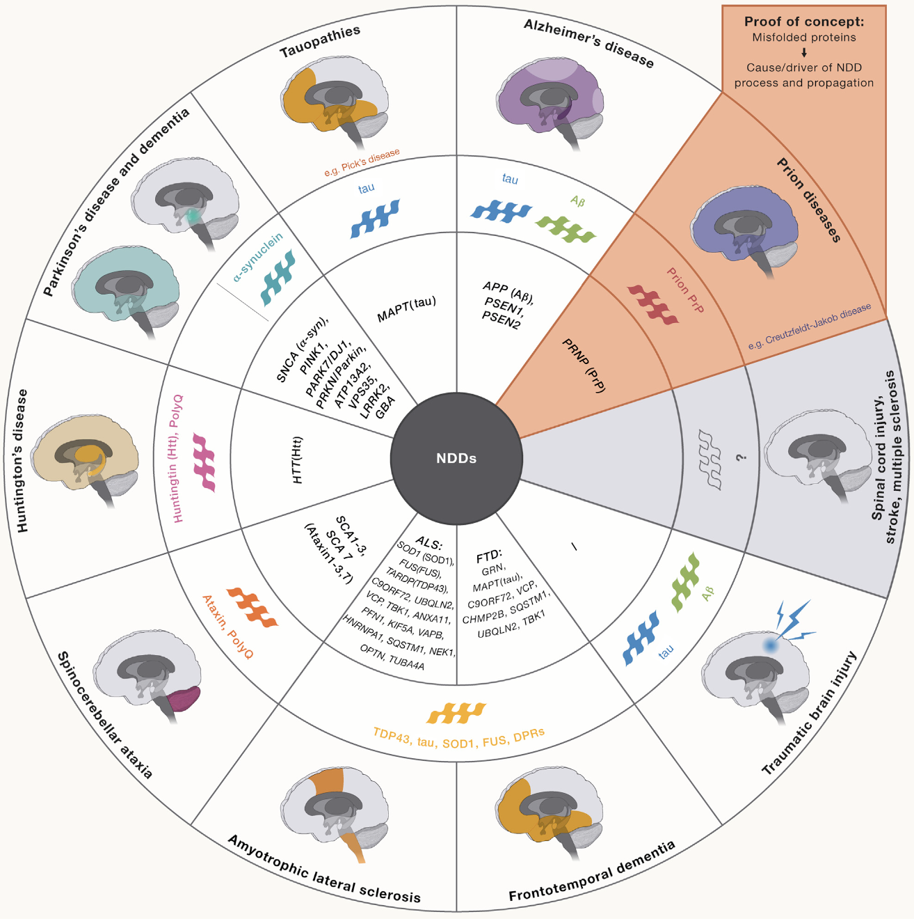
Figure 1. Neurodegenerative diseases and misfolded proteins.
The circular diagram provides an overview of various neurodegenerative diseases (NDDs) and their associated misfolded proteins, which are implicated in disease progression and propagation. The center of the diagram is labeled "NDDs", representing neurodegenerative diseases as a collective group. The inner ring lists specific proteins and genetic factors linked to each disease. The middle ring categorizes diseases based on common protein pathology. The outer ring contains brain illustrations, highlighting affected brain regions that are color-coded by the type of NDD. Adapted from [6], Cell.

Mitochondrial dysfunction
Mitochondrial dysfunction is an additional hallmark of the normal biological ageing process, which is inextricably linked to neurodegeneration. Besides generating most of the cellular chemical energy, in the form of adenosine triphosphate (ATP), mitochondria play key roles in lipid biosynthesis, cell apoptosis, and calcium buffering [17]. Reactive oxygen species (ROS), a direct by-product of “cellular respiration”, are major culprits behind oxidative damage to proteins, lipids and mitochondrial DNA (mtDNA), as well as mediators of inflammation [18, 19]. Chronic mitochondrial dysfunction can ultimately lead to cell death due to insufficient energy supply, increased ROS burden, and dysregulated calcium signaling [20].
Among various quality control mechanisms, mitophagy serves as the cell’s final line of defense to manage terminally damaged mitochondria. PTEN-induced putative kinase protein 1 (PINK1)-Parkin pathway is one of the pathways that activate mitophagy, and mutations in both of these genes have been associated with the early onset of autosomal recessive PD [21, 22].
The first study linking mitochondrial dysfunction to PD patients was published more than 30 years ago by Schapira et al [23]. This study associated mitochondrial dysfunction with reduced activity of the mitochondrial respiratory Complex I, which was detected in substantia nigra of PD patients and successfully reproduced in mouse model of induced parkinsonism. Dysfunctional mitochondria have also been detected in skin fibroblasts and peripheral blood mononuclear cells isolated from PD patients [24, 25]. Beyond PD, mitochondrial dysfunction and altered mitophagy are also linked to other neurodegenerative diseases such as Huntington’s disease (HD), AD, and ALS [26-29].

Cellular senescence
In 1961, Leonard Hayflick and Paul Moorhead demonstrated that human somatic cells in culture have a finite number of divisions before entering a state of replicative senescence [30]. Cellular senescence is a form of stable cell cycle arrest triggered by cellular stress in response to damaged cells and ageing [31]. Among other stimuli, DNA damage can halt the cell cycle until repaired through the DNA damage response pathways [32]. This process contributes to the accumulation of senescent cells in various tissues and organs, both in ageing individuals as well as those afflicted by neurodegenerative diseases [33, 34]. p53 (TP53)-p21 (CDKN1A) and p16^{INK4a} (CDKN2A)-retinoblastoma (RB) signaling pathways, triggered by damaged DNA, are among most studied regulators of cellular senescence [35]. Senescent cells adopt a senescence-associated secretory phenotype (SASP) and start secreting pro-inflammatory mediators to communicate damage to neighboring cells.
Riessland et al. were the first to show that the loss of the genetic risk factor SATB1 for PD activates p21-dependent cellular senescence in both human embryonic stem cell (hESC)-derived post-mitotic dopaminergic neurons, and in vivo - in murine dopaminergic neurons [36, 37]. This and others studies also established a connection between cellular senescence and PD, identifying elevated levels of p21, p16 and SASP factors in dopaminergic neurons and astrocytes from the substantia nigra pars compacta (SNpc) of PD patients [38]. Additionally, increased number of senescent astrocytes and neurons with elevated p16 and SASP levels were found in frontal cortex of both aged non-AD and AD individuals [33, 39]. Senescent glia exhibit a diminished capacity to clear deposits of misfolded α-syn and Aβ, while senescent neurons display decreased electrical activity and lower expression of proteins associated with synaptic plasticity [40-42]. The failure to effectively clear senescent cells leads to prolonged release of pro-inflammatory SASP factors, contributing to chronic neuroinflammation often associated with neurodegeneration.

Neuroinflammation
All cell types in central nervous system (CNS): neurons, microglia, macroglia and infiltrating leukocytes, respond to altered homeostasis and contribute to neuroinflammation in unique ways influenced by their morphology, function and localization. While neuroinflammation typically serves as a protective mechanism against diverse insults and, when effective, restores homeostasis, uncontrolled chronic inflammation can escalate and spiral out of control. This is commonly characterized by sustained glial cell activation, prolonged release of pro-inflammatory factors, and increased oxidative stress – all associated with age-related neurodegeneration [6].
Microglia are the brain’s parenchyma resident phagocytic cells with indispensable functions in both the developing and adult brain [43]. They are critical for mediating immune responses, clearing of cellular debris, maintaining neuronal networks, and removal of protein deposits implicated in various neurodegenerative diseases. In response to different stressors, such as danger-associated molecular patterns (DAMPs) released from damaged neurons, activated microglia traditionally differentiate into M1, characterized by pro-inflammatory and neurotoxic phenotype, or M2, regarded as anti-inflammatory and neuroprotective. However, this overly simplistic classification does not adequately reflect the complexity of their responses to the challenges such as protein precipitation, neuronal damage and degeneration, and interactions with other CNS cell types [44].
While elevated numbers of reactive microglia have been reported in AD and PD patient brains, Keren-Shaul et al. identified and characterized a unique subset of microglia, termed disease-associated microglia (DAM) [45, 46]. Using single-cell RNA sequencing (scRNA-seq) of CNS immune cells from ALS and AD mouse models, as well as human postmortem AD brains, they observed that DAM cells predominantly localize to sites of AD pathology. Many genes expressed by DAM have been previously linked to AD, including the receptor TREM2 which is essential for DAM activation.
In a separate study, neuroinflammation in a PD mouse model was found to be mediated by border-associated macrophages (BAMs), which typically reside in the choroid plexus, meningeal and perivascular spaces of the CNS [47]. scRNA-seq of ventral midbrain mononuclear cells in α-syn-overexpressing mice identified both DAMs and disease-activated BAMs (DaBAMs). Interestingly, although DaBAMs shared many transcriptional similarities with DAMs, they took on distinct roles, particularly in recruiting immune cells, facilitating infiltration, and presenting antigens - key processes required to activate a CD4 T cell response.
In conjunction with microglia, astrocytes play an equally important role in the neuroinflammatory response. As the most abundant glial cell subtype, astrocytes exhibit diverse morphological and functional characteristics across different regions of the CNS [48]. These functions involve regulation of key processes such as synaptic connectivity, ion and neurotransmitter concentrations, and blood-brain permeability, all of which collectively support CNS homeostasis. Similar to microglia, astrocytes respond to pathological changes to their local microenvironment by switching to a reactive phenotype, known as astrogliosis. As a part of their efforts to reestablish homeostasis, astrocytes undergo transcriptional, biochemical, morphological and physiological remodeling, which varies depending on the type of insult. Reactive astrogliosis, accompanying neurodegeneration, has been evidenced through neuroimaging studies of sporadic, familial, and prodromal cases of AD [49, 50]. Additionally, elevated levels of serum and plasma biomarkers of astrogliosis have also been observed in PD patients, but the extent and regional distribution of astrogliosis in the brains of these patients remain elusive [51-54].
In an ageing brain, and in many neurodegenerative diseases, the morphology and function of astrocytes appear strikingly altered compared to those in young and healthy brains [55]. Moreover, dysregulated astrocytic calcium signaling is detected in different neurodegeneration mouse models and shown to have a profound negative effect on the connectivity of neuronal networks [56-58].

Synaptic and neuronal dysfunction
Functional connectivity of neuronal networks relies on numerous cell-autonomous and non-cell autonomous functions. These functions include the role of functional mitochondria in the maintenance of ion homeostasis and energy supply, the stabilization end elimination of synapses in regulating presynaptic vesicle dynamics and postsynaptic signaling, and the presence of extracellular matrix components, which contribute to the overall functional and architectural support [6, 59].
Aberrant neuronal firing patterns in AD are evidenced by hyperactivity of cortical and hippocampal neurons and reported in the patients and AD mouse models [60, 61]. The notion that these perturbations precede the onset of AD-related dementia is showcased by dysfunctional neuronal networks in presymptomatic carriers of genetic mutations or alleles associated with AD, patients with mild cognitive impairment, as well as in cognitively normal individuals with fibrillar amyloid deposition in the cerebral cortex. Functional neuronal network connectivity is also disturbed in PD patients and, intuitively, appears to precede the onset of advanced PD symptoms [62]. Among others, this disturbance was observed in a study examining axonal transport of motor proteins in nigral dopaminergic neurons from postmortem PD brains at different stages of the disease. While the reduction in kinesin levels has been observed already in the early stages, decreased levels of the DYNLT3 subunit of cytoplasmic dynein were detected only in late PD stages.
Although pathological neuronal activity within the substantia nigra and other basal ganglia structures has been the most extensively studied in the context of PD, peripheral neuropathy and disruptions in the brain-wide connectivity have also been reported [63-68]. Specifically, these disruptions have been noted across the entire neocortex and cerebellum, as well as in distinct CNS regions, such as the locus coeruleus, pedunculopontine nucleus, nucleus basalis of Meynert, dorsal motor nucleus of the vagus nerve, and raphe nucleus [68-74].
Experimentally, additional studies have also reported altered neuronal connectivity and changes in extracellular matrix composition associated with PD. These studies indicate a drastically decreased rate of synaptic current events and dysregulated pathways related to extracellular matrix in induced pluripotent stem cell (iPSC)-derived dopaminergic neurons from cases of genetic or sporadic PD [75-77].

Neuronal death
Pathological alterations in all the aforementioned mechanisms lead up to and ultimately culminate in cell death. The literature on neuronal cell death in aged individuals without a diagnosed neurological condition is conflicting and appears to depend on factors such as age differences, lifestyle and intra-individual variability. By contrast, it is indisputable and well documented in individuals afflicted by neurodegenerative diseases.
With PD as an example, neuronal cell loss affects noradrenergic neurons of the locus coeruleus, cholinergic neurons of the pedunculopontine nucleus, nucleus basalis of Meynert, and dorsal motor nucleus of the vagus, dopaminergic neurons of the ventral tegmental area, and, to a varying extent, serotonergic neurons of the raphe nucleus [78]. However, the most studied and frequently documented finding is the extensive loss of SNpc dopaminergic neurons, observed in postmortem PD brains.
Neuronal degeneration in specific areas of the CNS is usually mirrored by different cognitive, behavioral and/or motor symptoms characteristic of the disease. For instance,
bradykinesia, or slowness of movement, typically seen in PD patients, is associated with the depleted striatal dopamine levels [79]. The mechanism behind this symptom is explained by the dysregulation of the cortico-basal ganglia-thalamocortical motor circuit. This circuit originates and terminates in cortical areas related to movement and it is extensively regulated by the activity of the striatal medium spiny neurons. These neurons are further divided into two distinct subtypes based on the dopamine receptors expressed. Specifically, direct pathway neurons express dopamine D1 receptors and facilitate movement while indirect pathway neurons, expressing dopamine D2 receptors, inhibit it. Therefore, loss of striatal dopamine, resulting mainly from SNpc neuronal loss, creates an imbalance between the excitatory and inhibitory signaling within the basal ganglia facilitatory and inhibitory pathways. This gradually leads to impaired stimulation of the motor cortex areas and is ultimately manifested as bradykinesia.
This process can also be modeled experimentally. For instance, a widely used PD model relies on the use of 6-hydroxydopamine (6-OHDA), a hydroxylated dopamine analogue, to specifically deplete nigrostriatal dopamine neurons, resulting in non-cell autonomous alterations (i.e., changes in other cell types) and resembling motor and non-motor deficits commonly seen in individuals with PD during both the early and late stages of the disease [80, 81].
The pinnacle of neurodegenerative disease research is to prevent cell death. Unfortunately, due to the complexity of neurodegenerative diseases, uncertainties about the ideal therapeutic targets or time windows, diverse risk factors, and individual genetic susceptibilities, efforts to develop disease-modifying therapies or treatments that can halt the disease progression have so far been unsuccessful.

α-SYNUCLEIN

α-synuclein structure
Synucleins belong to a family of structurally similar proteins whose expression is enriched in the CNS, and include three members: α- ,β-, and γ-synuclein [82].
Monomeric α-syn is soluble, intrinsically disordered protein that can adopt a wide range of conformations upon interaction with diverse biomolecules or binding to different cellular compartments [83]. This small, acidic protein, with an approximate molecular weight of 14 kDa, is conserved across various vertebrate species and is encoded by the SNCA gene mapped to a human chromosome 4q21.3-q22 [84].
α-syn is composed of 140 amino acids, with the N-terminal region spanning residues 1-60, the central/non-amyloid-β component (NAC) region encompassing residues 61-95, and the C-terminal portion comprising residues 96-140 [85]. The N-terminus of α-syn is characterized by seven 11-mer repeats (XKTKEGVXXXX), which have a tendency to form an amphipathic alpha-helix that mediates α-syn’s interaction with membranes. Negatively charged and highly unstructured C-terminal region has been reported protective against α-syn fibril formation and is implicated in calcium (Ca²⁺) binding, chaperone-like activity, and the modulation of α-syn’s synaptic vesicle binding [86]. Finally, the most aggregation-prone region is the hydrophobic NAC domain, which plays a crucial role in catalyzing α-syn fibrillation [87].

α-synuclein localization and physiological function
This protein was first isolated in 1988 by Luc Maroteaux, James Campanelli, and Richard Scheller from the electric organ of the Pacific electric ray (Torpedo californica) and named based on its localization at presynaptic nerve terminals and neuronal nuclear membranes [88]. While α-syn is abundantly expressed in the CNS, it is not restricted to this region, as it has also been detected in peripheral nervous system (PNS) sensory, sympathetic, and motor neurons, as well as in enteric nervous system (ENS) and in the olfactory epithelium [89, 90]. Apart from nervous tissues, α-syn’s expression is also reported in other tissues, including muscle, kidney, liver, lung, heart, testis, blood vessels, cerebrospinal fluid (CSF), plasma, platelets, lymphocytes, and in red blood cells [82, 85]. However, it is considered a neuronal protein as it predominantly localizes around synaptic vesicles in presynaptic terminals [91]. Although many of its physiological functions are still debated, presynaptic localization of α-syn suggests its role in neurotransmitter release and transmembrane trafficking [92, 93]. This is supported by experimental data highlighting α-syn’s role in regulating multiple steps of the synaptic vesicle cycle, such as vesicle clustering and docking, soluble N-ethylmaleimide-sensitive factor activating protein receptor (SNARE) complex assembly, and the homeostasis of synaptic vesicle pools. α -syn has also been reported to interact with and regulate the activity of the presynaptic human dopamine transporter (DAT), a protein essential for the dopamine reuptake into neurons [94-97].
In addition to the presynaptic compartment, α-syn has been found localized to the nucleus, mitochondria, endoplasmatic reticulum (ER), and Golgi apparatus [90]. Recently, cytosolic α-syn was shown to directly interact with processing bodies (P-bodies) - membraneless organelles involved in mRNA turnover - and regulate mRNA stability through its association with the decapping module located within these structures [98]. Moreover, in vitro studies have reported the interaction of α-syn with multiple components of the cytoskeleton [90].
Under physiological conditions, α-syn resides in the cell cytosol as a natively unfolded monomer and adopts an α-helical structure upon interacting with curved membranes. This helical, membrane-bound α-syn conformation is associated with the formation of α-syn multimers that act as SNARE complex chaperones and facilitate SNARE complex assembly [99].

Pathological α -synuclein
By contrast, pathological, misfolded α-syn, implicated in PD and other synucleinopathies, is rich in β-sheets and exists in various interconvertible conformational states [90, 92, 100]. These include transient oligomeric and prefibrillar species which assemble into insoluble α-syn amyloid fibrils and eventually deposit into large multiprotein intercellular inclusions known as Lewy bodies and Lewy neurites [90, 101].

α-synuclein fibril formation
While the molecular mechanisms driving α-syn aggregation in vivo remain poorly understood, numerous in vitro studies emphasize the pivotal role of nucleation in the molecular cascade of fibril formation [102-104]. Nucleation refers to the formation of β-sheet – rich nuclei (“seeds”), the smallest irreversible aggregates essential for the formation of amyloid fibrils. This process involves the recruitment and templated misfolding of the normal, soluble protein into its insoluble and aberrant β-sheet isoform. Repeated cycles of recruitment and misfolding of the soluble growth substrate elongate the aggregate at its ends, eventually forming large fibrils.
Nuclei can arise either directly from smaller α-syn species, such as β-sheet monomers or oligomers (primary nucleation), or from pre-existing fibrils (secondary nucleation). The formation of nuclei from the fragmentation of pre-existing fibrils is a catalytic process involving multiple steps. It begins with the binding of soluble α-syn species to the surface of the fibril, followed by their conversion into β-sheet – rich isoforms and detachment, which ultimately yields additional seeds for new fibril formation.
In vitro, nucleation-dependent polymerization typically follows a sigmoidal amyloid growth kinetics, defined by three individual phases: lag phase, exponential growth phase and a stationary phase [105, 106]. The lag phase involves the least thermodynamically favorable processes, encompassing molecular events such as polymerization of α-syn into nuclei and the formation of detectable aggregates. The exponential growth phase is characterized by the elongation of aggregates, secondary nucleation processes, and the emergence of multiple polymorphic species, including oligomers, protofibrils, and fibrils. Finally, during the stationary phase, most of the soluble α-syn is converted into amyloid fibrils, and thermodynamic equilibrium between aggregates and monomers is established.
However, it is important to note that while in vitro studies provide crucial mechanistic insights, in vivo aggregation pathways may be influenced by additional factors, such as genetic and epigenetic modifications, cellular compartmentalization, post-translational modifications, protein environment alterations, and interactions with other biomolecules [107-110].
Various aggregation mechanisms have been proposed, which may operate simultaneously and yield distinct aggregate polymorphs [111]. These mechanisms include the addition of monomers to growing aggregates, the clustering of preformed aggregates, and phase separation – a process that has received a significant attention in recent years.
Liquid-liquid phase separation (LLPS) is a process in which two or more phases with unique biophysical properties emerge. This process is driven by biophysical interactions, including electrostatic forces and multivalent interactions that both influence and are influenced by the spatial arrangement of molecules in the resulting droplets [112, 113]. Sequestration of specific proteins or nucleic acids into these membraneless organelles is a physiological process that regulates a wide range of cellular functions, including transcription, genome organization, innate and adaptive immune responses, and synaptic signaling. However, protein aggregates, characteristic of different neurodegenerative diseases, have also been shown to form via LLPS as well as irreversible liquid-to-solid phase transitions [113, 114]. These pathological phase transitions are currently thought to be driven by the disease-associated mutations, posttranslational modifications and intrinsically disordered protein regions [113, 115].

α-synuclein-based experimental models
To clarify the role of α-syn in neurodegeneration, multiple experimental models have been developed. These range from in vitro fibrillation assays to produce, amplify or characterize distinct α-syn fibrils, to various α-syn – based cellular and tissue models, as well as transgenic and non-transgenic animal models inoculated with different exogenous α-syn fibrillar isoforms.

α-synuclein overexpression–based models
Neuronal overexpression of wild-type (wt) human α-syn using viral vectors or transgenic techniques in rodent models has been associated with altered dopaminergic transmission, behavioral and motor learning deficits [116-120]. While some of these models usually develop ubiquitinated α-synuclein inclusions, these are usually not followed by cell death. Recently, overexpression of wt human α-syn in dopaminergic neurons was studied in accelerated aging mouse model [121]. In this model, altered dopamine metabolism was accompanied by degeneration of dopaminergic neurons in the substantia nigra and noradrenergic neurons in the locus coeruleus, as well as age-related motor coordination impairment and gut dysfunction. Overexpression of human wt- or A53T- α-syn (mutation in the SNCA gene linked to early-onset PD) was also investigated in non-human primates [122]. While both animal groups exhibited intracellular inclusions of phosphorylated α-syn at serine residue 129 (Ser129), worsened motor performance and nigral dopaminergic cell loss were more pronounced and consistent within the A53T group.
Collectively, these studies underscore the detrimental effects of dysregulated α-syn expression levels, disease-associated mutations such as A53T, and age-related vulnerabilities, all of which contribute to α-syn – mediated cellular insults.

Soluble α -synuclein–based models
SNCA point mutations including A53T, A30P, A53E, A53V, E46K, H50Q, G51D, and A30G segregate with rare familial forms of PD [123-126]. These mutations have been shown to modulate SNCA expression levels, enhance α-syn secretion, alter its interaction with other proteins, or increase its aggregation propensity and fibrillation. In contrast, artificial point mutations, such as E35K and E57K, have been linked to increased α-syn oligomerization and, due to their higher membrane affinity, lead to membrane disruption [125]. A study by Winner at al. demonstrated structure-related toxicity of α-syn conformers, highlighting increased neurotoxicity of oligomeric species observed both in cultured cells and in vivo [127]. In this study, the substantia nigra of rats was injected with a lentivirus expressing the E35K and E57K oligomer-forming variants, resulting in increased dopaminergic cell loss compared to rats overexpressing either wild-type human α-syn or familial PD mutants.
Additionally, soluble α-syn species have been linked to altered glutamatergic neurotransmission by influencing the function and distribution of glutamate-gated Ca²⁺ channels. Studies conducted on cultured dopaminergic cells and primary murine hippocampal neurons, either overexpressing human α-syn transgene or treated with monomeric human α-syn, demonstrated reduced expression of the surface GluN1 subunit of N-methyl-D-aspartate receptors (NMDARs) [128, 129]. Another study published by the same group found phosphorylated α-syn oligomers more effective than monomeric species in promoting the internalization of GluN1 [130]. In all these studies, α -syn-induced reduction of the NMDR subunit was diminished upon blocking clathrin-mediated endocytosis by employing different procedures, including the knockdown of RAB5B gene, a small GTPase isoform essential for NMDR internalization.
In their ex vivo study, this group reported elevated levels of monomeric and oligomeric α-syn in striatum and hippocampus of aged human postmortem brains [131]. This age-related increase in α-syn in selective brain regions correlated with the reduced expression of the GluN1 subunit of NMDARs and increased expression of Rab5B protein.
Another group demonstrated that oligomeric α-syn induces calcium-dependent glutamate release from astrocytes, contributing to the loss of neuronal dendritic spines [130]. This damage is reported to occur either directly through the activation of extrasynaptic NMDRs (eNMDRs) by oligomeric α-syn or indirectly via the overstimulation of eNMDRs by astrocytic glutamate.
Aditionally, a study by Durante et al. revealed α-syn-mediated toxicity in a specific subtype of striatal GABAergic neurons [132]. Neuronal dysfunction was observed exclusively in pharmacologically isolated GluN2A NMDR subunit-containing spiny projection neurons from brain slices of α-syn injected rats. In contrast, no electophysiological impairments were observed in neurons containing either AMPA receptors – or GluN2B NMDR subunit. This toxicity was characterized by reduced postsynaptic NMDAR-mediated synaptic currents and impaired corticostriatal long-term potentiation in both direct (D1-positive) and indirect (D2-positive) neuronal pathways. Furthermore, intrastriatal injections of oligomeric α-syn caused severe visuospatial learning deficits and early behavioural alterations, surpassing those induced by α-syn PFF.
Dopaminergic neurons, along with their associated brain regions, are frequently identified as the most vulnerable to α-syn-mediated insults. This susceptibility is attributed to their exceptionally high basal oxidative stress levels and elevated free cytosolic Ca²⁺ compared to other neuron types [133]. However, the aforementioned studies suggest that the selective vulnerability of distinct neuronal (sub)populations may also be influenced by specific features of their expressed postsynaptic receptors. Moreover, these findings emphasize the dominant role of small soluble α-syn forms over fibrillary species in striatal synaptic plasticity and striatal-dependent behavioral impairments, independent of dopaminergic neurons.

α -synuclein preformed fibrils–based models
Although prefibrillar α-syn oligomeric assemblies are often associated with higher cytotoxicity compared to their fibrillar isoforms, these assemblies are most likely transient and eventually generate fibrils [134-137]. Through secondary nucleation processes, these fibrils, in turn, release additional oligomer nuclei [103]. Notably, in animal models of α-synucleinopathy, only fibrillar α-syn has been demonstrated to propagate from cell-to-cell, thereby contributing to the spread of the pathology.
Animal models relying on α-syn mutants and/or overexpression are primarily suited to study SNCA-associated familial synucleinopathies and may not faithfully model the more prevalent sporadic forms of the diseases [138]. To account for the sporadic cases, animal models injected with α-syn preformed fibrils (α-syn PFFs) have been developed. In vitro produced, and therefore non-phosphorylated fibrils injected into animal brains are shown to seed the aggregation and promote fibril formation of soluble endogenous α-syn, as evidenced by the appearance of phosphorylated α-synuclein inclusions following the injection [139]. Luk et al. reported the formation and cell-to-cell transmission of hyperphosphorylated α-syn-rich inclusions and their correlation with the observed neuronal loss and motor impairments in the wt mice injected with murine α-syn PFFs [140]. In addition, the spread of pathological α-syn, loss of dopaminergic nigral neurons, and dopamine transporter upregulation were also observed in non-human primates following injection of human α-syn PFFs into their putamen [141].
A study by Kam et al. provides mechanistic insights into the neurotoxicity of murine α-syn fibrils, produced in vitro (α-syn PFFs), mediated through the activation of the DNA damage repair protein - poly(ADP-ribose) polymerase-1 (PARP-1) [142]. Activation of PARP-1 was followed by increased protein levels of poly (ADP-ribose) (PAR) in both primary mouse cortical neurons and in vivo. The authors also reported direct interaction between PAR and the N-terminal domain of α-syn. Moreover, findings from their in vitro fibrillation assay indicate accelerated fibril formation of recombinant α-syn in the presence of PAR, whereas the resulting fibrils (PAR- α-syn PFFs) comprised biochemically distinct conformers with increased resistance to proteinase K digestion. Lastly, mice administered a single intrastriatal injection of PAR-α-syn PFF exhibited significantly altered dopamine levels, loss of dopaminergic neurons, and behavioral deficits, at earlier timepoints compared to those injected with α-syn PFFs.
Pathological α-syn species have also been reported to drive neuroinflammation, microglia activation, mitochondrial and lysosomal dysfunction and to impair autophagy, microtubule transport, and synaptic vesicle homeostasis [85, 143]. However, this process is not unidirectional, as dysfunctional lysosomes or mitochondria, as well as inflammatory environment have also been shown to promote the accumulation of pathological α-syn species [144, 145].

Experimental models based on loss of α-synuclein
Animal models lacking endogenous α-syn have been generated to account for the loss-of-function hypothesis as the trigger for the development of synucleinopathies.
Although α-syn knockout animals appear to lack the specific pathological features associated with synucleinopathies, substantia nigra-targeted knockdown of α-syn in studies involving both rodents and non-human primates has been shown to result in altered dopamine homeostasis and loss of dopaminergic neurons [146].

Collectively, all these studies suggest that while α-syn plays a significant role in the pathogenesis of synucleinopathies and that precise regulation of endogenous α-syn expression levels is indeed essential, efficient clearance mechanisms and the maintenance of cellular homeostasis are equally critical for preserving the physiological function of neuronal networks.

SYNUCLEINOPATHIES
Synucleinopathies is an umbrella term for a group of clinically and pathologically distinct neurodegenerative diseases [147]. The common characteristic of these heterogenous diseases is the presence of highly ordered and stable fibrillar α-syn deposits in both neuronal and glial cells. This heterogeneity among synucleinopathies stems from the existence of multifaceted α-syn conformers that target distinct vulnerable cell types and brain regions [148].
The most common synucleinopathies include Lewy body disease and multiple system atrophy (MSA). Based on the core clinical presentations, Lewy body disease is further classified into PD, PD with dementia (PDD), and dementia with Lewy bodies (DLB). In PD, PDD and DLB α-syn fibrils predominantly accumulate within neuronal perikarya (Lewy bodies) and neurites (Lewy neurites). On the contrary, glial cytoplasmic inclusions (GCI; Papp-Lantos bodies) of α-syn within oligodendrocytes are the main histopathological hallmark of multiple system atrophy (MSA).
The Newcastle-McKeith criteria categorize Lewy body disease into three main patterns: brainstem predominant (affecting regions such as the IX/X motor nucleus, locus coeruleus, and substantia nigra), limbic or transitional (involving areas like the amygdala, transentorhinal cortex, and cingulate cortex), and diffuse neocortical (impacting the frontal, temporal, and parietal lobes) [149, 150]. Notably, the latest consensus has introduced two additional stages: olfactory-only and amygdala-predominant.
In 1912, Fritz Heinrich Lewy first identified intracellular neuronal inclusions in the nucleus basalis of Meynert, dorsal motor nucleus of the vagus nerve, and the thalamic paraventricular nucleus in PD brains, describing them as a light-microscopic entity [147, 151, 152]. Seven years later, these inclusions were named after Lewy when a Russian neuropathologist, Konstantin Nikolaevich Tretiakoff, found similar inclusions in the substantia nigra of PD patients [153, 154]. For almost 80 years, the composition of Lewy bodies remained a mystery. It wasn’t until 1997 that the A53T missense mutation in the SNCA gene was found to segregate with familial PD, and only two months later, that Lewy bodies and Lewy neurites of idiopathic PD were discovered to be positive for α-syn [100, 101]. One year after, α-syn filaments were also reported as the major component of Lewy bodies and Lewy neurites from DLB patients [155]. Although often enriched in various α-syn isoforms, Lewy inclusions are a complex mixture composed of also hundreds of other proteins, lipids, membranes, damaged organelles and nucleic acids [156, 157]. Similarly, glial cytoplasmic inclusions, were identified in 1989 by Mátyás Papp, Jean-Emmanuel Kahn, and Peter Lantos in the CNS of 11 MSA patients with distinct clinical and histopathological features [158]. While the expression of α-syn in oligodendrocytes remains a topic of debate, these inclusions are also known to abundantly contain insoluble phosphorylated α-syn aggregates, potentially originating from neurons [159, 160].
Over the past decade, significant advances in the cryogenic electron microscopy (cryo-EM) techniques have enabled the determination of biomolecular structures at near-atomic resolution [161]. The breakthrough in the high-resolution cryo-EM imaging methods propelled the field of structural biology and unveiled accurate postmortem amyloid filament structures from patients affected by different neurodegenerative diseases [162]. Structure of these pathological inclusions has been resolved by cryo-EM also for the most common synucleinopathies [163, 164]. Schweighauser et al. were the first to report the structure of human brain-isolated α-syn fibrils, demonstrating that this structure is faithfully replicated across different MSA-diagnosed individuals [164]. MSA fibrils harbor two types of filaments - MSA Type I and Type II filaments, each of which is made of two asymmetric protofilaments. Notably, this structure differs from fibrils isolated from DLB, PDD and PD individuals, which contain a single, structurally distinct protofilament known as the Lewy fold [164]. Furthermore, the conformers of synthetic fibrils made in vitro, generated using either recombinant monomeric α-syn or postmortem-derived human brain material, fail to recapitulate the structure and biochemical properties of those isolated from human brains.
Significant progress has clearly been made in understanding the intracellular inclusions and their constituents that are pathognomonic of synucleinopathies. Nevertheless, many critical questions remain unanswered, such as: “What triggers their formation?” "Why do some cells with inclusions succumb to cell death while others remain viable?" “Which cellular factors determine the formation of one isoform over another?” and “Does impaired homeostasis precede aggregation, or is it the other way around?”.

Parkinson’s disease
The first clear medical description of PD was provided by James Parkinson in his 1817 monograph, An Essay on the Shaking Palsy [165]. This concise work describes six patients with symptoms of diminished muscular strength, involuntary tremulous movements, and frequent falls. However, Parkinson’s observations went largely unnoticed for several decades until the late 1800’s, when a prominent French neurologist Jean-Martin Charcot introduced them in his lectures [147]. Charcot identified rigidity as a major symptom and clarified that the disability is not due to paralysis. He was also the first to propose naming the condition Parkinson's disease.
This disease currently affects more than 1% of individuals worldwide aged 65 and older, making it the second most prevalent neurodegenerative disorder [166].
Parkinson’s disease, as defined by the International Parkinson and Movement Disorders Society (IPMDS) Task Force, is characterized as “a clinical motor syndrome (parkinsonism) associated with neurodegeneration in the SNpc and the deposition of synuclein” [167, 168]. Characteristic motor features of PD include bradykinesia, gait impairment, resting tremor and muscular rigidity, as well as non-motor symptoms such as sleep disturbances, cognitive dysfunction and mood swings, which become more pronounced as the disease progresses [169].
Postmortem analyses of PD brains consistently reveal significant neuronal loss in nigrostriatal dopaminergic neurons, often accompanied by the presence of Lewy inclusions [133]. However, neuronal loss is not confined to this region and is frequently observed in the brainstem as well. Moreover, specific subset of neurons within the same brain region exhibit varying vulnerabilities. For instance, the loss of cholinergic neurons, but not glutamatergic or GABAergic neurons, has been reported in the pedunculopontine nucleus.
Interestingly, while Lewy pathology is often linked to neuronal death, this association is not universal. For example, neuronal death has been documented in the supraoptic nucleus even in the absence of Lewy inclusions, whereas Lewy inclusion-laden neurons in the tuberomammillary nucleus of the hypothalamus appear to resist cell death.
Since pre-mortem neuronal loss in the SNpc cannot be determined, the diagnosis - particularly for the more common sporadic cases - depends on identifying characteristic parkinsonian motor features and ruling out symptoms indicative of alternative conditions [168]. The Movement Disorder Society (MDS) clinical diagnostic criteria are the most widely utilized framework in both clinical practice and research to improve diagnostic precision. The updated 2015 MDS criteria for Parkinson's disease have demonstrated a high degree of accuracy (92.6%) when compared with expert clinical evaluations, although clinicopathological validation is still pending. Additionally, the MDS Task Force recognizes the prodromal phase as a distinct stage of Parkinson's disease, characterized by its earlier manifestation in non-dopaminergic neural structures.
While genetic testing is not routinely used for diagnosing Parkinson's disease, it can provide valuable prognostic insights into the disease and help assess the genetic risk for relatives. Individuals carrying highly penetrant genetic mutations can be classified as having Parkinson's disease regardless of the presence of α-syn pathology. This classification acknowledges the genetic underpinnings of the disease in specific rare cases, broadening the diagnostic framework. Currently, seven genes are recognized as monogenic causes of the disease. Four of these - LRRK2, CHCHD2, VPS35, and SNCA - are associated with later-onset, autosomal dominant inheritance, while the remaining three - PARKIN, DJ1, and PINK1 - are linked to early-onset, autosomal recessive forms. Additionally, mutations in the GBA gene represent the most common genetic risk factor for Parkinson's disease, with a penetrance of up to 30%.

Multiple system atrophy
More than 120 years ago, Jules Dejerine and André Thomas first described MSA in two middle-aged individuals with adult-onset sporadic ataxia accompanied by symptoms such as rigidity, akinesia, brisk leg reflexes, and dysarthria [170]. Postmortem analysis of their brains revealed pathological changes in the brainstem and cerebellum. Observing degeneration in the olives of the medulla, pons, and cerebellum, they coined the term “olivo-ponto-cerebellar atrophy”.
In 1960, American neurologist George Milton Shy and physician Glenn Albert Drager described four additional cases of autonomic failure and parkinsonism [170, 171]. Postmortem examination identified widespread cell loss and/or gliosis most prominent in distinct brain regions such as the caudate nuclei, substanita nigra, pons, putamen, locus coeruleus, globus pallidus, inferior olivary nuclei and cerebellar Purkinje’s cells.
Olivo-ponto-cerebellar atrophy, striatonigral degeneration, and Shy-Drager syndrome were once considered three separate diseases but are now collectively recognized as MSA. This uncommon, sporadic neurodegenerative disorder is characterized by a range of clinical features, including parkinsonism, cerebellar syndrome, and autonomic dysfunction. MSA symptoms are categorized into two distinct subtypes: MSA-P, the parkinsonian subtype, which accounts for 80% of cases, and MSA-C, the cerebellar subtype [169, 172]. While it is sometimes possible to distinguish PD from MSA, definitive differentiation often requires a neuropathological examination. Notably, MSA is characterized by widespread neuronal loss and gliosis affecting the basal ganglia, cerebellum, pons, inferior olivary nuclei, and spinal cord [172]. The hallmark pathological feature of MSA is the presence of predominantly oligodendroglial cytoplasmic inclusions; however, neuronal, Lewy body-like inclusions have also been identified in MSA brains [169, 173].

Dementia with Lewy bodies
DLB is another progressive and intricate disorder which ranks among the most common neurodegenerative dementias [169]. In 1962, American neuropathologist John Woodard provided some of the earliest descriptions of DLB [174, 175]. He documented neuropsychiatric symptoms and cognitive decline in 27 patients with autopsy-confirmed inclusion bodies, noting that only about a quarter of them exhibited parkinsonian symptoms. In the decades that followed, a group of Japanese physicians conducted detailed autopsies on patients exhibiting diverse clinical symptoms, including varying levels of cognitive decline, along with neuropsychiatric and motor symptoms [176, 177]. Following these autopsies, which revealed a variable distribution of Lewy bodies throughout the brainstem and cerebral cortex, the term “Lewy body disease (LBD)” was introduced [177, 178]. This group later proposed a classification of LBD into three subtypes: type A (brain stem type), type B (transitional type) and type C (diffuse type). Type C, also referred to as the diffuse type, is now recognized as dementia with Lewy bodies [177].
MSA and PD patients generally have a similar age of onset, whereas DLB typically begins about ten years later [169]. In addition, while the degeneration of substantia nigra neurons is a hallmark of PD, it is not consistently observed in DLB. Instead, DLB is marked by a more rapid progression of α-synuclein pathology, particularly in the cortical and limbic regions. Another distinguishing feature of DLB is the higher density of phosphorylated α-synuclein observed in the olfactory bulb and transentorhinal cortex compared to PD. Clinically, DLB differs from PD in that it predominantly presents with dementia and visual hallucinations, alongside parkinsonian features, rather than motor dysfunction as the primary characteristic. Although rare DLB familial cases linked to genetic mutations have been described, the disease is predominantly considered to be sporadic and nonhereditary [149].
Cognitive impairment that varies in severity, recurrent visual hallucinations, spontaneous extrapyramidal motor symptoms, and a history of rapid eye movement (REM) sleep behavior disorder (RBD) are among the most prominent features. The presence of at least two of these symptoms in a person with dementia is sufficient for a clinical diagnosis of probable DLB.

THERAPEUTIC STRATEGIES AGAINST SYNUCLEINOPATHIES

Monoclonal antibodies
Therapeutic strategies targeting α-syn in synucleinopathies have primarily focused on monoclonal antibodies, with several having progressed to clinical trials. Monoclonal antibodies (mAbs) are engineered to specifically bind to α-syn, facilitating its clearance and preventing aggregation. Two mAbs, designed to bind aggregated α-syn, have undergone clinical evaluation - prasinezumab and cinpanemab [179, 180]. Prasinezumab recognizes C-terminus of α-syn and binds to both its monomeric and aggregated forms [179]. Although this mAb did not achieve the primary endpoint of significantly delaying motor symptom progression in early-stage PD patients, it showed potential efficacy in a subgroup of patients with faster progression of motor symptoms [181]. As a result, prasinezumab is currently being evaluated in Phase 2b clinical trial to further assess its therapeutic potential in PD patients with more advanced symptoms. While prasinezumab is a humanized mAb, cinpanemab is a fully human-derived mAb recognizing α-syn’s N-terminus but has a low affinity for its monomeric form [180, 182]. The results from a Phase 2 clinical trial in early-stage PD patients showed that cinpanemab did not significantly impact disease progression compared to placebo. Due to the lack of demonstrated efficacy, the development of cinpanemab was discontinued for PD.

Antisense oligonucleotides and microRNAs
In contrast to mAbs, approaches involving antisense oligonucleotides (ASOs) and microRNAs (miRNAs) are still in the preclinical or early clinical stages. ASOs are designed to reduce α-syn production by targeting its mRNA. Notably, ION464, an ASO designed to inhibit α-syn production, is currently undergoing a Phase 1/2 clinical trial to evaluate its safety and efficacy in patients with MSA [183]. Preliminary data suggest that ION464 is well-tolerated, with no serious adverse events related to the drug reported thus far. miRNAs are small non-coding RNAs that regulate gene expression post-transcriptionally. Several miRNAs have been identified to directly or indirectly modulate α-syn expression [184]. For example, miR-7 and miR-153 have been shown to bind to the 3'-untranslated region of α-syn mRNA, leading to decreased protein levels. While these findings suggest the therapeutic potential of miRNA-based interventions, issues such as delivery methods, stability, immunogenicity, and off-target effects need to be addressed before miRNA-based therapies can advance to clinical trials.

In summary, while mAbs targeting α-synuclein have reached clinical trials, ASO and miRNA-based therapies remain in the early stages of development. However, the limited efficacy of targeting α-syn alone in slowing disease progression underscores the need for broader therapeutic strategies. Understanding the molecular mechanisms and interactors involved in synucleinopathies is crucial for developing more effective combinatorial therapies that can advance toward clinical application.

SPREAD OF α -SYNUCLEIN PATHOLOGY

The Braak staging scheme
Numerous in vivo and in vitro studies, along with neuropathological examinations of transplanted tissues, suggest that α-syn pathology propagates through anatomically connected, vulnerable brain regions [126].
In humans, the first evidence of pathological α-syn propagation was reported nearly two decades ago [185, 186]. These studies demonstrated that some of the dopaminergic neuronal grafts transplanted into the basal ganglia of individuals with PD exhibited α-syn-positive Lewy body-like inclusions, which were detected several years after the transplantation. This finding was regarded as the first indication of the spread of Lewy pathology from the host to the grafts.
In 2003, Heiko Braak and colleagues aimed to trace the progression of α-syn pathology across different brain regions to develop a staging system [187]. Their study included postmortem analyses of brains from individuals with sporadic PD as well as those who did not exhibit clinical symptoms of PD during their lifetime. They identified six distinct stages of PD-related lesions, categorized as early (stages 1 and 2), intermediate (stages 3 and 4), and advanced (stages 5 and 6). The group suggested a sequential progression of the disease, with specific brain regions affected at each stage. According to their findings, Lewy pathology in PD begins in the dorsal motor nucleus of the vagus nerve and/or the intermediate reticular zone, often involving the anterior olfactory nucleus, which defines the first stage. In the second stage, the lesions extend from the medulla oblongata to pontine tegmentum. As the disease progresses to stages 3 and 4, pathology spreads to the midbrain, followed by the basal forebrain and mesocortex. In the advanced stages (5 and 6), they reported a significant cortical involvement, including the sensory and motor areas of the neocortex. This framework correlates the spatio-temporal progression of PD-related pathology with the emergence and severity of clinical symptoms, reflecting the selective vulnerability of certain brain regions and neuronal populations. While the 2003 paper focuses on CNS involvement, Braak's later research incorporates the PNS and ENS into the understanding of PD pathology [188-190].
Despite its influence, the Braak hypothesis has faced several challenges in explaining PD pathology. As Surmeier et al. argue, only about half of individuals with clinical PD show a distribution of Lewy pathology that aligns with Braak's proposed staging, suggesting significant variability in the pattern of disease progression [133]. Additionally, the hypothesis relies on cross-sectional analyses rather than longitudinal studies, meaning that the sequential spread of Lewy pathology has not been directly observed within the same individuals over time. Furthermore, the presence of Lewy inclusions does not always correlate with neuronal death or the severity of clinical symptoms, questioning the central role of α-syn aggregates as the primary driver of neurodegeneration in PD. These observations point to the involvement of other factors, beyond the prion-like spread (a process in which misfolded protein aggregates act as seeds to induce the misfolding and aggregation of their physiological counterparts, propagating pathology across interconnected neuronal networks), in driving the disease progression.

Peripheral origins of α-synuclein propagation
Gastrointestinal deficits, such as constipation, often precede the onset of motor symptoms in PD [191]. Pathological α-syn inclusions have been detected in the gastric mucosa and submucosa of PD patients, supporting the hypothesis that α-syn fibrils may ascend from the ENS to the CNS in some cases of PD [192-194]. This hypothesis has also been tested experimentally. For instance, Holmqvist et al. conducted a study in which they injected the intestinal wall of rats with distinct pathological α-syn species and provided the first experimental evidence supporting the gut-to-brain transmission of α-syn via the vagus nerve [195]. Aditionally, in a more recent study, non-human primates were inoculated with α-syn-positive Lewy body extracts derived from PD patients, either by injecting the ENS or direct inoculation into the striatum [196]. The group demonstrated a bidirectional spread of α-syn pathology, with transmission observed from the gut to the brain and vice versa. This was accompanied by evidence of nigrostriatal degeneration and synucleinopathy in both the brain and the ENS, regardless of the injection site. In contrast to the findings of Holmqvist et al., this study proposed that the dissemination occurred primarily through the systemic circulation rather than via the vagus nerve.
Olfactory dysfunction is yet another prominent early-stage PD symptom reported to appear years before motor symptoms develop [197]. In this context, the olfactory bulb has been investigated as a potential induction site for the spread of Lewy pathology in several experimental studies conducted in animal models. Rey et al. injected α-syn PFFs into the olfactory bulbs of wt mice, demonstrating a time-dependend spread of α-syn pathology to multiple anatomically connected brain regions, consistent with the Braak staging scheme [198]. Similarly, Herman et al. administered extracellular vesicles isolated from the CSF of PD patients intranasally to healthy wt mice [199]. Several months later, these animals exhibited multiple motor and non-motor PD-like symptoms, along with α-syn aggregates in midbrain structures, dopaminergic neurodegeneration, neuroinflammation, and altered autophagy. In line with these findings, the propagation of α-syn pathology from the olfactory bulb to topographically connected brain regions, including the limbic , basal ganglia and brainstem areas, has also been observed in non-human primates [200].

Cell-to-cell transmission of α-synuclein
A deeper understanding of the molecular mechanisms underpinning the spread and accumulation of pathological α-syn is of utmost importance for the development of diagnostic biomarkers and therapies that can modify or halt the progression of synucleinopathies.
Pathological α-syn species were shown to spread intracellularly via various pathways, including unconventional protein secretion (UPS), tunneling nanotubes, enhanced secretion, or through compromised membranes of dying cells (Figure 2) [126].

Unconventional protein secretion
UPS is a process enabling the transport of proteins that lack classical secretion signals, such as signal peptides or transmembrane domains, across the plasma membrane [201]. Unlike the traditional ER-to-Golgi secretory pathway, UPS is independent of this route and often activated under stress conditions.
Multiple lines of evidence suggest that α-synuclein can be secreted via unconventional endosomal routes, including exosome-mediated release, misfolding-associated protein secretion (MAPS), and lysosomal trafficking [202]. These alternative pathways are believed to be highly regulated by Rab GTPase family proteins, which play a crucial role in intracellular vesicle transport. In this regard, Underwood et al. demonstrated that Rab27b regulates the secretion of monomeric α-syn via both exosomal and non-exosomal pathways in a neuroblastoma cell line.
A study by Jang et al. emphasizes the critical role of UPS in maintaining α-syn proteostasis during cellular stress [203]. The researchers demonstrated that conditions such as serum deprivation, proteasomal inhibition, and lysosomal inhibition drive the accumulation of oxidatively damaged and misfolded α-syn. They further revealed that these challenges, along with the folding state of α-syn, regulate its vesicular translocation and subsequent release via unconventional exocytosis pathways in neuronal cell models. Additionally, Lee et al. identified MAPS as a key pathway within the UPS framework [204]. This study revealed that MAPS relies on ER-associated deubiquitylase USP19 (Ubiquitin-Specific Protease 19) for the selective export of misfolded cytosolic proteins. USP19 exhibits a unique chaperone-like activity in its catalytic domain, recruiting aberrant proteins, including natively unfolded wt α-syn and PD-associated mutants, to the ER surface for deubiquitylation. Such proteins are then packed into ER-associated late endosomes and eventually released outside the cell. These findings underscore MAPS’s indispensable role in maintaining proteostasis, particularly under conditions of proteasome impairment, emphasizing its importance in cellular adaptation to proteotoxic stress.

Exosomes
Exosomes are specialized extracellular vesicles that transport proteins, lipids, and genetic material from donor cells to neighboring or distant recipient cells [205]. They are formed through the inward budding of multivesicular body (MVB) membranes, creating intraluminal vesicles that encapsulate cargo. Upon fusion of MVBs with the plasma membrane, these vesicles are released into extracellular space. Elevated levels of exosomal α-syn have been detected in individuals with various synucleinopathies, prompting extensive research into the role of these vesicle-associated α-syn species in disease progression and propagation [206-208]. In SH-SY5Y cells, α-syn localized within vesicles aggregates more rapidly than its cytosolic counterpart, and its secretion is significantly influenced by intracellular calcium levels, with elevated calcium promoting vesicular release [209, 210]. Alvarez-Erviti et al. further demonstrated that lysosomal dysfunction in SH-SY5Y cells overexpressing wt α-syn enhances exosomal α-syn secretion [211]. Additionally, these exosomes were shown to transfer α-syn to naïve dividing as well as differentiated SH-SY5Y cells. In human H4 neuroglioma cells, α-syn oligomers were identified both within exosomes and on their surface. It was observed that inhibition of autophagosome-lysosome fusion, but not proteasomal inhibition, significantly enhanced the release of exosomal oligomeric α-syn species. Notably, exosomal α-syn oligomers were found to be more toxic to neighboring cells compared to α-syn present in the exosome-free fraction. In addition to cells with a neuronal background, microglia were also found to play an important role in the internalization of exosomal α-syn [212]. Xia et al. extracted exosomes, containing monomeric and oligomeric α-syn, from individuals diagnosed with PD and injected them into the striatum of wt mice. Their findings demonstrated that PD-derived exosomes were preferentially uptaken by microglia cells, leading to their activation into a reactive phenotype. Furthermore, when BV2 murine microglial cells were exposed to these exosomes, autophagy was inhibited, resulting in the accumulation of α-syn within the cells. Lastly, recent research highlights the indispensable role of endogenous α-syn within exosomes in driving neurodegeneration [213]. The study revealed that exosome-enriched extracellular vesicles derived from α-syn PFF-inoculated wt mice, but not from α-syn knockout mice, were capable of inducing α-syn-related pathology when introduced into recipient mice.

Tunneling nanotubes
Alongside exosomes, cells can also rapidly exchange materials and communicate directly through tunneling nanotubes (TNTs) [214]. TNTs are open-ended channels composed of cytoskeletal proteins, primarily actin, which can extend up to several hundred microns to connect the plasma membrane of one cell to another. Abounit et al. showed that treating neuronal cells with human wt α-syn PFFs increased the formation of TNTs compared to untreated cells [215]. In a neuronal co-culture model, these PFFs were observed to propagate from donor to recipient cells via these structures, triggering the aggregation of endogenous cytosolic α-syn. Interestingly, α-syn PFFs traveled through TNTs encapsulated within lysosomal vesicles, rather than as free assemblies. Similarly, another study demonstrated the transfer of monomeric α-syn via TNTs in both SH-SY5Y cells and pericytes derived from brains of individuals with PD [216].
Scheiblich et al. investigated the TNT-mediated exchange of α-syn PFFs and mitochondria among microglial cells [217]. They observed that the transfer of α-syn PFFs from microglia burdened with these fibrils to naïve microglial cells enhanced fibril degradation and alleviated microglial inflammation. Remarkably, the group reported the transfer of mitochondria from healthy microglia to those loaded with α-syn PFFs, suggesting a supportive mechanism to maintain cellular function. Similar to Abounit et al., a recent study confirmed that α-syn PFFs induce the formation of TNTs in cells of the same type, specifically in HMC3 microglia cells [218]. This study also demonstrated functional TNTs facilitating the transfer of α-syn aggregates between HMC3 microglia and SH-SY5Y neuronal cells. Aggregated α-syn was preferentially transferred from neurons to microglia, while microglia predominantly delivered mitochondria to α-syn-burdened neurons. These findings align with those of Scheiblich et al. and further suggest a bidirectional communication in which neurons offload aggregated α-syn to microglia for clearance, while microglia provide metabolic support to compromised neurons.

Enhanced secretion
Increased neuronal firing enhances α-syn release, while extracellular α-syn, in turn, modulates neuronal excitability and synaptic activity [219, 220]. Neuronal activity and α-syn secretion are therefore bidirectionally linked, with increased firing promoting α-syn release and reduced activity suppressing its extracellular levels [220]. In vivo microdialysis and electrophysiological studies indicate that excitatory glutamatergic pathways regulate this release, and disruptions in excitatory balance may accelerate α-syn propagation. Apart from neuronal activity, specific SNCA point mutations, such as H50Q and A53T, have also been shown to enhance α-syn secretion in human neuroblastoma cell models [221, 222].

Upon release its into extracellular space, various α-syn species were shown to be internalized by healthy neuronal or glial cells through endocytosis, membrane disruption, or passive diffusion (Figure 2)[126].

Endocytosis
Active endocytosis has been widely recognized as a major pathway for the cellular internalization of distinct α-syn species [126]. At the same time, α-syn itself plays a regulatory role in endocytic processes, including clathrin-mediated endocytosis (CME), where it influences the uptake of specific cargo. For instance, in both neuronal and non-neuronal cell cultures, monomeric α-syn has been shown to enhance the CME of transferrin receptors [223]. Additionally, both monomeric and oligomeric α-syn were found to reduce the surface expression of NMDAR NR1 subunits in a dopaminergic cell line [129]. This reduction was mediated by an α-syn-induced increase in the RAB5B expression, a small GTPase known to regulate CME and NMDA receptor internalization. These findings suggest that α-syn promotes NMDAR endocytosis via Rab-5B-dependent clathrin-mediated pathway.
In addition to regulating CME, α-synuclein monomers and oligomers are internalized through this pathway in SH-SY5Y cells, with larger oligomers exhibiting a greater dependence on CME [224]. A study by Oh et al. demonstrated that SH-SY5Y cells co-cultured with α-syn PFF-treated mesenchymal stem cells (MSCs) exhibited significantly reduced α-syn internalization, accompanied by decreased clathrin expression [225]. The study proposed a mechanism in which MSC-derived Galectin-1 (Gal-1) inhibits α-syn uptake via CME by competing with α-syn for binding to NMDA receptors. In contrast, heparan sulfate proteoglycans (HSPGs), cell surface glycoconjugates involved in cellular adhesion and endocytosis, are known mediators of α-syn PFF internalization [226]. In this context, Zhang et al. identified SLC35B2, a crucial component in the HSPG biosynthesis, as essential for recruiting α-syn PFFs to the cell surface [227]. Their study further demonstrated that the HSPG-mediated internalization of α-syn PFFs relies on both myosin-7B (MYO7B) and actin filaments. Moreover, MYO7B was found to modulate plasma membrane dynamics at clathrin-enriched domains, facilitating the maturation of clathrin-coated pits and thereby promoting the CME of α-syn PFFs. These findings underscore the coordinated roles of SLC35B2, MYO7B, and the actin cytoskeleton in mediating α-syn PFFs internalization via HSPG-dependent pathways and CME.
Furthermore, other cell surface proteins, such as PrP^{c}, LAG3, neurexin1ß, LRP1, Cx32, FcγRIIB, and FAM171A2 have been implicated in the internalization of various α-syn conformers by different cell types [228-234]. However, it's important to note that the roles of PrP^{c} and LAG3 in α-syn internalization remain debated, with recent studies suggesting they may not be as involved as previously thought [235, 236].
Besides CME and surface receptor-mediated pathways, macropinocytosis has also been recognized as an important route for α-syn PFF internalization, with evidence from U2OS cells as an experimental model [237]. A study by Bayati et al. demonstrated that α-syn PFFs can be taken up via macropinocytosis, a non-selective endocytic process that involves large, actin-driven vesicular uptake and differs mechanistically from receptor-mediated internalization.
Together, these studies highlight the variability in α-syn internalization pathways, which depend on its conformation and the experimental model used.

Passive diffusion
Unlike larger α-syn species that require active endocytosis for cellular entry, α-synuclein monomers can passively diffuse across the plasma membrane. Lee et al. explored how different forms of extracellular α-syn-fibrils, oligomers, and monomers-are internalized and processed by neuronal cells [238]. Their findings indicate that the uptake of exogenous α-syn fibrils is inhibited at low temperatures (4°C) or by expressing a dominant-negative dynamin-1 K44A mutant, supporting an endocytosis-dependent mechanism. Once internalized, fibrils traffic through the endosomal pathway and are degraded in lysosomes, leading to the clearance of α-syn aggregates from the extracellular environment. Similarly, non-fibrillar oligomeric assemblies underwent endocytic uptake and lysosomal degradation. Conversely, monomeric α-syn entered cells independently of temperature or dynamin-1 K44A expression, suggesting passive diffusion across the plasma membrane. These monomers rapidly moved in and out of the cell before undergoing degradation by proteolytic systems, suggesting that only higher-order assemblies of extracellular α-syn undergo receptor-mediated uptake and lysosomal degradation. Notably, while exogenously added monomers appear to move freely across the plasma membrane, endogenously expressed α-syn is retained within the cell and does not exit via passive diffusion [210]. This distinction highlights potential differences in the regulation of intracellular and extracellular α-syn dynamics.

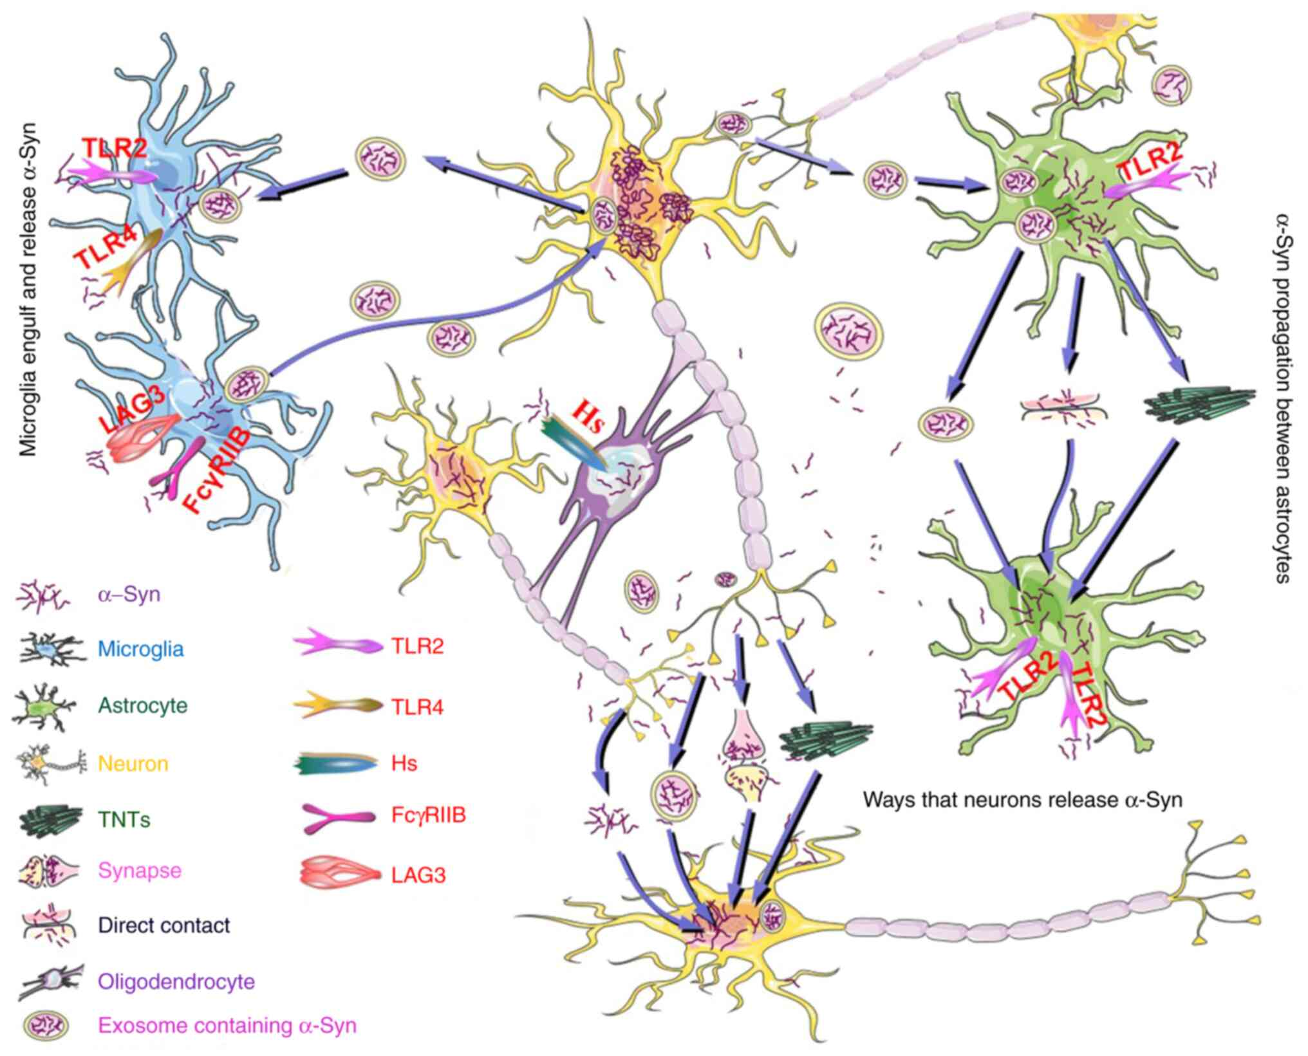
Figure 2. α-synuclein propagation and cell-to-cell transfer mechanisms.
Microglia (blue cells) express receptors TLR2, TLR4, LAG3, FcγRIIB, which mediate α-synuclein (α-syn) uptake. Microglia endocytose and release α-syn via exosomes (pink vesicles). Astrocytes (green cells) also express TLR2, which facilitates α-syn internalization. Astrocytes propagate α-syn to other astrocytes via exosomes, tunneling nanotubes (TNTs), and direct contact. Neurons (yellow cells) release α-syn through synapses, exosomes, and TNTs. Released α-syn spreads to other neurons, astrocytes, and microglia. Adapted from [239], Exp. Ther. Med.

CLEARANCE OF α -SYNUCLEIN
Cellular homeostasis relies on the efficiency of its proteolytic machinery. The autophagy-lysosomal pathway (ALP) and the ubiquitin-proteasome system function as two distinct yet complementary pathways, working together to degrade faulty or non-functional proteins [240]. Their coordinated activity is imperative for preventing the buildup of toxic protein aggregates that could compromise cellular function. The ubiquitin-proteasome system primarily degrades short-lived and soluble misfolded proteins by tagging them with ubiquitin, specifically through polyubiquitination, marking them for proteolysis. Once labeled, these proteins are directed to the proteasome, a multicatalytic complex containing proteases such as caspase-like, trypsin-like, and chymotrypsin-like enzymes [241, 242]. Within the proteasome, proteins are first unfolded before being hydrolyzed into small peptides. In contrast, lysosomes are responsible for breaking down long-lived proteins, insoluble protein aggregates, entire organelles, and various macromolecular structures, including intracellular pathogens like certain bacteria [240]. This process occurs through receptor-mediated endocytosis, phagocytosis, or autophagy. Unlike the proteasome, lysosomal degradation relies on the fusion of vesicles containing substrates with the lysosome, where acidic hydrolases like cathepsins function optimally at low pH to break down proteins and other macromolecules [243]. Both the lysosome and the proteasome can degrade wt monomeric α-syn and compensate for each other when one of these pathways is impaired [244-246]. However, the clearance of larger molecular assemblies, such as α-syn oligomers, predominantly depends on the lysosomal pathway [247]. Sacino et al. reported that the lysosomal system struggles to degrade extracellular α-syn PFFs when cells are overwhelmed with excessive fibrils [248]. This overload disrupts lysosomal processing, resulting in the accumulation of internalized α-syn fibrils and the eventual formation of intracellular aggregates composed of endogenous α-syn. Other studies have also reported that α-syn PFFs compromise lysosomal integrity and function, leading to cytotoxicity and the propagation of α-syn aggregates [249, 250]. When it comes to the efficiency of different cell types in degrading fibrils, a study by Lee et al. compared the degradation rates of α-syn PFFs in neurons, astrocytes, and microglia, finding that microglia were the most effective at clearing these fibrillar species [251]. In addition to clearing extracellular α-syn, microglia can also degrade neuron-derived α-syn through the TLR4-NF-κB-p62 signaling pathway, which activates autophagy [252].

MicroRNAs

Discovery
In 1993, Ambros and Ruvkun discovered two genes, lin-4 and lin-14, essential for the embryonic development of Caenorhabditis elegans [253, 254]. They found that lin-4 produces small non-coding RNAs that bind to the 3' untranslated region (UTR) of lin-14 mRNA, inhibiting its translation and reducing LIN-14 protein levels. Their discovery unveiled a novel post-transcriptional gene regulation mechanism mediated by miRNAs, earning Ambros and Ruvkun the 2024 Nobel Prize in Physiology or Medicine. Initially, the significance of miRNA-mediated regulation was not fully recognized beyond C. elegans. This perspective shifted in 2000 when the miRNA let-7, first identified in C. elegans, was found to be conserved across various species, including humans [255]. Today, miRNAs are recognized as key regulators of cellular and physiological processes, influencing development, homeostasis, and disease, including cancer, neurodegenerative disorders, and cardiovascular conditions [256].

Biogenesis
MiRNAs are small, ~22 nucleotide-long molecules that do not encode for proteins but instead regulate translation of mRNA transcripts into proteins [257]. They are typically derived from intronic regions of protein-coding or non-coding genes, though some originate from exonic sequences or intergenic regions. The canonical miRNA biogenesis pathway starts with RNA polymerase II (Pol II), a multiprotein complex that transcribes primary miRNA (pri-miRNA) from a DNA template. This pri-miRNA adopts a characteristic hairpin-loop structure and contains multiple sites for post-transcriptional modifications, such as adenylation and uridylation, which regulate its stability and processing [258]. Inside the nucleus, pri-miRNA is cleaved into precursor miRNA (pre-miRNA) by the RNAse III enzyme Drosha and its cofactor DGCR8, together forming the Microprocessor complex. The resulting pre-miRNA is then recognized by exportin 5 (EXP5) in a complex with the GTP-bound Ran protein (Ran-GTP) at the nuclear membrane. This complex translocates through the nuclear pore, releasing pre-miRNA into cytoplasm, where it undergoes further processing into its mature miRNA form. Following its export to the cytoplasm, pre-miRNA undergoes cleavage of its hairpin-loop by the RNase III enzyme Dicer, generating a short RNA duplex. The double-stranded RNA molecule is then loaded into the Argonaute (AGO) protein family in an ATP-dependent manner [259]. However, only one strand actively regulates gene expression levels. Strand selection is thought to depend on the thermodynamic stability of the RNA duplex, with the strand having the less stable 5′ end base pairing being preferentially retained as the mature miRNA (guide strand). This guide strand, together with AGO, forms the RNA-induced silencing complex (RISC), while the other (passenger strand) is ejected and subsequently degraded (Figure 3).

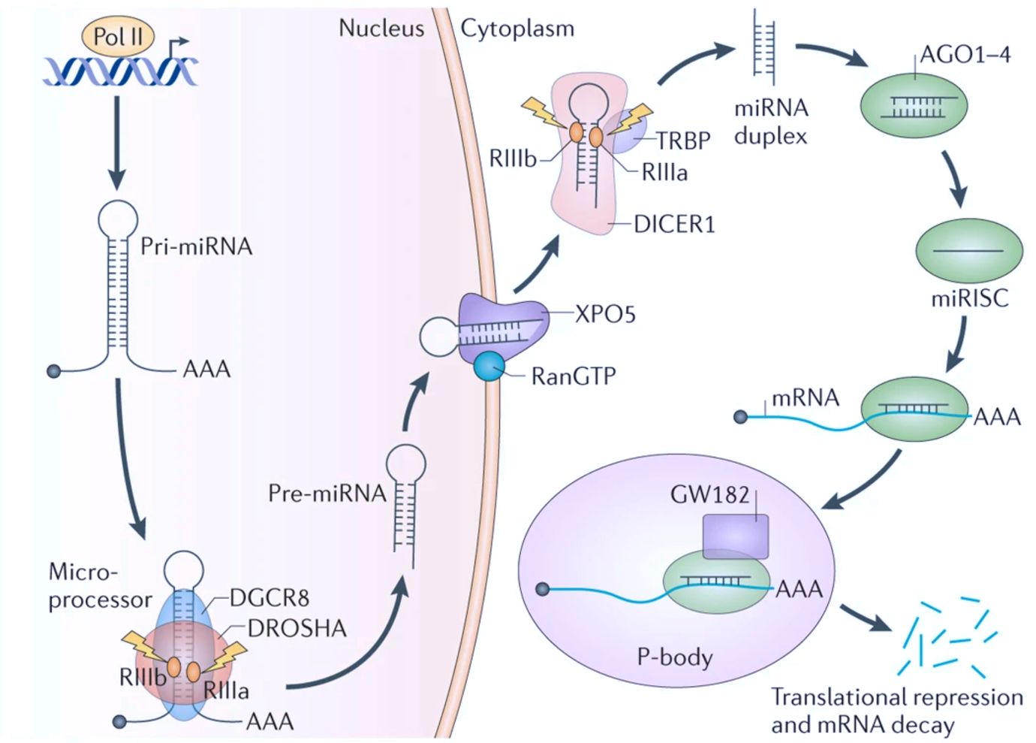
Figure 3. The biogenesis, processing and function of microRNAs (miRNAs).
RNA Polymerase II (Pol II) transcribes Pri-miRNA from the genome. Pri-miRNA contains a hairpin structure and a poly-A tail (AAA). The Microprocessor complex (DROSHA + DGCR8) processes Pri-miRNA to produce a shorter stem-loop Pre-miRNA. Pre-miRNA is exported from the nucleus to the cytoplasm via Exportin-5 (XPO5) and RanGTP. In the cytoplasm, Dicer (DICER1) along with cofactors TRBP (TAR RNA-binding protein) and RIIa/RIIb domains further cleaves Pre-miRNA. This generates a miRNA duplex, consisting of two complementary miRNA strands, which associate with Argonaute proteins (AGO1-4). Only one strand is incorporated into miRNA-induced silencing complex (miRISC). The miRISC binds to target mRNA (typically at the 3' untranslated region (3' UTR)) which results in mRNA translation repression or mRNA degradation in processing bodies (P-bodies). GW182 is a key protein in P-bodies that facilitates mRNA decay. Adapted from [260], Nat. Rev. Cancer.

Mechanism of action
MiRNA-mediated gene regulation is a complex process shaped by multiple factors. These include the extent of complementarity between the miRNA and its target mRNA, the presence of RNA-binding proteins or other competing endogenous RNAs that can sequester miRNAs, specific microenvironmental conditions within the cell, and on the structural properties of mRNA itself [261].
In animals, miRNAs guide the RISC complex to complementary mRNAs, where they typically recognize the 3′ UTR region through direct or indirect pairing, resulting in reduced protein levels. Once integrated into RISC, guide strands of short RNAs, such as miRNAs or small interfering RNAs (siRNAs), operate through four distinct domains that determine their binding and regulatory mechanisms. [262]. These domains include the seed, central, 3’ supplementary and a tail region. The seed region (2nd -8th nucleotide from the 5’ end) is essential for the target mRNA recognition through complementary base pairing. The central region (nucleotides 9-12) regulates the mRNA cleavage, while the 3’ supplementary region (nucleotides 13-17) stabilizes the miRNA-mRNA complex, especially in cases of mismatches with the seed region [263]. Lastly, the tail region (18th nucleotide-3’end) contributes to miRNA stability, interaction with AGO proteins, and target recognition [262-265].
In vertebrates, there are four Argonaute proteins (AGO1–4), all of which can incorporate small RNA duplexes [257]. However, only AGO2 has endonuclease (slicer) activity, which allows it to cleave mRNA directly when full complementarity is present [262]. Despite lacking slicer activity, AGO1, AGO3, and AGO4 still contribute to translational repression and mRNA degradation through alternative mechanisms.
Perfect pairing with the miRNA’s seed sequence triggers the degradation of its target mRNAs through AGO2-mediated cleavage, which occurs between the 10th and 11th nucleotide relative to the miRNA guide strand. However, in most animal systems, where miRNA-mRNA interactions are only partially complementary, gene silencing primarily occurs through mRNA destabilization and translational repression rather than direct cleavage.

Synthetic miRNA mimics and inhibitors
miRNA mimics act as synthetic counterparts to endogenous miRNAs, restoring or stimulating their regulatory function, while miRNA inhibitors (antimiRs) suppress specific endogenous miRNAs and effectively block their activity [266]. MiRNA mimics are short synthetic RNA duplexes with a predetermined guide strand and passenger strand [267]. The guide strand is designed to be incorporated into the RISC and regulate target mRNAs, while the passenger strand is typically degraded. To guarantee proper strand selection, chemical modifications are frequently applied to the passenger strand, inactivating it and preventing RISC incorporation. In contrast, synthetic antimiRs are antisense oligonucleotides, characterized by more extensive chemical modifications [268]. Common modifications such as 2′-O-methyl (2′-OMe), 2′-fluoro (2′-F), and locked nucleic acids (LNAs), enhance antimiRs’ stability, binding affinity, and resistance to nucleases. AntimiRs hybridize to their target miRNAs, preventing their association with the RISC or displacing them from an already formed complex [269]. This inhibition occurs through a steric blocking mechanism rather than incorporation into the RISC itself. Consequently, antimiRs do not become part of the RISC but instead sequester miRNAs, rendering them unavailable for gene silencing activities. Other studies have also demonstrated that antimiRs associate with miRNA-AGO protein complexes via seed region pairing, further reinforcing their role in blocking miRNA function [270, 271].
Both miRNA mimics and antimiRs allow researchers to study the function of individual miRNAs. While they offer a powerful approach for regulating multiple target genes, their widespread influence on cellular signaling pathways comes with challenges. One major caveat is the risk of off-target effects, which not only complicate the interpretation of experimental data but also raise questions about their specificity in therapeutic settings, particularly in precision medicine.

MiRNA target identification
A single miRNA can regulate multiple mRNAs, and conversely, one mRNA can be targeted by multiple miRNAs [272]. The first step in miRNA target identification typically involves bioinformatic prediction using tools which analyze sequence complementarity, thermodynamic stability, and evolutionary conservation of binding sites [273]. Yet, these tools rely on different algorithms, resulting in variable prediction accuracy. For instance, TargetScan prioritizes evolutionarily conserved seed matches and ranks predicted targets based on conservation and sequence context. It evaluates 3′ UTR conservation and identifies key sequence motifs to refine target predictions. In contrast, miRanda follows a three-step approach; first, it scans for Watson-Crick base pairing; then, it calculates the stability of miRNA-mRNA binding; and finally, it filters targets based on conservation. Unlike many other prediction tools, miRanda analyses base-pairing across the full miRNA sequence and allows for mismatches, guanine-uridine (G-U) wobble pairs, and small insertions or deletions.
However, despite advances in computational methods, miRNA target prediction remains challenging and error-prone, requiring experimental validation to confirm meaningful interactions. Direct experimental approaches to mapping miRNA targets rely on cross-linking, immunoprecipitation, and sequencing (CLIP-seq) [274]. In a CLIP-based experiment, cells are first irradiated with UV light to covalently crosslink RNA-RISC protein complexes. The crosslinked complexes are then immunoprecipitated and treated with RNase to isolate RNA fragments protected from degradation by RNA-binding proteins. This is followed by 3′ adapter ligation, sodium dodecyl sulfate-polyacrylamide gel electrophoresis (SDS-PAGE) purification of complexes, and protein digestion. The resulting 3′-labeled, protein-free RNA molecules are then ligated to another adapter at the 5′ end and amplified by RT-PCR for cDNA library preparation and sequencing. Various adaptations of this technique have been developed and are summarized in Figure 4.

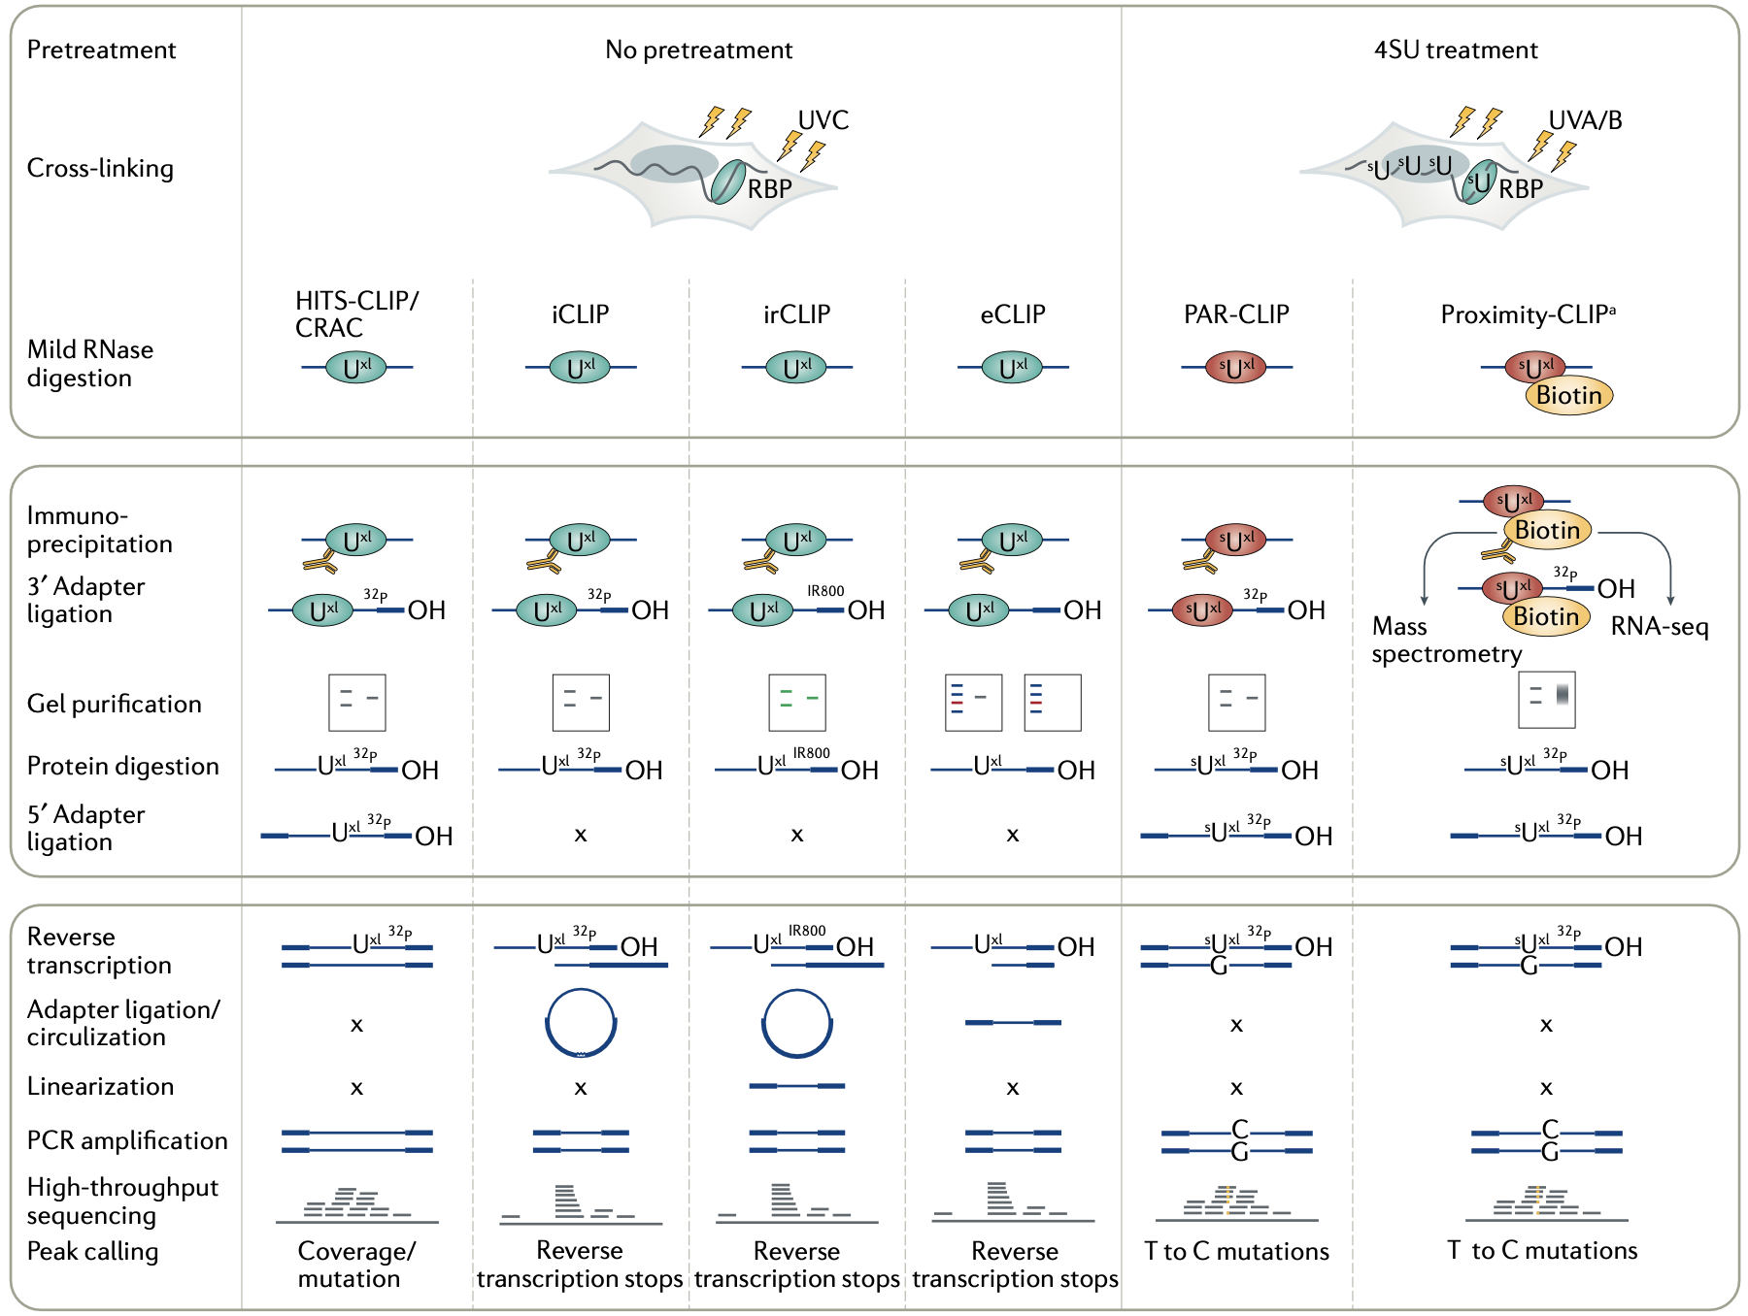
Figure 4. Schematic overview of CLIP-based techniques.
Top section: initial steps before immunoprecipitation. Middle section: RNA processing and manipulation steps. Bottom section: cDNA synthesis, sequencing, and peak identification. CLIP = cross-linking and immunoprecipitation; HITS-CLIP/CARC = high-throughput sequencing of RNA isolated by CLIP/cross-linking and analysis of cDNAs; iCLIP = individual-nucleotide resolution CLIP; irCLIP = infrared CLIP; eCLIP = enhanced CLIP; PAR-CLIP = photoactivatable ribonucleoside-enhanced CLIP ; 4SU = 4-thiouridine; C = cytidine; G = guanosine; T = thymidine; RBP = RNA-binding protein; U^{xl} = uridine crosslinked to RBP; ^{s}U^{xl} = 4SU crosslinked to RBP. Adapted from [274], Nat. Rev. Methods Primers.

MiRNAs in synucleinopathies
MiRNAs have emerged as key regulators of α-syn expression and accumulation in synucleinopathies, likely playing distinct roles at different stages of the disease. MiR-7, miR-153, miR-34b, miR-34c, and miR-214 have been identified as direct repressors of α-syn expression by binding to the 3’ UTR of its mRNA [275-278]. Likewise, several miRNAs have been shown to influence α-syn protein levels indirectly by modulating the expression of proteins involved in its clearance [279-282]. Other miRNAs regulate the expression of genes whose mutations are associated with PD, such as PRKN, PINK1, LRRK2 and PARK7 [283-286]. Moreover, miRNAs such as miR-15b-5p and miR-124-3p have been shown to regulate α-syn aggregation, while miR-7 mitigates α-syn-induced neuroinflammation by suppressing the NLRP3 inflammasome [287-289]. Conversely, α-syn overexpression also alters miRNA expression, highlighting the intricate feedback network between miRNAs and α-synuclein pathology [290-292].
Moreover, detectable changes in miRNA expression patterns suggest their potential as biomarkers for synucleinopathies. Extracellular miRNAs have been detected in peripheral biofluids, including CSF and blood, where their dysregulation reflects pathological cellular alterations and correlates with disease severity, as demonstrated in postmortem brain tissue analyses from PD patients [293]. Beyond CSF and blood, PD-specific miRNAs can also be detected from oral and nasal swabs, as shown for hsa-miR-1260a, whose overexpression positively correlates with PD progression [294]. Additionally, colonic biopsies may serve as a source for diagnostic biomarkers in synucleinopathies, such as submucosal hsa-miR-486-5p, which was found to be significantly enriched in idiopathic PD patients [295]. Given the urgent need for timely and accurate diagnosis, the evolving field of miRNA biomarkers continues to identify novel candidates for monitoring disease progression and treatment efficacy.

AIM OF THE STUDY
The primary goal of this project was to conduct a comprehensive, unbiased investigation into miRNA modulators of α-syn fibril internalization. To achieve this, we have aimed to:

- Perform a genome-wide miRNA mimic screen:
Conduct a high-throughput genome-wide miRNA mimic screen in a human cell line treated with recombinant α-syn PFFs to identify potential modulators.
- Validate primary screen hits:
Use an orthogonal validation approach to confirm the reproducibility of miRNA candidates identified in the primary screen.
- Assess miRNA candidates across different cell models:
Test validated miRNA candidates in additional human-derived cell lines to evaluate their broader relevance in α-syn regulation.
- Evaluate miRNA(s) against patient-derived α-syn fibrils:
Determine whether validated miRNAs are effective against pathologically relevant α-syn fibrils isolated from patient samples.
- Investigate the mechanism of action of miRNA(s)
Characterize the functional role of validated miRNAs in α-syn internalization and accumulation, uncovering their underlying molecular mechanisms.

MATERIALS AND METHODS

CELL CULTURES

U-87 MG
U-87 MG (ATCC) cells were cultured in Minimal Essential Medium (MEM) + GlutaMAX
(Thermo Fisher Scientific) supplemented with, 10% Fetal Bovine Serum (Euroclone), 1X Eon-Essential Amino Acids (Euroclone), 1mM Sodium Pyruvate (Sigma-Aldrich) and 1X Penicillin/Streptomycin solution (Euroclone).

U-87-m-Cherry
A U-87 MG cell line was engineered to stably express m-Cherry reporter gene (hereafter referred to as U-87-m-Cherry line). U-87-m-Cherry cells were cultured in Minimal Essential Medium (MEM) + GlutaMAX (Thermo Fisher Scientific) supplemented with, 10% Fetal Bovine Serum (Euroclone), 1X Eon-Essential Amino Acids (Euroclone), 1mM Sodium Pyruvate (Sigma-Aldrich), 1μg/mL puromycin (Thermo Fisher Scientific) and 1X Penicillin/Streptomycin solution (Euroclone).

LN-229
LN-229 (ATCC) cells were cultured in Dulbecco's Modified Eagle Medium (DMEM) supplemented with, 10% fetal bovine serum (Clontech Laboratories), 1% GlutaMAX, 1% MEM Non‐Essential Amino Acids, 1% Penicillin/Streptomycin (Thermo Fisher Scientific).

U-251 MG and SH-SY5Y
U-251 MG (ATCC) and SH-SY5Y (ATCC) cells were cultured in Opti-MEM supplemented with, 1% GlutaMAX, 1% MEM Non‐Essential Amino Acids, 1% Penicillin/Streptomycin (Thermo Fisher Scientific).

All cell cultures were maintained in culture flasks at 37° C and 5% CO2 in humified atmosphere and passaged every 3 to 5 days by trypsinization using Trypsin-EDTA 1X solution (Sigma-Aldrich).

Human induced pluripotent stem cell (hiPSC)-derived astrocytes
Human induced pluripotent stem cells (hiPSCs) were derived from normal human skin fibroblasts through episomal reprogramming methods. hiPSC line (ASE-9209; 47y.o. female; Applied StemCell Inc.) was cultured and expanded in mTeSR™ Plus (STEMCELL Technologies, 05825) on Matrigel (Corning, 354277)-coated dishes, with daily medium changes. hiPSCs were split using 1mL of ReLeSR (Stem cell technologies, 100-0484) for each well of the 6-well plate. Following 1 minute incubation at 37°C, 900µl of ReLeSR was removed and cells were additionally incubated for 7 minutes at 37°C. hiPSCs were collect for centrifugation with DMEM (Thermo Fisher, 31966047) in a Falcon tube after which the supernatant was removed and cells were resuspended in 1mL of mTeSR™ medium.
Protocol for hiPSCs differentiation into immature astrocytes was adapted from a previously published method (Padmashri et al., 2020). Specifically, hiPSCs colonies were split manually with ReLeSR (Stem cell technologies, 100-0484) to generate the embryoid bodies (on approximately day 5 of differentiation). Embryoid bodies (EBs) were then grown in suspension on a 6-well plate using DMEM/F-12 (Thermo Fisher, 11330032), supplemented with 1× N2 supplement (Invitrogen, 17502048) and Noggin (40 ng/ml, PeproTech, #120-10C) for 3–5 days, with daily medium changes.
After 3-5 days, the EBs were plated on Matrigel (Corning, 354277)-coated 6-well plates in neural rosette medium containing DMEM/F12, 1× N2 supplement, and laminin (1 μg/ml, Invitrogen,2317-015) to form neural rosettes (neural progenitor cells, NPCs) over 5-7 days, with daily medium changes. To differentiate into immature astrocytes, the neural rosettes were mechanically dissociated and replated on a Matrigel-coated 6-well plate in astrocyte differentiation medium, consisting of DMEM/F12, 1× N2 supplement, 1× B27-RA supplement (Invitrogen, 12587010), BMP4 (10 ng/ml, Peprotech, 120-05ET), and FGF-basic (20 ng/ml, PeproTech, 100-18B). Medium was changed every other day.

α-SYNUCLEIN PREFORMED FIBRIL PRODUCTION
Prior to fibrillation, the monomeric protein was filtered with 0.22 μm syringe filter and the concentration was determined by absorbance measured at 280 nm. Purified human α-synuclein (α-syn; 1.5 mg/mL) was incubated with 100 mM NaCl and 20 mM Tris-HCl pH 7.4 and 10 μM ThioflavinT (ThT; Sigma-Aldrich). Reactions were performed in black 96-well plates with a clear bottom (Perkin Elmer) and one 3-mm glass bead (Sigma-Aldrich) in a final reaction volume of 200 μL. Plates were sealed and incubated in BMG FLUOstar Omega microplate reader (BMG LABTECH) at 37 °C with cycles of shaking (300 seconds, 400 rpm, double-orbital) and reading (11 seconds). ThT fluorescence measurements (excitation: 450 nm, emission 480 nm, bottom read) were taken every 5 minutes.
For cell culture experiments, α-syn preformed fibrils (α-syn PFFs) were produced as described above, but in the absence of ThT. After fibrillation, the reaction mixtures were aliquoted and stored at −80 °C until use.

AFM AND TEM ANALYSIS
Atomic force microscopy (AFM) analysis was performed in tapping mode. 10 μL of fibril solution was deposited onto a freshly cleaved piece of mica and left to adhere for 30 min. Samples were then washed with distilled water and blow-dried under a flow of nitrogen. Images were collected at a line scan rate of 0.5–2 Hz in ambient conditions. The AFM free oscillation amplitudes ranged from 25 nm to 40 nm, with characteristic set points ranging from 75% to 90% of these free oscillation amplitudes. AFM data were analyzed with Gwyddion (gwyddion. net).
For transmission electron microscopy (TEM) analysis, 10 μL of fibril solution was placed on a piece of parafilm. 200-mesh Formvar-carbon coated nickel grid (Electron Microscopy Sciences) was then placed on a sample solution for about 1 minute and the remaining drop was blotted dry using Whatman filter paper. The sample was stained with UranyLess (Micro to Nano); staining substitute for uranyl acetate, by placing the grid on a droplet of UranyLess for 1 minute. The staining solution was removed using Whatman filter paper and the grids were air-dried for 5 minutes before the imaging. α-syn PFF samples were visualized using a FEI Tecnai Spirit Transmission Electron Microscope operating at 120 kV and equipped with an Olimpus Megaview G2 camera.

α-SYNUCLEIN PREFORMED FIBRIL LABELING
Prior to labeling, α-syn PFFs were dialysed against a sodium (bi)carbonate buffer (0.1M NaHCO₃ and 2.5 mM Na₂CO₃ pH 8.3) in Slide-A-Lyzer MINI dialysis devices (35 kDa cut-off, Thermo Fisher Scientific). In brief, the dialysis devices containing α-syn PFFs were placed in a beaker filled with 500mL of the buffer and left to incubate at +4°C on a magnetic stirrer for about 3 hours. The buffer was then replaced with 1L of fresh (bi)carbonate buffer and the samples were additionally incubated overnight at +4°C. Alexa Fluor 488 NHS Ester dye (0,5 mg/mL; Thermo Fisher Scientific) was used to label the fibrils by incubating the samples for 1h at room temperature (RT) and 300 rpm. The labeling was followed by dialysis against 1X PBS as described above. Labeled α-syn PFFs were aliquoted and stored at −80 °C until use. Aliquots were sonicated for 7 minutes (30 seconds ON/ 30 seconds OFF) in at 250 W immediately before cell culture experiments.

CONSTRUCTION OF U-87-m-Cherry CELL LINE

Lentiviral packaging
HEK293T (ATCC) cells were seeded in 24-well plates at a density of 4.0 × 10⁵ cells per well. The second day, cells at 80–90% confluency were transfected with three different Addgene-deposited plasmids (TFORF3550 (#145026), psPAX-2 (#12260), VSV-G (#8454); ratios: 16:9:6) using Lipofectamine 3000 (Thermo Fisher Scientific) for lentivirus production. After an overnight incubation, the medium was changed to virus harvesting medium (DMEM + 10% FBS + 1% BSA). The supernatant containing the lentiviral particles was then harvested 48 hours after the change to virus harvesting medium. Suspended cells or cellular debris was pelleted by centrifugation at 250 rcf for 5 min. Clear supernatant was collected and stored at −80 °C.

Lentivirus titration
For the titration of the lentiviral particles, 1 × 10⁵ HEK293T cells were grown in 24-well plates, and infected by adding small volumes (V) of the abovementioned viral supernatant (-e.g. 3 µl). A representative batch of cells was used to determine the cell count at the time of infection (N). 72 hours after infection, the cells were harvested and analysed by flow cytometry to quantify the fraction of infected cells (m-Cherry positive). The percentage of positive cells (P) is then used to calculate the titre (T) of the virus according to the following formula: T=P*N/V.

U-87 MG cell line transduction
To construct U-87 MG cell line stably expressing m-Cherry reporter gene, U-87 MG cells were seeded in a 12-well plate at the density of 6 × 10⁴ . Cells at 60% confluency were transduced with TFORF3550 (#145026) plasmid packaged into lentiviral particles at the multiplicity of infection (MOI) of 2. Clones stably expressing m-Cherry protein were selected the day after with puromycin (1 μg/ml, GIBCO) containing medium.

MICROSCOPY-BASED HIGH-THROUGHPUT SCREENING

Cell transfection
Library of 2042 miRIDIAN human microRNA mimics (miRBASE, version 19.0, GE Healthcare Dharmacon) were reverse-transfected into human glioblastoma-astrocytoma U-87 MG cells (ATTC HTB-14; LGC Standards) using automated liquid handling workstation, Microlab STAR Line (Hamilton). Specifically, library was replicated from the stock library plates to 384-well black optical cell culture microplates (ViewPlate-384 Collagen Coated; Perkin Elmer). 500nM concentration of each microRNA in a 5 μl volume was spotted into individual wells. Columns 1,2 and 23,24 were left empty for the addition of controls (miRNA resuspension buffer, microRNA control 4 (cel-miR-234)). MicroRNAs were transfected into U-87 MG cells following a standard reverse transfection protocol, at a final microRNA concentration of 50nM and a final volume of 50 μl. In brief, transfection reagent (Lipofectamine RNAiMAX; Life Technologies) was first diluted in Opti-MEM reduced-serum medium (Life Technologies) and the mixture (1% RNAiMAX in Opti-MEM) was incubated for 5 minutes at RT. The mixture was then robotically dispensed to the microRNAs arrayed in 384-well plates, using Thermo Multidrop Combi reagent dispenser (Thermo Fisher Scientific). Transfection mix with microRNAs was incubated for additional 30 minutes (at RT) and immediately after the cells, in the cell culture medium, were seeded at the final concentration of 900 cells/well. 48 hours after the transfection, Alexa Fluor 488 labeled α–syn PFFs (0.5 μM) were added to the cell medium and the cells were left to incubate with the PFFs for 24 hours.

Immunostaining
Immunostaining was performed on fixed but not permeabilized cells. In short, cells were fixed in 4% buffered paraformaldehyde (PFA; Sigma-Aldrich) in 1X PBS for 12 minutes and non-specific staining was blocked with buffered 5% normal goat serum (NGS; Abcam) in 1X PBS for 30 minutes at RT. Immunolabelling using anti α–syn antibody (α–syn 211; Thermo Fisher Scientific) was carried out for 2 hours at RT in 1% NGS/PBS. Cells were incubated with secondary Goat anti-Mouse Alexa Fluor 594 conjugated antibody (Life Technologies) for 1 hour at RT in 1% NGS/PBS. Viable cell density after fixing was determined after fixing the cells and staining with Hoechst 33342 stain (Invitrogen, Thermo Fischer Scientific). Cells were stained with HSC Blue Cell Mask (Thermo Fisher Scientific).

Image analysis
Image acquisition was performed using an automated ImageXpress Micro high-content screening microscope (Molecular Devices). 384-well plates were imaged (9 images/wavelength/well) with a 10x magnification objective (NA=0.30). Images were analyzed by MetaXpress v.5.1 software (Molecular Devices) using both Transfluor and Multi Wavelength Cell Scoring modules.
These two modules allow for the count of total cell numbers (nuclear count by segmentation based on nuclear size and fluorescence intensity) and the total number of pits; either single positive (green: internalized fibrils) or double positive (green and red: fibrils localized outside the cells or attached to the cell membrane). Images were analyzed with respect to the percentage of double labeled fibrils from the total Alexa Fluor 488 labeled fibrils to selected miRNAs that either inhibit or promote the α–syn PFFs internalization.
The screening was performed at the ICGEB High-Throughput Screening Facility (https://www.icgeb.org/high-throughput-screening-equipment/).

FLOW CYTOMETRY
For the uptake validation assays, cells were transfected with miRNA mimics and cultured in 24-well plates. 48 hours after the transfection, fluorescently labeled proteins (α-syn PFFs, Tau-K18 PFFs, m-syn or tansferrin) were added to the cell culture medium. Trypsinization of the cells and resuspension in a FACS buffer (1% BSA in 1X PBS) was performed on the following day, prior to flow cytometry. Propidium iodide (PI) was used as a live/dead stain.
For the experiments concerning the secretion of α-syn PFFs, cells were seeded in a 24-well plate and maintained in a culture medium for 24 hours before the addition of Alexa Fluor 488 labeled α-syn PFFs. Cells were then incubated with the PFFs for additional 24 hours, followed by PBS washes, trypsinization, transfer to a new 24-well plate and reverse transfection with miRNA mimics. Incubation with miRNA mimics lasted for additional 48 hours and cells were then prepared for flow cytometry as mentioned above.
For the co-culture experiments, wild-type U-87 MG cell line was seeded in a 24-well plate and treated with labeled α-syn PFFs on the next day. U-87 MG-m-Cherry cell line was seeded separately in the same well plate format and transfected with miRNA mimics. Incubation of cells with either PFFs or miRNAs lasted for 24 hours after which the cells were washed, trypsinized and pooled together in a 12-well plate. Cells were left in co-culture for three days before the flow cytometry.
For all of the above-mentioned experiments, cells were seeded in a 24-well plate at the density of 45000 cells/well.
Cells were acquired for analysis using S3e Cell Sorter (Bio-Rad Laboratories, Inc.) at the International School for Advanced Studies (SISSA; https://neurotech.sissa.it/floor-6%C2%A0-%C2%A0room-641%C2%A0pcr-and%C2%A0cell%C2%A0sorter) or LSRFortessa (BD) at the Institute of Pathology and Molecular Pathology, USZ (https://www.cytometry.uzh.ch/en/About-us/Facility-labs.html).
Data analysis was performed with a FlowJo software. In brief, forward (FFC-A) and side scatter (SSC-A) gating was used to identify cell population of interest excluding cell debris and aggregated cells. From this population, single cells were obtained by drawing a tight diagonal gate on the FCS-A/FCS-H plot. Dead cells were identified as PI positive and excluded from the analysis by gating on the unstained population. Identification of fluorophore positive population was done based on the fluorescence intensities of the fluorophores (from the exogenously added fluorophore-conjugated miRNAs or proteins used for the treatments, or from the endogenous m-Cherry expression) compared to fluorophore negative control cells. Single live cells were analysed in all experiments. Fluorophores’ Median Fluorescence Intensities (MFI) were analysed from single cell populations for all the experiments apart from the co-culture experiment, where the percentage of fluorophore positive cells was used for further data analysis.

CELL VIABILITY ASSAY
U-87 MG cells were seeded in 384-well plates, at the density of 10 000 cells/well, and reverse transfected with 50nM miRNAs. Fourty eight hours later, 0.5 μM α-syn PFFs were added to the cell medium and the plates were further incubated at 37° C for one day. Cell viability was determined using CellTiter-Glo® (Promega) according to the manual. The luminescence was measured with the EnVision plate reader (Perkin Elmer).

CELL PROLIFERATION ASSAY
Cell Trace Yellow (CTY) 5mM stock solution was prepared as per manufacturer's instructions (Thermo Fisher Scientific) and further diluted in PBS 1X to final working solution immediately before use. In brief, U-87 MG were resuspended in PBS 1X at the density of 1 × 10⁶ cells/mL, and labeled in suspension with 5 μM CTY at 37°C for 20 min, protected from light. To remove any free dye remaining in the solution, five times the original staining volume of the culture medium was added to the cells and incubated additionally for 5 minutes. Cells were pelleted by centrifugation and resuspended in a pre-warmed culture medium prior to transfection with 50nM miRNAs. Flow cytometry analysis was performed 72 hours after CTY labeling and miRNA transfection.

CLICK-IT EDU ASSAY
All reagents, supplied with Click-iT Edu Alexa Fluor-488 Imaging Kit (#C10337, Thermo-Fisher Scientific) were prepared according to manufacturer’s instructions. U-87 MG cells, seeded in 6-well plates at the density of 1 × 10⁵ cells/mL and a final volume of 2mL were transcfected with 50nM miRNAs and incubated for 72 hours prior to the addition of 5-ethynyl-2′-deoxyuridine (EdU). Cells were incubated with 10 μM EdU (5-ethynyl-2′-deoxyuridine) in culture medium for 1 hour at 37°C to label actively replicating DNA. Following incubation, cells were harvested by centrifugation and subsequently fixed and permeabilized following the manufacturer’s recommended protocol. To detect incorporated EdU, a copper-catalyzed azide–alkyne cycloaddition ("click reaction") was performed using Alexa Fluor-488 azide, according to the manufacturer’s instructions. After the click reaction, cells were washed and stained with FxCycle Violet (2 drops per 1 × 10⁶ cells/mL) to assess DNA content. The staining was carried out for 30 minutes at 25°C, followed by flow cytometry analysis.

ANNEXIN V ASSAY
U-87 MG cells were transfected with 50 nM miRNA and maintained in culture for 72 hours. After incubation, the culture medium was aspirated, and cells were washed with 1X PBS before being collected by centrifugation. A total of 1 × 10⁵ cells were resuspended in 100 μL of culture medium and stained with PE Annexin V (BD Biosciences) for apoptosis assessment. Specifically, 5 μL of PE Annexin V stock solution was added to 100 μL of the cell suspension and incubated for 2 hours at 37°C. Following staining, cells were analyzed by flow cytometry.

STATISTICAL ANALYSES
All flow cytometry data were analyzed using FlowJo software, while data visualization and statistical analyses were performed in RStudio. Statistical significance was determined using the Wilcoxon rank-sum test. For comparisons involving multiple conditions against the control, a Bonferroni correction was applied. When a single condition was compared to the control, the Wilcoxon rank-sum test was used without adjustment.

RESULTS

Image-based high content microRNA screen
To expand the repertoire of molecular modifiers and assess the involvement of the human microRNAome in the internalization of α-syn PFFs, our group conducted a comperhensive high-throughput miRNA screen. We utilized a genome-wide human miRNA mimic library (miRBase v19) to screen 2,042 human miRNA mimics in an arrayed format. The screen was performed in U-87 MG glioblastoma cells, which were reverse-transfected with individual miRNA mimics (50 nM) in 384-well plates. At this concentration, all U-87 MG cells were efficiently transfected after 72 hours, as shown in Fig. S2B. Following miRNA transfection, Alexa Fluor-488 labeled α-syn PFFs (0.5 μM) were added to the cell medium (Fig. 1A).
The short α-syn PFFs and oligomeric species (collectively referred to as α-syn PFFs) used in our screen were generated by fibrillating recombinant human monomeric α-syn (Hu-m-syn) (Fig. S2A). To obtain this heterogeneous mixture, α-syn PFFs were collected at the midpoint of the exponential growth phase and characterized by atomic force microscopy, as shown in Fig. S2A, S2B.
Since our primary screen was image-based (fluorescence microscopy), we employed a double immunostaining strategy to distinguish between membrane-associated and internalized PFFs. This approach utilized an α-syn-specific antibody (Syn211), detected with a secondary antibody conjugated to Alexa Fluor-594. PFFs labeled only with Alexa Fluor-488 were considered internalized, whereas those located outside the cells or associated with the cell membrane were double-labeled with both Alexa Fluor-488 and Alexa Fluor-594 (Fig. 1A, 1B, 1C). In our screen, we included four non-targeting (NTG) miRNAs as controls. However, for data quantification, we selected NTG mimic#4 (MC4; cel-miR-231)-a C. elegans miRNA with no homology to human miRNAs-since its α-syn PFF internalization values were intermediate among all NTG controls. Image analysis followed by detailed visual inspection revealed nine miRNA enhancers and eight miRNA suppressors of α-syn PFFs internalization (Fig. 1D, 1C, 1B, S1).

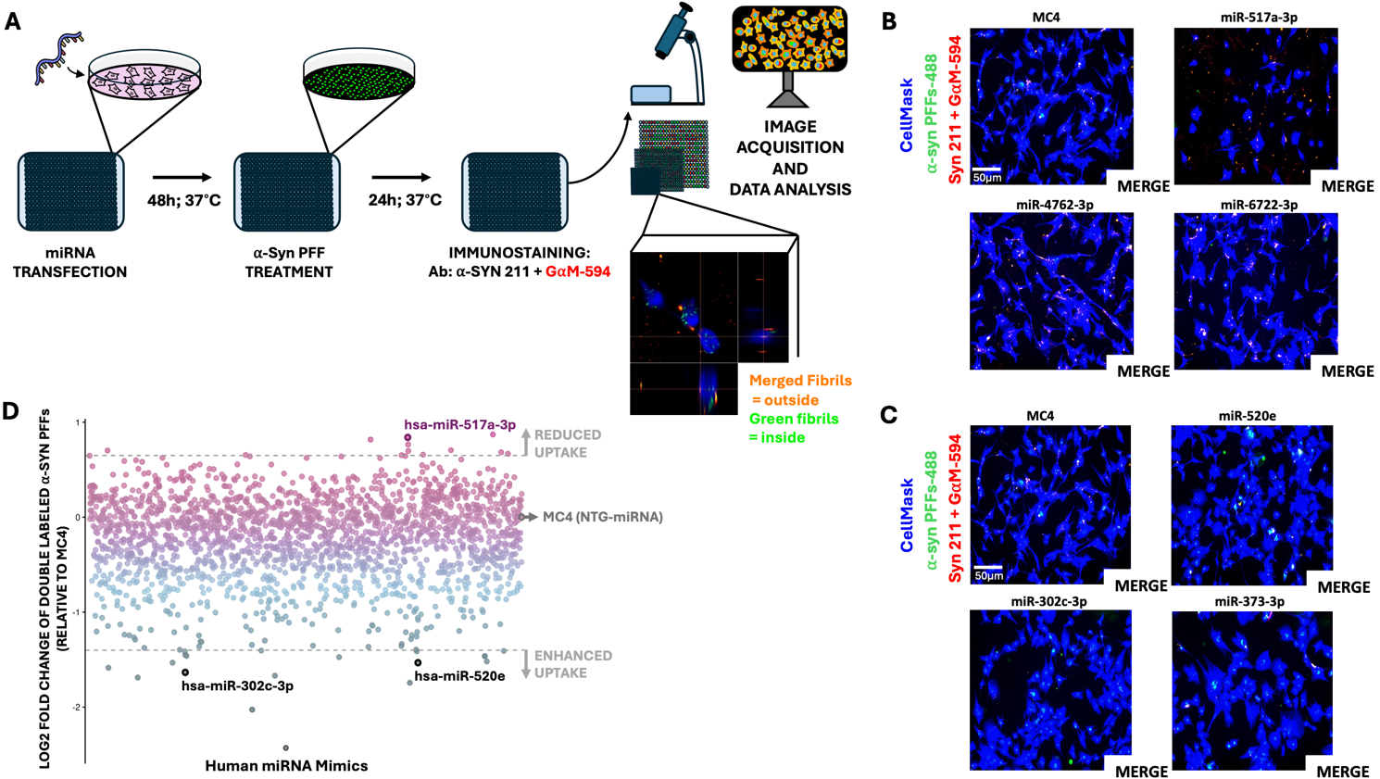

Fig. 1. An image-based high-throughput miRNA screen identifies regulators of α-synuclein preformed fibril uptake in U-87 MG cells. (A) Schematic of the miRNA high-throughput screen. (B, C) Representative images of U-87 MG cells transfected with miRNAs that suppress (B) or enhance (C) α-syn PFF uptake compared to the non-targeting control miRNA (MC4). Internalized α-syn PFFs are shown in green (α-syn PFFs-488). Double-labeled α-syn PFFs (α-syn PFFs-488 + Syn211-GaM-594) are shown in yellow-red. Staining with HCS CellMask Blue stain (CellMask) is shown in blue. Scale bar: 50 μm. (D) Scatter plot quantifying log2 fold change in double-labeled α-syn PFF uptake relative to MC4. Each dot represents an individual miRNA mimic, with suppressors (reduced uptake) shown in pink and enhancers (increased uptake) shown in blue. Dashed lines indicate the threshold for significant deviations from MC4. Validated hit miRNAs are highlighted. α-syn PFFs, α-synuclein preformed fibrils.

Orthogonal validation of primary screen hit microRNA mimics
We further set out to validate our primary screen hits using an orthogonal approach-flow cytometry (Fig. 2A). The α-syn PFFs used in the validation assays were generated from recombinant Hu-m-syn using the same fibrillation method as in the primary screen (Fig. S2C). These PFFs, characterized by transmission electron microscopy, were found to be slightly longer than expected; therefore, we sonicated them to obtain a heterogeneous mixture similar to that used in the primary screen, as shown in Fig. S2D, S2E. To ensure that passive endocytosis does not contribute to α-syn PFF internalization, we conducted an assay to measure passive uptake. U-87 MG cells were analysed under three conditions: untreated cells (ut), cells treated with α-syn PFFs at 4°C (4°C), and cells treated with PFFs at 37°C (37°C), all incubated for 3 hours. The results showed that cells treated at 4°C had signal levels comparable to the ut condition, indicating negligible passive fibril internalization at low temperatures. In contrast, cells treated at 37°C exhibited significantly higher median fluorescence intensity (MFI) values, confirming that active endocytosis is required for α-syn PFF internalization (Fig. S3A).
Initially, we used the same miRNA mimic concentration (50 nM) and α-syn PFF concentration (0.5 μM) for cell perturbation. Under these conditions, we validated three miRNA modulators-hsa-miR-520e (miR-520), hsa-miR-302c-3p (miR-302), and hsa-miR-517a-3p (miR-517)-of α-syn PFF internalization in U-87 MG cells (Fig. 2B, S3C). Because the cells were trypsinized before collection into FACS tubes, thereby removing membrane-bound PFFs, the quantified fluorescence originated mainly from internalized Alexa Fluor-488-labeled α-syn PFFs, with the gating strategy shown in Fig. S4A.
Encouraged by the results of our initial validation assay, we lowered the miRNA concentration to 30 nM, the lowest concentration that ensured 100% transfection efficiency in U-87 MG cells (Fig. S5A, S3B), with the gating strategy shown in Fig. S4B. At this concentration, miR-517 remained the only miRNA that consistently downregulated α-syn PFF uptake (~40% reduction relative to UT), whereas the two enhancers (miR-520 and miR-302) still increased uptake but showed variability among replicates and did not reach statistical significance (Fig. 2D, S3D). Consequently, further analyses focused solely on miR-517.
To account for the transient nature of oligomeric α-syn species, U-87 MG cells were transfected with 30 nM miR-517, and the incubation period with α-syn PFFs (0.5 μM) was shortened from 24 to 4 hours. The results further confirm that miR-517a-3p significantly reduces α-syn PFF internalization in U-87 MG cells, with the strongest effect (~73% reduction relative to UT) observed during this early treatment window (Fig. 2C, S3E).
In the same cell line, we further explored the effect of miR-517a-3p on the internalization of cell-to-cell transmitted α-syn PFFs using a co-culture system. In this assay, untransfected U-87 MG wild-type (wt) cells pre-treated with Alexa Fluor-488-labeled α-syn PFFs for 24 hours (donor cells) were co-cultured for 3 days with U-87 MG-mCherry recipient cells transfected with 30 nM miR-517a-3p (Fig. S10A). Transfection efficiency was confirmed using Cy3-labeled NTG miRNA (Fig. S10B). Flow cytometry gating identified donor cells (Alexa Fluor-488+), recipient cells (mCherry+), and double-positive recipient cells that internalized α-syn PFFs (mCherry+/Alexa Fluor-488+), along with a non-assigned (NA) intermediate population, which may represent mCherry transfer from recipient to donor cells (Fig. S10C).
After 3 days of co-culture, the percentage of recipient cells positive for α-syn PFFs remained lower in the miR-517-transfected condition compared to untransfected controls, despite the increased proportion of donor cells in the miR-517 group (Fig. S10D, S10E). This suggests that miR-517a-3p suppresses the internalization of fibrils transferred via cell-to-cell transmission, potentially by affecting multiple endocytic pathways.

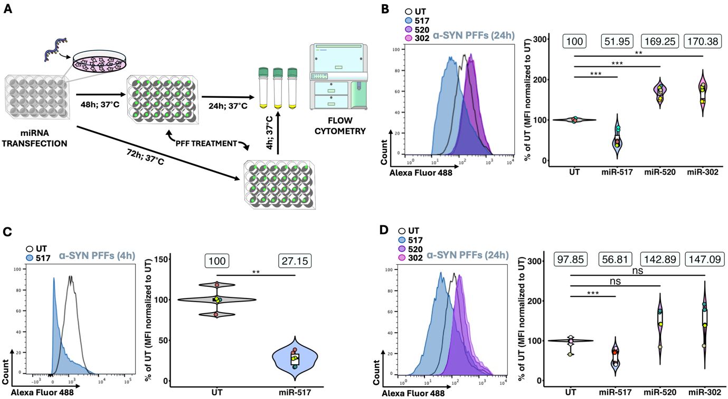

Fig. 2. Flow cytometry-based validation of hit miRNAs in U-87 MG cells. (A) Schematic of the miRNA validation assays. (B) Validation of identified miRNAs at 50 nM miRNA concentration and a 24-hour incubation with α-syn PFFs. The histogram (left) shows fluorescence intensity distribution of Alexa Fluor-488-labeled α-syn PFFs in UT and miRNA-transfected cells. The violin-boxplot (right) quantifies the percentage of α-syn PFF uptake relative to UT (MFI normalized to UT). Statistical significance was determined using the Wilcoxon rank-sum test with Bonferroni adjustment. **p < 0.01; ***p < 0.001. (C) Validation of hit miRNA suppressor at 30 nM concentration with 4-hour α-syn PFF incubation period. Flow cytometry histograms (left) show fluorescence intensity distributions, and the violin-boxplot (right) quantifies α-syn PFF uptake relative to UT. Statistical significance was determined using the Wilcoxon rank-sum test (non-adjusted p-value). **p < 0.01. (D) Validation of hit miRNAs at 30 nM concentration with a 24-hour α-syn PFF incubation. The histogram (left) displays fluorescence intensity distributions, while the violin-boxplot (right) quantifies α-syn PFF uptake. The Wilcoxon rank-sum test with Bonferroni adjustment was used for statistical comparisons. ns, not significant; ***p < 0.001. (B, C, D) Violin plots in all panels illustrate data distribution, with boxplots inside showing the median and interquartile range. The boxes above the violins indicate the mean uptake percentages for each condition. Individual points are color-coded to represent independent experiments (biological replicates), with technical replicates sharing the same color within each condition. MFI, median fluorescence intensity; UT, untransfected control; miR-517, hsa-miR-517a-3p; miR-520, hsa-miR-520e; miR-302, has-miR-302c-3p; α-syn PFFs, α-synuclein preformed fibrils; 24h, 24 hours; 4h, 4 hours. N = at least 3 independent experiments.

Cytotoxicity assessment of miR-517a-3p in U-87 MG cells
U-87 MG cell viability was assessed using CellTiter-Glo Kit under conditions with and without α-syn PFFs (Fig. 3A). This assay quantifies ATP levels as a measure of metabolically active cells, with luminescence intensity directly correlating with cell viability. miR-517a-3p-transfected cells treated with α-syn PFFs exhibited approximately a 20% reduction in viability compared to untransfected, PFF-treated controls (UT, MAX). However, a more pronounced cytotoxic effect was observed in our co-culture system (growth-competition assay), suggesting a stronger impact of miR-517a-3p on cell survival (Fig. S10A, S10E). After 3 days of co-culture, we observed an approximately 50% reduction in the number of miR-517a-3p-transfected U-87-mCherry cells compared to untransfected (UT) or transfection reagent (MAX)-treated cells, further supporting a significant cytotoxic effect of miR-517a-3p (Fig. S10E).
To further investigate this effect, we conducted a cell proliferation assay using CellTrace Yellow dye (Fig. 3B). This method enables lineage tracing through dye dilution analysis via flow cytometry. U-87 MG cells transfected with 50 nM miR-517a-3p in the absence of α-syn PFFs exhibited a modest (~10%) reduction in proliferation compared to untransfected (UT) and RNAiMAX-treated (MAX) controls, while NTG-transfected cells showed a significantly slower division rate (~60% reduction).
To dissect the mechanisms underlying these effects, we analyzed cell cycle progression using the Click-iT EdU assay (Fig. S11A, S11B) and assessed apoptosis induction via Annexin V staining (Fig. S11C, S11D). U-87 MG cells were transfected with 50 nM miRNA for 72 hours in the absence of α-syn PFFs for both assays. We observed an increased proportion of cells in S-phase (~12% more) in miR-517a-3p transfected U-87 MG cells compared to untransfected (UT) controls (Fig. S11A, S11B). This suggests a possible delay in S-phase progression, which could indicate impaired DNA synthesis or a cell cycle checkpoint activation. Since prolonged S-phase accumulation can lead to apoptosis, we investigated whether miR-517a-3p treatment induces programmed cell death using an Annexin V assay. Cells were prepared under the same conditions as for our α-synuclein uptake experiments, except that PFFs were omitted from the treatment. U-87 MG cells were transfected with 50 nM miRNA and maintained in culture for 72 hours before collection. The medium was aspirated, and cells were washed with PBS before collection by centrifugation. Importantly, while we collected both PI-negative (live) and PI-positive (dead) cells, our gating strategy in the uptake experiments focused solely on PI-negative live cells. (Fig. S4A). Since PI stains late apoptotic and necrotic cells but does not detect early apoptosis, Annexin V staining was used to assess early apoptosis. For the Annexin V assay, cells were stained exclusively with Annexin V, without PI, and gated on the entire population, including both live and dead cells (as shown in Fig. S11C). This analysis confirmed that miR-517a-3p-transfected cells did not exhibit an increased proportion of Annexin V-positive early apoptotic cells compared to UT controls (Fig. S11D).

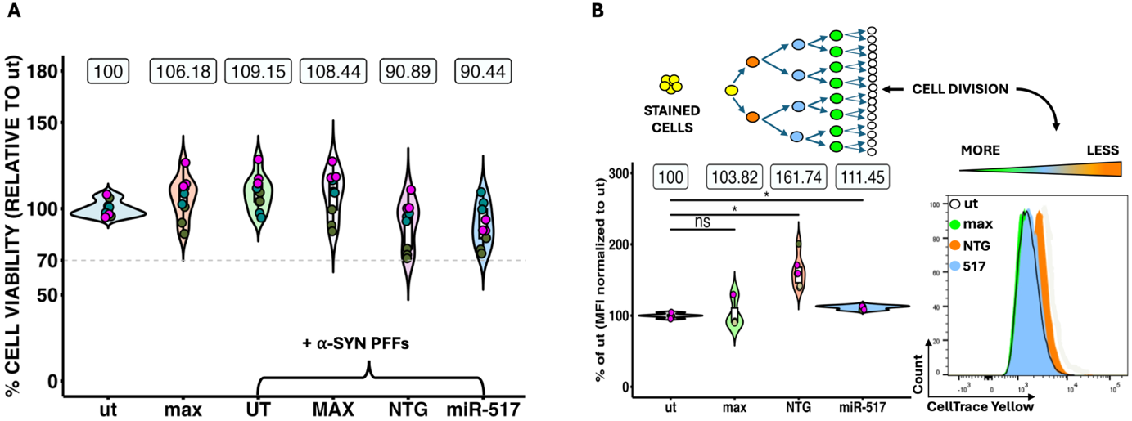

Fig. 3. U-87 MG cell viability and cell proliferation assays. (A) Cell viability assay. U-87 MG cell viability was assessed using CellTiter-Glo Kit under various experimental conditions, with and without α-syn PFFs. The y-axis represents cell viability relative to untreated, untransfected cells (ut). The gray dotted line intersecting the y-axis represents the 70% viability threshold. (B) Cell proliferation assay. The schematic illustrates the tracking of U-87 MG cell division rate via dye dilution. The histogram (right) displays the fluorescence intensity distribution of CellTrace Yellow dye across experimental conditions (ut, max, NTG, 517). The violin-boxplot (left) quantifies proliferation relative to ut (MFI normalized to ut). Statistical significance was determined using the Wilcoxon rank-sum test (Bonferroni adjusted p value). ns, not significant; *p < 0.05. (A, B) Violin plots depict data distribution, with boxplots inside indicating the median and interquartile range. The boxes above the violins represent mean uptake percentages for each condition. Individual points are color-coded to distinguish independent experiments (biological replicates), with technical replicates sharing the same color within each condition. MFI, median fluorescence intensity; α-syn PFFs, α-synuclein preformed fibrils; ut, untransfected control without α-syn PFFs; UT, untransfected control with α-syn PFFs; max, RNAiMAX transfection reagent without α-syn PFFs; MAX, RNAiMAX transfection reagent with α-syn PFFs; miR-517, hsa-miR-517a-3p; NTG, non-targeting microRNA. N = 3 independent experiments.

Insights into the mechanism of miR-517a-3p: exploring the fate of internalized α-synuclein preformed fibrils
To determine whether the previously observed reduction in α-syn PFF accumulation upon miR-517a treatment was due to enhanced secretion or degradation of internalized fibrils, U-87 MG cells were first treated with α-syn PFFs for 24 hours, followed by trypsinization, replating, and transfection with 50 nM miR-517a-3p (Fig. 4A). Twenty-four hours after α-syn PFF treatment, all cells were Alexa Fluor-488-positive, and technical replicates exhibited comparable MFI values, confirming consistent α-syn PFF uptake (Fig. 4B). Efficient miRNA transfection was confirmed after a 48-hour incubation period using a Cy3-labeled NTG miRNA tracer (Fig. S5A). Flow cytometry analysis demonstrated that miR-517a-3p does not promote secretion nor degradation of internalized α-syn PFFs (Fig. 4C). Although miR-517a-3p-treated cells showed increased α-syn PFF accumulation compared to UT controls (Fig. 4C), the levels remained similar to those observed in untransfected cells treated with RNAiMAX reagent (MAX), indicating that this effect is not due to altered fibril processing (Fig. S5B).

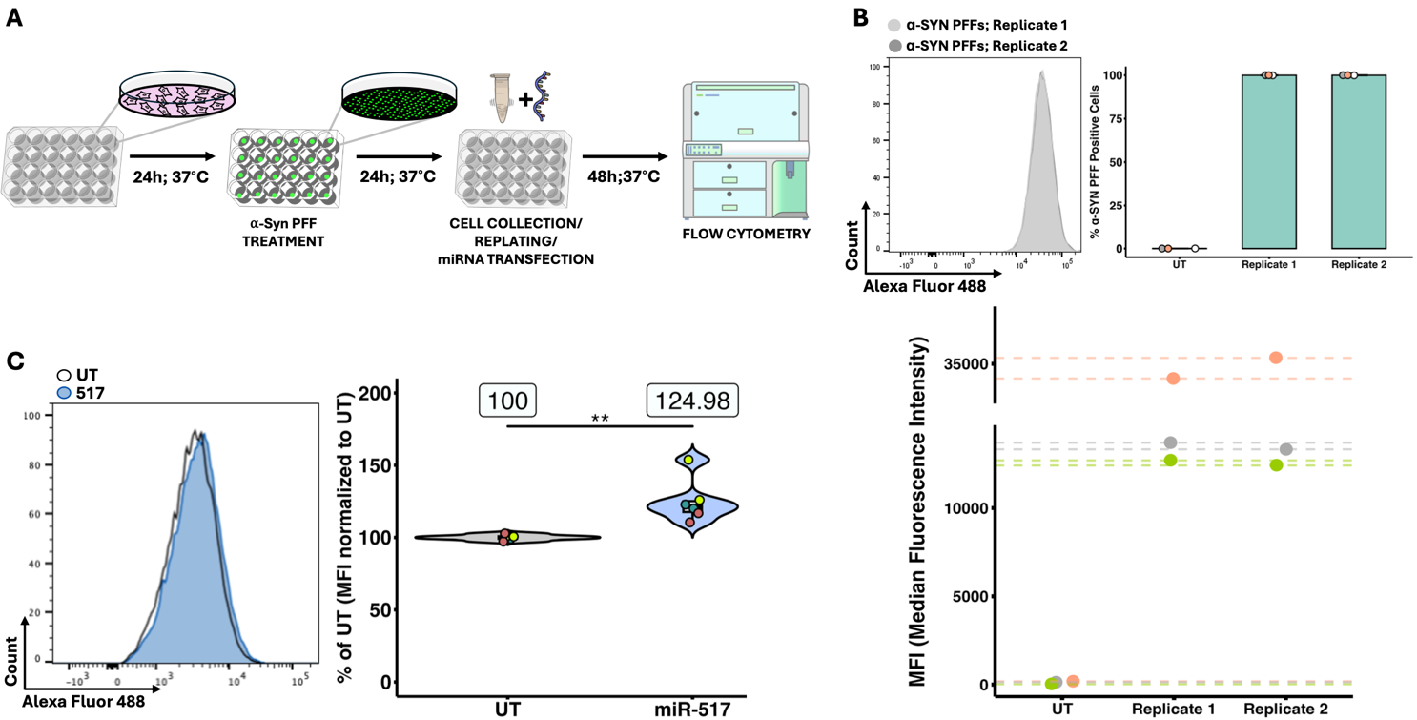

Fig. 4. Secretion/degradation assay to assess the mechanism of action of miR-517a-3p in U-87 MG cells. (A) Schematic representation of the secretion/degradation assay. (B) The histogram (left) displays fluorescence intensity distributions of Alexa Fluor-488 labeled α-syn PFFs for technical (same color) and biological (different color) replicates. The bar plot (right) quantifies the percentage of α-syn PFF-positive cells. The plot below shows the median fluorescence intensity (MFI) values for each replicate. (C) The histogram (left) shows fluorescence intensity distributions for the UT and miR-517-transfected cells at 50 nM concentration. The violin-boxplot (right) quantifies α-syn PFF uptake relative to UT. Statistical significance was determined using the Wilcoxon rank-sum test (unadjusted p value). **p < 0.01. The violin plot illustrates data distribution, with boxplots inside indicating the median and interquartile range. The boxes above the violins indicate the mean uptake percentages for each condition. Individual points are color-coded to represent independent experiments (biological replicates), with technical replicates sharing the same color within each condition. MFI, median fluorescence intensity; UT, untransfected control; miR-517, hsa-miR-517a-3p; α-syn PFFs, α-synuclein preformed fibrils. N = 3 independent experiments.

The role of miR-517a-3p in endocytosis of monomeric α-synuclein and transferrin
To evaluate the effect of miR-517a-3p on the internalization of recombinant Hu-m-syn, U-87 MG cells were transfected with 30 nM miRNA mimics, followed by treatment with Hu-m-syn for either 24 hours (Fig. 5A, S6A) or 4 hours (Fig. 5B, S6B). The results confirm a reduction in Hu-m-syn uptake at both time points, with a ~25% decrease relative to UT after 24 hours and a ~48% decrease after 4 hours. Notably, while miR-517a-3p reduced Hu-m-syn internalization, it remained unclear whether this effect was specific to α-synuclein or reflected a broader impact on endocytic pathways. To address this, we assessed the effect of miR-517a-3p on clathrin-mediated endocytosis by using transferrin. U-87 MG cells were transfected with 30 nM miRNA and subsequently treated with transferrin for either 24 hours (Fig. 5C, S6C) or 4 hours (Fig. 5D, S6D), with the gating strategy shown in Fig. S4A and S4B. Interestingly, miR-517a-3p-transfected cells exhibited increased transferrin accumulation compared to UT controls.

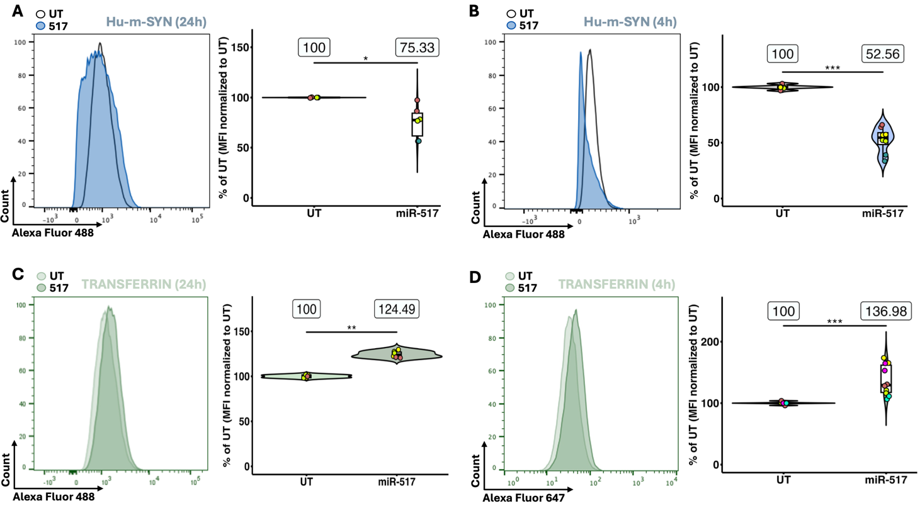

Fig. 5. Human monomeric α-synuclein and transferrin uptake in miR-517a-3p transfected U-87 MG cells. (A) Flow cytometry histogram (left) displaying fluorescence intensity distributions for Alexa Fluor- 488 labeled Hu-m-syn after 24 hours in UT and miR-517-transfected cells. The violin-boxplot (right) quantifies internalization relative to UT (MFI normalized to UT). (B) Flow cytometry histogram (left) for Hu-m-syn uptake after 4 hours, with violin-boxplot (right) quantifying uptake relative to UT. (C) Flow cytometry histogram (left) for Alexa Fluor-488 labeled transferrin uptake after 24 hours, with violin-boxplot (right) quantifying uptake relative to UT. (D) Flow cytometry histogram (left) for Alexa Fluor-647 labeled transferrin internalization after 4 hours, with violin-boxplot (right) quantifying uptake relative to UT. (A, B, C, D) Statistical significance was determined using the Wilcoxon rank-sum test (unadjusted p value). *p < 0.05; **p < 0.01; ***p < 0.001. Violin plots in all panels illustrate data distribution, with boxplots inside indicating the median and interquartile range. The boxes above the violins indicate the mean uptake percentages for each condition. Individual points are color-coded to represent independent experiments (biological replicates), with technical replicates sharing the same color within each condition. MFI, median fluorescence intensity; UT, untransfected control; miR-517, hsa-miR-517a-3p; Hu-m-syn, recombinant human monomeric α-synuclein; 24h, 24 hours; 4h, 4 hours. N = at least 3 independent experiments.

miR-517a-3p reduces the internalization of Tau-K18 and patient-derived pathological α-synuclein fibrils
We next examined whether this miRNA also affects the uptake of other fibrillar proteins implicated in distinct neurodegenerative diseases. First, we tested the internalization of Tau-K18 fibrils (0.5 uM), generated from the human Tau K18 construct and consisting of the microtubule-binding pseudorepeats R1–R4 of the tau protein (Fig. S7B) [296]. We then evaluated the uptake of patient-derived α-syn fibrils (0.1 uM), amplified from brain homogenates of patients with DLB, MSA, and PD (Fig. S7F) [297].
U-87 MG cells were transfected with 30 nM miR-517a-3p 48 hours prior to fibril treatment. After 24 hours of incubation with fibrils, miR-517a-3p-transfected cells showed consistent reduction in the internalization of all fibril types compared to UT. The reduction was most pronounced for Tau-K18 (~57%) (Fig. 6A, S7A), followed by DLB (~30%) (Fig. 6B, S7C), MSA (~25%) (Fig. 6C, S7D), and PD (~15%) (Fig. 6D, S7E). Statistically significant reductions were observed for Tau-K18 (p < 0.05), DLB (p < 0.01), MSA (p < 0.01), and PD (p < 0.05), indicating that miR-517a-3p broadly affects fibril uptake but with varying degrees of inhibition depending on fibril type.

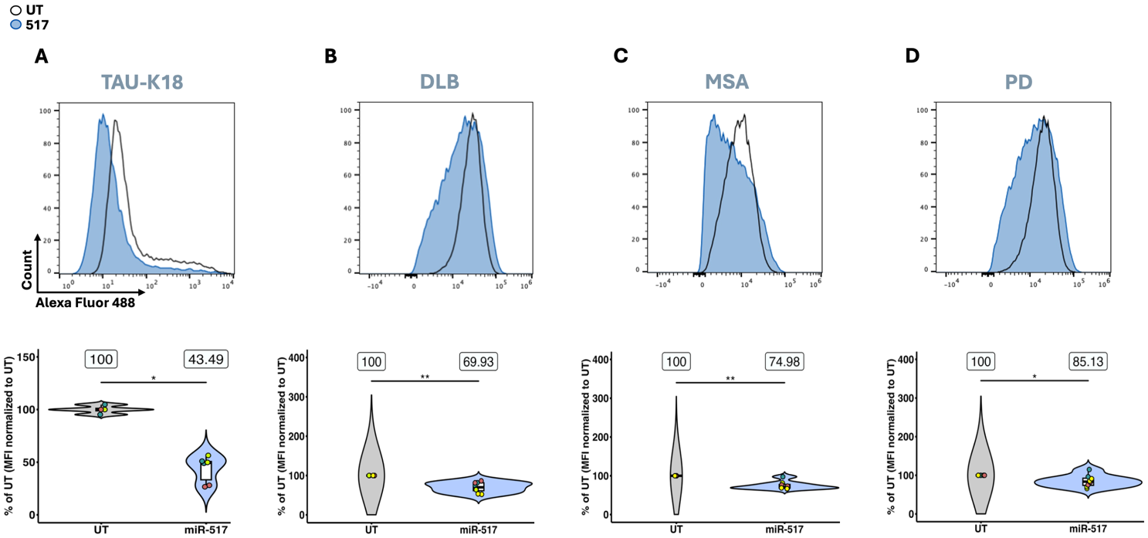

Fig. 6. miR-517a-3p reduces the internalization of Tau-K18 and patient-derived α-synuclein fibrils in U-87 MG cells. (A, B, C, D) Flow cytometry histograms (top) display fluorescence intensity distributions for UT and miR-517-transfected cells treated with Alexa Fluor-488 labeled recombinant Tau-K18 fibrils (A) or patient-derived α-synuclein fibrils (B, C, D). (A, B, C, D) The violin-boxplots (bottom) quantify fibril internalization as median fluorescence intensities (MFI) normalized to UT. Statistical significance was determined using the Wilcoxon rank-sum test (unadjusted p value). *p < 0.05; **p < 0.01. Violin plots in all panels illustrate data distribution, with boxplots inside indicating the median and interquartile range. The boxes above the violins indicate the mean uptake percentages for each condition. Individual points are color-coded to represent independent experiments (biological replicates), with technical replicates sharing the same color within each condition. MFI, median fluorescence intensity; UT, untransfected control; miR-517, hsa-miR-517a-3p; Tau-K18; Tau fibrils produced from recombinant human Tau K18 construct; DLB, fibrils amplified from a patient with Dementia with Lewy Bodies; MSA, fibrils amplified from a patient with Multiple System Atrophy; PD, fibrils amplified from a patient with Parkinson’s Disease. N = at least 3 independent experiments.

miR-517a-3p reduces α-synuclein preformed fibril uptake across glioblastoma cell lines
To assess the scope of miR-517a-3p’s inhibitory effect, we analyzed its impact on α-syn internalization in two additional glioblastoma cell lines, U-251 MG and LN-229. Cells were transfected with 30 nM miR-517a-3p for 48 hours prior to 24-hour incubation with either α-syn PFFs (Fig. 7A, 7C, S8B, S8E) or recombinant human monomeric α-syn (Hu-m-syn) (Fig. 7B, 7D, S8C, S8F). In both cell lines, efficient miRNA transfection was confirmed using a Cy3-labeled NTG miRNA tracer after a 72-hour incubation period (Fig. S8A, S8D).
Flow cytometry analysis revealed a significant reduction in both α-syn PFF and Hu-m-syn uptake in miR-517a-3p-transfected cells compared to UT controls. In U-251 MG cells, miR-517a-3p treatment led to an approximate 16% decrease in α-syn PFF internalization (p < 0.05) and a 15% reduction in Hu-m-syn uptake (p < 0.001) (Fig. 7A, 7B, S8B, S8C). In LN-229 cells, miR-517a-3p transfection resulted in a more pronounced reduction of α-syn PFF uptake (~31%, p < 0.01), while Hu-m-syn internalization decreased by ~10% (p < 0.01) (Fig. 7C, 7D, S8E, S8F).
Together, these findings confirm that miR-517a-3p consistently reduces α-syn internalization across multiple glioblastoma cell lines.
However, this effect appears to be cell-type specific, as it did not extend to SH-SY5Y neuroblastoma cells or hiPSC-derived astrocytes. Efficient miRNA transfection at 30 nM was confirmed in both cell types using a Cy3-labeled NTG miRNA tracer 72 hours post-transfection (Fig. S9A, S9D). Unlike glioblastoma cell lines, miR-517a-3p transfection, followed by 24-hour incubation with Alexa Fluor-488-labeled α-syn PFFs did not lead to a reduction in α-syn PFF uptake in either SH-SY5Y or hiPSC-derived astrocytes (Fig. S9B, S9C, S9E, S9F).

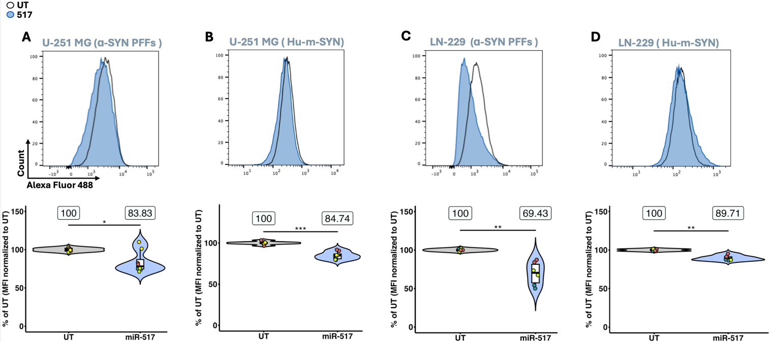

Fig. 7. miR-517a-3p reduces the internalization of α-synuclein across different glioblastoma cell lines. (A, B) Flow cytometry histograms (top) display fluorescence intensity distributions for UT and miR-517-transfected U-251 MG cells treated with Alexa Fluor-488 labeled α-syn PFFs (A) or Hu-m-syn (B). (C, D) Flow cytometry histograms (top) display fluorescence intensity distributions for UT and miR-517-transfected LN-229 cells treated with Alexa Fluor-488 labeled α-syn PFFs (C) or Hu-m-syn (D). (A, B, C, D) The violin-boxplots (bottom) quantify α-synuclein internalization as median fluorescence intensities (MFI) normalized to UT. Statistical significance was determined using the Wilcoxon rank-sum test (unadjusted p value). *p < 0.05; **p < 0.01; ***p < 0.001. Violin plots in all panels illustrate data distribution, with boxplots inside indicating the median and interquartile range. The boxes above the violins indicate the mean uptake percentages for each condition. Individual points are color-coded to represent independent experiments (biological replicates), with technical replicates sharing the same color within each condition. MFI, median fluorescence intensity; UT, untransfected control; miR-517, hsa-miR-517a-3p; α-syn PFFs, α-synuclein preformed fibrils; Hu-m-syn, recombinant human monomeric α-synuclein. N = at least 3 independent experiments.

DISCUSSION
Synucleinopathies are complex, progressive disorders characterized by toxic α-syn aggregates that exhibit prion-like behavior, spreading from cell to cell. While microglia and, to some extent, astrocytes internalize and degrade extracellular α-syn aggregates, their clearance capacity becomes overwhelmed over time. This dysfunction can promote intracellular accumulation of pathological α-syn species and create opportunities for their release and further spread to neighboring cells.
MiRNAs are increasingly recognized as crucial regulators of α-syn expression levels and can influence its degradation and clearance pathways. Moreover, changes in miRNA expression profiles detected in body fluids of synucleinopathy patients highlight their potential as biomarkers for disease diagnosis and monitoring.
To our knowledge, no miRNAs have been previously implicated in the regulation of α-syn fibril internalization. However, studies on other neurotoxic protein aggregates suggest a possible role for miRNAs in modulating their uptake. For instance, miR-155 has been shown to influence the internalization of amyloid-beta (Aβ) fibrils in microglia [298, 299]. These findings suggest that miRNAs may play a broader role in regulating pathogenic protein uptake, warranting further investigation into their impact on α-syn fibril internalization. To identify miRNA regulators of α-syn fibril internalization, we conducted an unbiased miRNA-based screen in a human glioblastoma cell line (U-87 MG). Our genome-wide miRNA screen identified distinct groups of miRNAs that either suppressed (Fig. S12A) or enhanced (Fig. S12B) α-syn PFF internalization (Fig. S1). Sequence analysis revealed that miRNAs within each group share highly conserved seed sequences (nucleotides 2-8), as illustrated in the bottom panels of Fig. S12A and S12B, suggesting that miRNAs in the same category may regulate α-syn fibril internalization through common target interactions. However, the seed sequences differ between suppressors and enhancers, indicating that these two groups likely modulate distinct pathways or mechanisms. Nevertheless, it is also possible that they act on the same pathway but exert opposing effects. The presence of multiple miRNAs with identical seed sequences within each category reinforces the specificity of our findings and validates the robustness of our primary screen. This strong conservation within groups further suggests that miRNA-mediated regulation of α-syn fibril internalization is not random but follows defined sequence-dependent interactions.
Typically, miRNAs are classified into families based on conserved seed sequences located at their 5’ end [300]. Additionally, miRNA families often cluster together in specific chromosomal loci, which allows functionally related members to be co-expressed and co-regulate target genes, contributing to the maintenance of biological processes [301]. A subset of miRNA suppressors identified in our screen, including miR-517a-3p, miR-517b-3p, and miR-517c-3p, share almost identical sequences and belong to the C19MC cluster (Fig. S12A, Fig. S13). In contrast, the subset of enhancers of α-syn fibril internalization is distributed across different miRNA clusters: miR-302a-3p, miR-302b-3p, miR-302c-3p, and miR-302e originate from the miR-302 cluster, miR-373-3p belongs to the miR-372 cluster, and miR-520e-3p - though part of C19MC - shares an identical seed sequence with the miR-302/372 enhancers (Fig. S12B, Fig. S13). Notably, the identified subset of miRNA enhancers contains the conserved AAGUGC hexameric seed sequence, which has been reported to play a significant role in regulating cell proliferation, cellular reprogramming, maintenance of pluripotency, and apoptosis through multiple signaling pathways [302]. This clustering pattern suggests that miRNAs within closely related regulatory networks may exert opposing effects on α-syn fibril internalization, as observed with suppressors from the C19MC cluster and enhancers from the miR-302/372 clusters.
While the data presented here focus on the miRNA(s) that exhibited the strongest effects, it is important to note that not all identified enhancers and suppressors were validated, leaving additional candidates for future evaluation.
From our primary screen, we selected and validated one strong miRNA suppressor (miR-517a-3p) and two miRNA enhancers (miR-302c-3p and miR-520e) of α-syn fibril internalization, using the same concentration (50 nM) as in the screen (Fig. 2B, S3C).
Interestingly, miR-302c-3p has been implicated in the pathogenesis of sporadic ALS, while miR-520e has been found dysregulated in PD and has also been associated with the regulation of TARDBP, a key gene involved in TDP-43 proteinopathies, which underlie ALS and other neurodegenerative disorders [303-305]. In contrast, miR-517a-3p has not yet been directly linked to neurodegenerative diseases (NDDs), but a closely related miRNA from the same C19MC cluster - miR-519a-3p - has been found elevated in cerebral samples from AD patients at Braak stage I and was shown to modulate PrPC expression [306]. Given that C19MC is normally epigenetically silenced in adult tissues but can be reactivated in cancer and certain pathological conditions, its dysregulation in neurodegeneration raises the possibility that miR-517a-3p may also be altered in NDD patients [302]. Moreover, since all miRNAs within C19MC are transcribed as a single polycistronic transcript, their expression is typically all-or-none in a given cell type. Therefore, if certain C19MC members such as miR-520e and miR-519a-3p are found to be dysregulated in neurodegenerative diseases, it is plausible that miR-517a-3p may also be co-expressed, implicating it in neurodegenerative disease pathology.
Among the validated candidates, miR-517a-3p (miR-517) was the only miRNA that consistently reduced α-syn PFF uptake even at a lower concentration (30 nM) than initially tested in the screen. Meanwhile, miR-520e (miR-520) and miR-302c-3p (miR-302) continued to enhance uptake, but their effects varied across replicates and failed to reach statistical significance (Fig. 2D, S3D). Another factor contributing to the exclusion of miR-520 and miR-302 from further experiments was the use of MIRIDIAN microRNA Mimic Negative Control #1 (Horizon Discovery), a non-targeting (NTG) miRNA based on the mature sequence of cel-miR-67, in validation assays. We observed that the NTG-transfected cells accumulated PFFs at levels comparable to those seen with miR-520 and miR-302, suggesting a confounding effect (Fig. S3C, S3D). Additionally, NTG-transfected cells exhibited slow proliferation (~60% reduction relative to the controls) and G0-G1 phase accumulation, likely due to off-target effects interfering with G1/S transition (Fig. 3B, S11A, S11B). Because of these limitations, NTG was not used as the reference condition in subsequent experiments, and untransfected control condition (UT) was used instead. Given these confounding factors, we prioritized miR-517, which consistently reduced PFF internalization in a reproducible manner. Additionally, the proliferation rate of miR-517-transfected cells was comparable to controls, with an approximately 10% reduction (Fig. 3B). This suggests that its effect on the PFF uptake was not due to an enhanced division rate - which would have diluted the amount of intracellular fibrils - but rather a direct effect of miR-517.
While CellTiter-Glo analysis showed an approximate 20% reduction in viability in miR-517a-3p-transfected U-87 MG cells treated with α-syn PFFs, a more pronounced cytotoxic effect (~50% reduction) was observed in the co-culture system (Fig. 3A, S10E). On top of that, in the miR-517 condition, we observed a higher fraction of the non-assigned (NA) intermediate population, likely representing mCherry transfer from recipient to donor cells (Fig. S10C, S10E). This population may have arisen due to secondary necrosis, a process that ultimately leads to cell death accompanied by the release of cell contents into extracellular space [307]. Given that cells were maintained in co-culture for three days before analysis, it is possible that miR-517a-3p-induced cytotoxicity contributed to the release of mCherry from dying recipient cells, resulting in their reassignment to the NA fraction. These findings indicate that CellTiter-Glo may underestimate viability changes. The observed discrepancy highlights a clear limitation of our study, but importantly, all cells analyzed in our validation assays were live cells, as confirmed by Annexin V staining and PI exclusion assays, with PI serving as the live-dead cell marker across all experiments (Fig. S11C, S11D, S4A).
Our findings indicate that miR-517a-3p alters the cell cycle dynamics of U-87 MG cells, as evidenced by the increased percentage of cells in S-phase and the concomitant reduction of cells in G0-G1 (Fig. S11A, S11B). This shift in cell cycle distribution suggests that miR-517a-3p may modulate G1 to S phase transition.
One possible explanation for this phenotype relates to the established link between endocytic impairments and sustained proliferative signaling in glioblastoma [308]. Endocytic dysfunction leads to the accumulation of various surface receptors, including growth factor receptors, due to reduced internalization. As a result, mitogenic signaling is prolonged, potentially providing a selective advantage for cancer cell proliferation.
In line with this, glioblastoma cells, including U-87 MG, secrete various growth factors which sustain autocrine and paracrine signaling loops that drive proliferation [309-311]. If miR-517a-3p further disrupts endocytosis, it may exacerbate this effect by increasing the surface availability of growth factor receptors, thereby amplifying downstream signaling cascades that promote G1-S phase transition. This hypothesis aligns with our observation that miR-517a-3p-treated cells exhibit an increased percentage of S-phase cells and a decreased proportion of cells in G0-G1.
However, accumulation of S-phase cells could also indicate a cell cycle delay or arrest. S-phase arrest should not be inferred solely from an increased S-phase fraction, and further validation using cell cycle markers (e.g., cyclins, checkpoint activation) is needed. While prolonged S-phase arrest can lead to apoptosis, this is not always the case. Our Annexin V assay did not reveal a significantly higher fraction of apoptotic cells relative to controls. This may be due to the exclusion of detached cells, as we processed the samples similarly to our uptake experiments. Therefore, the absence of a detectable increase in apoptosis does not rule out apoptotic events in general, as non-adherent and potentially apoptotic cells were not included in our analysis. Likewise, long-term effects on cell viability cannot be ruled out, as delayed apoptosis or cumulative cellular stress may still occur. Further investigation using apoptotic markers such as cleaved caspase-3 and PARP cleavage would be necessary to confirm this hypothesis.
Taken together, these findings highlight a potential unintended consequence of miR-517a-3p modulation - while it reduces α-synuclein internalization, its broader impact on endocytic regulation may affect proliferative signaling and cell cycle dynamics in glioblastoma cells. Whether miR-517a-3p primarily promotes G1-S transition, delays S-phase progression, or affects the duration of individual cell cycle phases remains an open question. Further studies are required to determine whether miR-517a-3p directly regulates specific growth factor receptors or if its effects are mediated through general dysregulation of endocytic trafficking. Understanding this balance is crucial for evaluating the potential therapeutic implications of miR-517a-3p in glioblastoma and neurodegenerative diseases.
Moreover, it remains unclear whether the altered cell cycle distribution reflects a transient delay or a more sustained dysregulation, as miR-517a has been reported to induce apoptosis in different cellular contexts [312-314]. While its apoptotic role in glioblastoma remains unclear, its effects are likely context-dependent, warranting further investigation into its impact on cell survival and proliferation in glioblastoma.
The α-syn PFFs used in our study consist of a heterogeneous mixture of short fibrils and oligomeric α-syn species (Fig. S2E). Oligomers are transient species, and their concentrations decrease as they either convert into fibrils or dissociate into monomers [315]. To account for this, we shortened the incubation period with α-syn PFFs from 24 hours to 4 hours in our experiments (Fig. 2C, S3E). This adjustment ensured that our miRNA treatment was also tested against oligomeric species before their conversion, allowing us to capture its potential effects on these early intermediates of α-syn aggregation. As shown in Fig. 2C, miR-517 significantly reduces α-syn PFF internalization at both 4 and 24 hours, with a stronger effect observed at the earlier time point. However, fibril accumulation continues over time, with approximately a 30% increase from 4 to 24 hours. This suggests that while miR-517a-3p effectively limits initial uptake, additional factors such as ongoing internalization, intracellular trafficking, or cellular adaptation mechanisms may contribute to the partial recovery of fibril accumulation at later time points.
In U-87 MG cells, miR-517a-3p reduced Hu-m-syn uptake by approximately 25% after 24 hours and 48% after 4 hours relative to UT (Fig. 5A, S6A). This reduction was even greater for α-syn PFF uptake, where miR-517a-3p induced a ~40% reduction at 24 hours and a ~73% reduction at 4 hours (Fig. 2D, S3D, 2C, S3E). Together, these findings suggest that miR-517a-3p has a stronger impact on the internalization of fibrillar α-synuclein than on its monomeric counterpart.
The results shown in Fig. S3A and S5B underscore miR-517's specific role in modulating active endocytic pathways for α-syn PFF uptake, while ruling out passive uptake, altered degradation, or secretion pathways as contributing mechanisms.
Buser et al. reported that patient-derived glioblastoma cells exhibit severe impairments in endocytic machinery, including reduced expression of key regulators such as AP-2, CHC17, EndoA1, and dynamin [308]. This in turn leads to impaired clathrin-dependent - and likely clathrin-independent - endocytosis, as well as accumulation of surface receptor proteins such as transferrin receptor. This phenotype reflects an inherent consequence of defective endocytosis in glioblastoma cells. Similarly, other studies have shown that the inhibition or depletion of AP-2, clathrin, or dynamin in multiple immortalized cell cultures results in a striking increase in transferrin surface receptor levels [316-320].
To assess whether miR-517a-3p specifically affects clathrin-mediated endocytosis, we treated U-87 MG cells with transferrin, a well-established marker of this pathway [321]. At both time points, miR-517a-3p-transfected cells showed increased transferrin accumulation compared to UT controls (Fig. 5C, 5D, S6C, S6D). Given that glioblastoma cells already show an upregulation of surface transferrin receptors due to impaired endocytosis, this increase in transferrin accumulation in miR-517a-3p-treated cells indicates that miR-517a-3p further suppresses the expression or function of key endocytic regulators consequently increasing transferrin receptor availability. More available receptors could lead to higher transferrin binding, and if there’s residual CME activity and/or incomplete cleavage of transferrin receptors after trypsinization, it could result in an apparent increase in transferrin accumulation despite overall endocytic dysfunction. Alternatively, miR-517 could be indirectly enhancing transferrin uptake by modulating an alternative endocytic pathway or stabilizing existing endocytic machinery. While CME is the primary route for transferrin, some studies suggest that alternative compensatory mechanisms (i.e., lipid raft-dependent pathways) may also contribute to its internalization [322]. If miR-517 influences regulators that increase membrane trafficking or receptor clustering, it might facilitate increased transferrin uptake.
Since miR-517a-3p reduced the internalization of both Hu-m-syn and α-syn PFFs while increasing transferrin uptake, these findings suggest that miR-517a-3p may modify the efficiency of different endocytic pathways in distinct ways. Transferrin is primarily internalized through CME, whereas α-synuclein is taken up via multiple routes, including CME, macropinocytosis, and receptor-mediated pathways involving lipid raft-associated proteins. These distinct mechanisms may be differentially influenced by miR-517a-3p. Further studies should identify the molecular targets of miR-517a-3p that may regulate both clathrin-dependent and -independent pathways, as well as its broader role in endocytic trafficking and surface receptor redistribution in glioblastoma cells.
Our results demonstrate that miR-517 significantly reduces the uptake of synthetic α-syn PFFs (Fig. 2D, S3D, S2C), Tau-K18 fibrils (Fig. 6A, S7A, S7B), and patient-derived α-syn fibrils (Fig. 6B, S7C, 6C, S7D, 6D, S7E, S7F), though the effect size is smaller for the latter [296, 297]. The shorter length of patient-derived fibrils (41± 2nm on average) might contribute to the observed differences in miR-517 efficacy but is unlikely to be the determining factor. Instead, structural and biochemical properties specific to these fibrils are more likely to influence their interaction with cellular uptake pathways. A previously published study by Van der Perren et al. suggest that these α-syn fibrils - amplified from patients with PD, MSA, and DLB - exhibit distinct structural, biochemical and phenotypic characteristics reflective of their disease-specific pathology [297]. These structural differences could play a crucial role in determining their mode of internalization and sensitivity to miR-517 regulation. Several factors may contribute to the reduced but still significant effect of miR-517 on patient-derived fibrils compared to our synthetic α-syn PFFs in the U-87 MG cell line. First, unique fibrillar conformations or surface properties of patient-derived aggregates may affect their recognition by cellular uptake receptors, leading to distinct entry routes that are less dependent on miR-517-regulated pathway(s). Second, differences in fibril rigidity or flexibility could alter their interactions with cellular membranes and trafficking efficiency, potentially bypassing pathway(s) influenced by miR-517. Third, variations in fibril charge or hydrophobicity may influence their interaction with lipid membranes and intracellular processing, further distinguishing their uptake from that of synthetic PFFs. Finally, it is also possible that cell-type-specific differences in receptor expression and endocytic pathways play a role in determining the extent to which miR-517 modulates fibril internalization.
In support of this, we found that miR-517a-3p consistently reduced α-syn internalization in other glioblastoma cell lines (Fig. 7A, 7B, S8B, S8C, 7C, 7D, S8E, S8F), but this effect was absent in SH-SY5Y neuroblastoma cells (Fig. S9B, S9C) and hiPSC-derived immature astrocytes (Fig. S9E, S9F). This suggests that glioblastoma cells may rely on miR-517a-3p-sensitive pathways for α-synuclein uptake, whereas neuroblastoma and immature astrocytes engage distinct internalization mechanisms that are unaffected by miR-517a-3p. Therefore, it is plausible that miR-517a-3p primarily regulates pathways that are more prominent in glioblastoma cells. Differences in receptor expression, lipid membrane composition, or alternative uptake routes might underlie this cell-type specificity.
Additionally, the developmental stage of astrocytes may play a role in determining their response to miR-517a-3p. The astrocytes used in this study were hiPSC-derived and represent an immature phenotype, which differs from their mature counterparts in terms of receptor expression and hence intracellular trafficking of α-synuclein. It remains to be determined whether miR-517a-3p influences α-synuclein internalization in fully differentiated astrocytes or primary human astrocytes.
The cell-type specificity observed here aligns with previous reports demonstrating that miRNAs often exert context-dependent effects due to variations in target gene expression across different cellular environments [323]. Further studies are needed to elucidate the molecular targets of miR-517a-3p in glioblastoma cells and to determine whether its regulatory effects extend to other cell types relevant to synucleinopathies, such as oligodendrocytes or microglia. Given that miRNAs exert their effects through partial sequence complementarity, traditional qPCR approaches may not be sufficient for target identification. Instead, future studies should employ Argonaute (Ago)-based CLIP approaches to comprehensively map miR-517a-3p’s direct interactions with mRNAs involved in endocytosis. Additionally, while we observed a significant reduction in α-syn internalization, the lowest concentration of miR-517a-3p used in our studies was 30 nM, a relatively high dose that may still induce off-target effects. Since the RISC complex is present in limited numbers, miRNA overloading can lead to non-specific target engagement, further highlighting the need for unbiased identification of miR-517a-3p’s functional targets.
In an era dominated by CRISPR-based screening, we chose a miRNA-based approach to explore modulators of α-synuclein uptake. While miRNA screens are known for their broader target spectrum and potential off-target effects, they offer unique advantages. Unlike CRISPR, which typically disrupts single genes, miRNAs simultaneously regulate multiple components within a pathway, making them ideal for studying complex, interconnected processes like endocytosis. Moreover, because miRNAs act post-transcriptionally, they can uncover regulatory effects that would remain hidden in transcriptional knockout or knockdown systems. Given that dysregulated miRNA expression is a hallmark of many NDDs, this strategy also provides insight into endogenous disease-relevant mechanisms that might be overlooked in CRISPR screens.
miR-517a-3p, a member of the C19MC cluster, emerged as a key hit in our screen. Dysregulation of this cluster - including members like miR-520e and miR-519a-3p - has been implicated in NDDs, supporting the potential relevance of miR-517a-3p in disease pathology. miR-517a-3p impairs endocytic function in glial cells, limiting their ability to internalize and clear pathogenic fibrils, which could accelerate disease progression.
Extensive efforts to develop disease-modifying therapies for synucleinopathies have largely focused on directly targeting α-syn, yet these approaches have not yielded effective treatments. As a result, current strategies remain limited to symptomatic therapies that provide only temporary relief without altering disease progression. Given the complexity of these diseases, effective therapeutic interventions will likely require multifaceted approaches to achieve meaningful and long-lasting results. Combining miRNA-based interventions that regulate α-synuclein uptake with complementary strategies - such as immunotherapies that enhance extracellular clearance or pharmacological agents that boost lysosomal degradation - may provide a more effective means of mitigating pathological protein accumulation and spread.
However, given the observed cytotoxicity in co-culture experiments and the lack of effect in neuroblastoma and astrocytes, miR-517a-3p may not represent a strong standalone candidate for therapeutic development. Investigating other miRNAs identified in our screen - particularly those that modulate α-synuclein uptake with greater specificity and fewer off-target effects - could help overcome current limitations. A combinatorial approach targeting multiple pathways involved in α-synuclein uptake, trafficking, and clearance may ultimately offer a more effective strategy for combating synucleinopathies. While miRNA-based therapies hold promise for selectively regulating disease-relevant endocytic pathways, further research is required to determine their translational potential and suitability for therapeutic applications in neurodegenerative diseases.
In conclusion, our findings establish miR-517a-3p as a regulator of α-synuclein internalization and accumulation across multiple glioblastoma cell lines. Specifically, miR-517a-3p significantly reduced the uptake of synthetic α-syn PFFs and monomeric α-syn, as well as patient-derived fibrils and Tau-K18 fibrils in U-87 MG cells. These data demonstrate that miR-517a-3p impacts α-synuclein internalization but its effects on transferrin uptake indicate that it may modulate multiple endocytic pathways rather than selectively targeting α-synuclein uptake. This could reflect changes in receptor availability, membrane trafficking, or compensatory mechanisms within the endocytic network. Identifying the specific genetic targets of miR-517a-3p responsible for the observed phenotype is crucial, as it may reveal new regulatory nodes in α-synuclein endocytosis and uncover mechanisms by which glial endocytic dysfunction contributes to synucleinopathies and related NDDs.

BIBLIOGRAPHY
[1] D. o. E. a. S. A. United Nations, Population Division, "World Population Prospects 2024," 2024. Accessed: December 30, 2024. [Online]. Available: https://population.un.org/wpp
[2] D. o. E. a. S. A. United Nations, "World Social Report 2023: Leaving no one behind in an ageing world.," United Nations, 2023.
[3] D. o. E. a. S. A. United Nations, Population Division., "World Population Prospects 2024: Summary of Results (UN DESA/POP/2024/TR/NO. 9)." United Nations, 2024. Accessed: December 30, 2024. [Online]. Available: https://population.un.org/wpp
[4] T. Wyss-Coray, "Ageing, neurodegeneration and brain rejuvenation," Nature, vol. 539, no. 7628, pp. 180-186, 2016/11/01 2016, doi: 10.1038/nature20411.
[5] C. B. López-Otín, M.A.; Partridge, L.; Serrano, M.; Kroemer, G., "The hallmarks of aging," (in eng), Cell, vol. 153, no. 6, pp. 1194-1217, June 6, 2013 2013, doi: 10.1016/j.cell.2013.05.039.
[6] D. M. Wilson, III, M. R. Cookson, L. Van Den Bosch, H. Zetterberg, D. M. Holtzman, and I. Dewachter, "Hallmarks of neurodegenerative diseases," Cell, vol. 186, no. 4, pp. 693-714, 2023, doi: 10.1016/j.cell.2022.12.032.
[7] B. Schumacher, J. Pothof, J. Vijg, and J. H. J. Hoeijmakers, "The central role of DNA damage in the ageing process," Nature, vol. 592, no. 7856, pp. 695-703, 2021/04/01 2021, doi: 10.1038/s41586-021-03307-7.
[8] S. Sepe et al., "Inefficient DNA Repair Is an Aging-Related Modifier of Parkinson’s Disease," Cell Reports, vol. 15, no. 9, pp. 1866-1875, 2016/05/31/ 2016, doi: https://doi.org/10.1016/j.celrep.2016.04.071.
[9] Y. L. Li, Z. X. Wang, C. Z. Ying, B. R. Zhang, and J. L. Pu, "Decoding the Role of Familial Parkinson's Disease-Related Genes in DNA Damage and Repair," Aging Dis, vol. 13, no. 5, pp. 1405-1412, Oct 1 2022, doi: 10.14336/AD.2022.0216.
[10] A. Konopka and J. D. Atkin, "DNA Damage, Defective DNA Repair, and Neurodegeneration in Amyotrophic Lateral Sclerosis," (in English), Frontiers in Aging Neuroscience, Review vol. 14, 2022-April-27 2022, doi: 10.3389/fnagi.2022.786420.
[11] N. M. Shanbhag et al., "Early neuronal accumulation of DNA double strand breaks in Alzheimer’s disease," Acta Neuropathologica Communications, vol. 7, no. 1, p. 77, 2019/05/17 2019, doi: 10.1186/s40478-019-0723-5.
[12] N. H. Myung et al., "Evidence of DNA damage in Alzheimer disease: phosphorylation of histone H2AX in astrocytes," (in eng), Age (Dordr), vol. 30, no. 4, pp. 209-15, Dec 2008, doi: 10.1007/s11357-008-9050-7.
[13] A. J. Schaser et al., "Alpha-synuclein is a DNA binding protein that modulates DNA repair with implications for Lewy body disorders," Scientific Reports, vol. 9, no. 1, p. 10919, 2019/07/29 2019, doi: 10.1038/s41598-019-47227-z.
[14] Y. Chu and J. H. Kordower, "Age-associated increases of α-synuclein in monkeys and humans are associated with nigrostriatal dopamine depletion: Is this the target for Parkinson's disease?," Neurobiology of Disease, vol. 25, no. 1, pp. 134-149, 2007/01/01/ 2007, doi: https://doi.org/10.1016/j.nbd.2006.08.021.
[15] K. M. Rodrigue et al., "β-Amyloid burden in healthy aging: regional distribution and cognitive consequences," (in eng), Neurology, vol. 78, no. 6, pp. 387-95, Feb 7 2012, doi: 10.1212/WNL.0b013e318245d295.
[16] C. Nascimento et al., "Prevalence of transactive response DNA-binding protein 43 (TDP-43) proteinopathy in cognitively normal older adults: systematic review and meta-analysis," (in eng), Neuropathol Appl Neurobiol, vol. 44, no. 3, pp. 286-297, Apr 2018, doi: 10.1111/nan.12430.
[17] A. Casanova, A. Wevers, S. Navarro-Ledesma, and L. Pruimboom, "Mitochondria: It is all about energy," (in eng), Front Physiol, vol. 14, p. 1114231, 2023, doi: 10.3389/fphys.2023.1114231.
[18] U. C. Dash et al., "Oxidative stress and inflammation in the pathogenesis of neurological disorders: Mechanisms and implications," Acta Pharmaceutica Sinica B, 2024/10/16/ 2024, doi: https://doi.org/10.1016/j.apsb.2024.10.004.
[19] D. M. K. van Soest et al., "Mitochondrial H2O2 release does not directly cause damage to chromosomal DNA," Nature Communications, vol. 15, no. 1, p. 2725, 2024/03/28 2024, doi: 10.1038/s41467-024-47008-x.
[20] P. Norat et al., "Mitochondrial dysfunction in neurological disorders: Exploring mitochondrial transplantation," npj Regenerative Medicine, vol. 5, no. 1, p. 22, 2020/11/23 2020, doi: 10.1038/s41536-020-00107-x.
[21] S. Wang et al., "The mitophagy pathway and its implications in human diseases," Signal Transduction and Targeted Therapy, vol. 8, no. 1, p. 304, 2023/08/16 2023, doi: 10.1038/s41392-023-01503-7.
[22] F. Koyano et al., "Ubiquitin is phosphorylated by PINK1 to activate parkin," Nature, vol. 510, no. 7503, pp. 162-166, 2014/06/01 2014, doi: 10.1038/nature13392.
[23] A. H. Schapira, J. M. Cooper, D. Dexter, J. B. Clark, P. Jenner, and C. D. Marsden, "Mitochondrial complex I deficiency in Parkinson's disease," (in eng), J Neurochem, vol. 54, no. 3, pp. 823-7, Mar 1990, doi: 10.1111/j.1471-4159.1990.tb02325.x.
[24] P. J. Carling et al., "Deep phenotyping of peripheral tissue facilitates mechanistic disease stratification in sporadic Parkinson's disease," (in eng), Prog Neurobiol, vol. 187, p. 101772, Apr 2020, doi: 10.1016/j.pneurobio.2020.101772.
[25] A. M. Smith et al., "Mitochondrial dysfunction and increased glycolysis in prodromal and early Parkinson's blood cells," (in eng), Mov Disord, vol. 33, no. 10, pp. 1580-1590, Oct 2018, doi: 10.1002/mds.104.
[26] J. S. Kerr et al., "Mitophagy and Alzheimer&#x2019;s Disease: Cellular and Molecular Mechanisms," Trends in Neurosciences, vol. 40, no. 3, pp. 151-166, 2017, doi: 10.1016/j.tins.2017.01.002.
[27] S. Franco-Iborra, A. Plaza-Zabala, M. Montpeyo, D. Sebastian, M. Vila, and M. Martinez-Vicente, "Mutant HTT (huntingtin) impairs mitophagy in a cellular model of Huntington disease," Autophagy, vol. 17, no. 3, pp. 672-689, 2021/03/04 2021, doi: 10.1080/15548627.2020.1728096.
[28] B. Khalil, N. El Fissi, A. Aouane, M. J. Cabirol-Pol, T. Rival, and J. C. Liévens, "PINK1-induced mitophagy promotes neuroprotection in Huntington’s disease," Cell Death & Disease, vol. 6, no. 1, pp. e1617-e1617, 2015/01/01 2015, doi: 10.1038/cddis.2014.581.
[29] A. Magrì et al., "ERK1/2-dependent TSPO overactivation associates with the loss of mitophagy and mitochondrial respiration in ALS," Cell Death & Disease, vol. 14, no. 2, p. 122, 2023/02/15 2023, doi: 10.1038/s41419-023-05643-0.
[30] L. Hayflick and P. S. Moorhead, "The serial cultivation of human diploid cell strains," (in eng), Exp Cell Res, vol. 25, pp. 585-621, Dec 1961, doi: 10.1016/0014-4827(61)90192-6.
[31] M. Reimann, S. Lee, and C. A. Schmitt, "Cellular senescence: Neither irreversible nor reversible," Journal of Experimental Medicine, vol. 221, no. 4, 2024, doi: 10.1084/jem.20232136.
[32] S. P. Jackson and J. Bartek, "The DNA-damage response in human biology and disease," Nature, vol. 461, no. 7267, pp. 1071-1078, 2009/10/01 2009, doi: 10.1038/nature08467.
[33] R. Bhat et al., "Astrocyte senescence as a component of Alzheimer's disease," (in eng), PLoS One, vol. 7, no. 9, p. e45069, 2012, doi: 10.1371/journal.pone.0045069.
[34] M. Asghar et al., "Mitochondrial biogenesis, telomere length and cellular senescence in Parkinson’s disease and Lewy body dementia," Scientific Reports, vol. 12, no. 1, p. 17578, 2022/10/20 2022, doi: 10.1038/s41598-022-22400-z.
[35] W. Huang, L. J. Hickson, A. Eirin, J. L. Kirkland, and L. O. Lerman, "Cellular senescence: the good, the bad and the unknown," Nature Reviews Nephrology, vol. 18, no. 10, pp. 611-627, 2022/10/01 2022, doi: 10.1038/s41581-022-00601-z.
[36] D. Chang et al., "A meta-analysis of genome-wide association studies identifies 17 new Parkinson's disease risk loci," Nature Genetics, vol. 49, no. 10, pp. 1511-1516, 2017/10/01 2017, doi: 10.1038/ng.3955.
[37] M. Riessland et al., "Loss of SATB1 Induces p21-Dependent Cellular Senescence in Post-mitotic Dopaminergic Neurons," Cell Stem Cell, vol. 25, no. 4, pp. 514-530.e8, 2019, doi: 10.1016/j.stem.2019.08.013.
[38] S. J. Chinta et al., "Cellular Senescence Is Induced by the Environmental Neurotoxin Paraquat and Contributes to Neuropathology Linked to Parkinson&#x2019;s Disease," Cell Reports, vol. 22, no. 4, pp. 930-940, 2018, doi: 10.1016/j.celrep.2017.12.092.
[39] J. R. Herdy et al., "Increased post-mitotic senescence in aged human neurons is a pathological feature of Alzheimer's disease," (in eng), Cell Stem Cell, vol. 29, no. 12, pp. 1637-1652.e6, Dec 1 2022, doi: 10.1016/j.stem.2022.11.010.
[40] B. Hong, Y. Ohtake, T. Itokazu, and T. Yamashita, "Glial senescence enhances α-synuclein pathology owing to its insufficient clearance caused by autophagy dysfunction," Cell Death Discovery, vol. 10, no. 1, p. 50, 2024/01/26 2024, doi: 10.1038/s41420-024-01816-8.
[41] N. N. Fancy et al., "Characterisation of premature cell senescence in Alzheimer’s disease using single nuclear transcriptomics," Acta Neuropathologica, vol. 147, no. 1, p. 78, 2024/05/02 2024, doi: 10.1007/s00401-024-02727-9.
[42] D. Li et al., "Trimethylamine-N-oxide promotes brain aging and cognitive impairment in mice," (in eng), Aging Cell, vol. 17, no. 4, p. e12768, Aug 2018, doi: 10.1111/acel.12768.
[43] M. Colonna and O. Butovsky, "Microglia Function in the Central Nervous System During Health and Neurodegeneration," (in eng), Annu Rev Immunol, vol. 35, pp. 441-468, Apr 26 2017, doi: 10.1146/annurev-immunol-051116-052358.
[44] S. Guo, H. Wang, and Y. Yin, "Microglia Polarization From M1 to M2 in Neurodegenerative Diseases," (in eng), Front Aging Neurosci, vol. 14, p. 815347, 2022, doi: 10.3389/fnagi.2022.815347.
[45] P. L. McGeer, S. Itagaki, B. E. Boyes, and E. G. McGeer, "Reactive microglia are positive for HLA-DR in the substantia nigra of Parkinson's and Alzheimer's disease brains," (in eng), Neurology, vol. 38, no. 8, pp. 1285-91, Aug 1988, doi: 10.1212/wnl.38.8.1285.
[46] H. Keren-Shaul et al., "A Unique Microglia Type Associated with Restricting Development of Alzheimer&#x2019;s Disease," Cell, vol. 169, no. 7, pp. 1276-1290.e17, June 15 2017, doi: 10.1016/j.cell.2017.05.018.
[47] A. M. Schonhoff et al., "Border-associated macrophages mediate the neuroinflammatory response in an alpha-synuclein model of Parkinson disease," Nature Communications, vol. 14, no. 1, p. 3754, 2023/06/26 2023, doi: 10.1038/s41467-023-39060-w.
[48] A. N. Brandebura, A. Paumier, T. S. Onur, and N. J. Allen, "Astrocyte contribution to dysfunction, risk and progression in neurodegenerative disorders," Nature Reviews Neuroscience, vol. 24, no. 1, pp. 23-39, 2023/01/01 2023, doi: 10.1038/s41583-022-00641-1.
[49] K. Chiotis et al., "Tracking reactive astrogliosis in autosomal dominant and sporadic Alzheimer’s disease with multi-modal PET and plasma GFAP," Molecular Neurodegeneration, vol. 18, no. 1, p. 60, 2023/09/12 2023, doi: 10.1186/s13024-023-00647-y.
[50] S. F. Carter et al., "Evidence for astrocytosis in prodromal Alzheimer disease provided by 11C-deuterium-L-deprenyl: a multitracer PET paradigm combining 11C-Pittsburgh compound B and 18F-FDG," Journal of Nuclear Medicine, vol. 53, no. 1, pp. 37-46, January 2012, doi: 10.2967/jnumed.110.087031.
[51] Y. Tang et al., "Plasma GFAP in Parkinson’s disease with cognitive impairment and its potential to predict conversion to dementia," npj Parkinson's Disease, vol. 9, no. 1, p. 23, 2023/02/09 2023, doi: 10.1038/s41531-023-00447-7.
[52] W. Su, H. B. Chen, S. H. Li, and D. Y. Wu, "Correlational study of the serum levels of the glial fibrillary acidic protein and neurofilament proteins in Parkinson's disease patients," (in eng), Clin Neurol Neurosurg, vol. 114, no. 4, pp. 372-5, May 2012, doi: 10.1016/j.clineuro.2011.11.002.
[53] H. Wilson et al., "Imidazoline 2 binding sites reflecting astroglia pathology in Parkinson's disease: an in vivo11C-BU99008 PET study," (in eng), Brain, vol. 142, no. 10, pp. 3116-3128, Oct 1 2019, doi: 10.1093/brain/awz260.
[54] S. Mazumder, A. Y. Bahar, C. E. Shepherd, and A. A. Prasad, "Post-mortem brain histological examination in the substantia nigra and subthalamic nucleus in Parkinson's disease following deep brain stimulation," (in eng), Front Neurosci, vol. 16, p. 948523, 2022, doi: 10.3389/fnins.2022.948523.
[55] A. Popov et al., "Mitochondrial malfunction and atrophy of astrocytes in the aged human cerebral cortex," Nature Communications, vol. 14, no. 1, p. 8380, 2023/12/16 2023, doi: 10.1038/s41467-023-44192-0.
[56] A. Bosson, S. Boisseau, A. Buisson, M. Savasta, and M. Albrieux, "Disruption of dopaminergic transmission remodels tripartite synapse morphology and astrocytic calcium activity within substantia nigra pars reticulata," (in eng), Glia, vol. 63, no. 4, pp. 673-83, Apr 2015, doi: 10.1002/glia.22777.
[57] R. Jiang, B. Diaz-Castro, L. L. Looger, and B. S. Khakh, "Dysfunctional Calcium and Glutamate Signaling in Striatal Astrocytes from Huntington's Disease Model Mice," The Journal of Neuroscience, vol. 36, no. 12, pp. 3453-3470, 2016, doi: 10.1523/jneurosci.3693-15.2016.
[58] A. Bosson, A. Paumier, S. Boisseau, M. Jacquier-Sarlin, A. Buisson, and M. Albrieux, "TRPA1 channels promote astrocytic Ca2+ hyperactivity and synaptic dysfunction mediated by oligomeric forms of amyloid-β peptide," Molecular Neurodegeneration, vol. 12, no. 1, p. 53, 2017/07/06 2017, doi: 10.1186/s13024-017-0194-8.
[59] D. Lam et al., "Tissue-specific extracellular matrix accelerates the formation of neural networks and communities in a neuron-glia co-culture on a multi-electrode array," Scientific Reports, vol. 9, no. 1, p. 4159, 2019/03/11 2019, doi: 10.1038/s41598-019-40128-1.
[60] J. J. Palop and L. Mucke, "Network abnormalities and interneuron dysfunction in Alzheimer disease," Nature Reviews Neuroscience, vol. 17, no. 12, pp. 777-792, 2016/12/01 2016, doi: 10.1038/nrn.2016.141.
[61] H. Targa Dias Anastacio, N. Matosin, and L. Ooi, "Neuronal hyperexcitability in Alzheimer’s disease: what are the drivers behind this aberrant phenotype?," Translational Psychiatry, vol. 12, no. 1, p. 257, 2022/06/22 2022, doi: 10.1038/s41398-022-02024-7.
[62] Y. Chu, G. A. Morfini, L. B. Langhamer, Y. He, S. T. Brady, and J. H. Kordower, "Alterations in axonal transport motor proteins in sporadic and experimental Parkinson's disease," (in eng), Brain, vol. 135, no. Pt 7, pp. 2058-73, Jul 2012, doi: 10.1093/brain/aws133.
[63] M. F. Corrà et al., "Peripheral neuropathy in Parkinson’s disease: prevalence and functional impact on gait and balance," Brain, vol. 146, no. 1, pp. 225-236, 2022, doi: 10.1093/brain/awac026.
[64] S. Sumarac et al., "Clinico-physiological correlates of Parkinson’s disease from multi-resolution basal ganglia recordings," npj Parkinson's Disease, vol. 10, no. 1, p. 175, 2024/09/12 2024, doi: 10.1038/s41531-024-00773-4.
[65] H. Bergman, T. Wichmann, B. Karmon, and M. R. DeLong, "The primate subthalamic nucleus. II. Neuronal activity in the MPTP model of parkinsonism," (in eng), J Neurophysiol, vol. 72, no. 2, pp. 507-20, Aug 1994, doi: 10.1152/jn.1994.72.2.507.
[66] A. Galvan, A. Devergnas, and T. Wichmann, "Alterations in neuronal activity in basal ganglia-thalamocortical circuits in the parkinsonian state," (in eng), Front Neuroanat, vol. 9, p. 5, 2015, doi: 10.3389/fnana.2015.00005.
[67] A. Galvan and T. Wichmann, "Basal ganglia neurons in healthy and parkinsonian primates generate recurring sequences of spikes," (in eng), J Neurophysiol, vol. 129, no. 5, pp. 1010-1020, May 1 2023, doi: 10.1152/jn.00265.2022.
[68] P. Helson, D. Lundqvist, P. Svenningsson, M. C. Vinding, and A. Kumar, "Cortex-wide topography of 1/f-exponent in Parkinson’s disease," npj Parkinson's Disease, vol. 9, no. 1, p. 109, 2023/07/13 2023, doi: 10.1038/s41531-023-00553-6.
[69] J. Sun et al., "Disruption of locus coeruleus-related functional networks in Parkinson’s disease," npj Parkinson's Disease, vol. 9, no. 1, p. 81, 2023/05/30 2023, doi: 10.1038/s41531-023-00532-x.
[70] B. W. Fling, R. G. Cohen, M. Mancini, J. G. Nutt, D. A. Fair, and F. B. Horak, "Asymmetric pedunculopontine network connectivity in parkinsonian patients with freezing of gait," (in eng), Brain, vol. 136, no. Pt 8, pp. 2405-18, Aug 2013, doi: 10.1093/brain/awt172.
[71] D. H. Hepp et al., "Damaged fiber tracts of the nucleus basalis of Meynert in Parkinson’s disease patients with visual hallucinations," Scientific Reports, vol. 7, no. 1, p. 10112, 2017/08/31 2017, doi: 10.1038/s41598-017-10146-y.
[72] B. R. Corradini, P. Iamashita, E. Tampellini, J. M. Farfel, L. T. Grinberg, and C. A. Moreira-Filho, "Complex network-driven view of genomic mechanisms underlying Parkinson's disease: analyses in dorsal motor vagal nucleus, locus coeruleus, and substantia nigra," (in eng), Biomed Res Int, vol. 2014, p. 543673, 2014, doi: 10.1155/2014/543673.
[73] L. Lv et al., "Associated factors and abnormal dorsal raphe nucleus connectivity patterns of freezing of gait in Parkinson's disease," (in eng), J Neurol, vol. 269, no. 12, pp. 6452-6466, Dec 2022, doi: 10.1007/s00415-022-11294-6.
[74] S. Pietracupa et al., "Understanding the role of cerebellum in early Parkinson’s disease: a structural and functional MRI study," npj Parkinson's Disease, vol. 10, no. 1, p. 119, 2024/06/19 2024, doi: 10.1038/s41531-024-00727-w.
[75] S. Stern et al., "Reduced synaptic activity and dysregulated extracellular matrix pathways in midbrain neurons from Parkinson’s disease patients," npj Parkinson's Disease, vol. 8, no. 1, p. 103, 2022/08/10 2022, doi: 10.1038/s41531-022-00366-z.
[76] I. Rosh et al., "Synaptic dysfunction and extracellular matrix dysregulation in dopaminergic neurons from sporadic and E326K-GBA1 Parkinson’s disease patients," npj Parkinson's Disease, vol. 10, no. 1, p. 38, 2024/02/19 2024, doi: 10.1038/s41531-024-00653-x.
[77] U. Tripathi et al., "Upregulated ECM genes and increased synaptic activity in Parkinson’s human DA neurons with PINK1/ PRKN mutations," npj Parkinson's Disease, vol. 10, no. 1, p. 103, 2024/05/18 2024, doi: 10.1038/s41531-024-00715-0.
[78] N. Giguère, S. Burke Nanni, and L. E. Trudeau, "On Cell Loss and Selective Vulnerability of Neuronal Populations in Parkinson's Disease," (in eng), Front Neurol, vol. 9, p. 455, 2018, doi: 10.3389/fneur.2018.00455.
[79] M. M. McGregor and A. B. Nelson, "Circuit Mechanisms of Parkinson's Disease," (in eng), Neuron, vol. 101, no. 6, pp. 1042-1056, Mar 20 2019, doi: 10.1016/j.neuron.2019.03.004.
[80] A. Slézia et al., "Behavioral, neural and ultrastructural alterations in a graded-dose 6-OHDA mouse model of early-stage Parkinson's disease," Scientific Reports, vol. 13, no. 1, p. 19478, 2023/11/09 2023, doi: 10.1038/s41598-023-46576-0.
[81] J. Cui et al., "Characterization of graded 6-Hydroxydopamine unilateral lesion in medial forebrain bundle of mice," Scientific Reports, vol. 14, no. 1, p. 3721, 2024/02/14 2024, doi: 10.1038/s41598-024-54066-0.
[82] D. F. Clayton and J. M. George, "The synucleins: a family of proteins involved in synaptic function, plasticity, neurodegeneration and disease," Trends in Neurosciences, vol. 21, no. 6, pp. 249-254, 1998, doi: 10.1016/S0166-2236(97)01213-7.
[83] D. Eliezer, E. Kutluay, R. Bussell, and G. Browne, "Conformational properties of α-synuclein in its free and lipid-associated states11Edited by P. E. Wright," Journal of Molecular Biology, vol. 307, no. 4, pp. 1061-1073, 2001/04/06/ 2001, doi: https://doi.org/10.1006/jmbi.2001.4538.
[84] J. M. George, "The synucleins," Genome Biology, vol. 3, no. 1, p. reviews3002.1, 2001/12/20 2001, doi: 10.1186/gb-2001-3-1-reviews3002.
[85] P. Calabresi, A. Mechelli, G. Natale, L. Volpicelli-Daley, G. Di Lazzaro, and V. Ghiglieri, "Alpha-synuclein in Parkinson’s disease and other synucleinopathies: from overt neurodegeneration back to early synaptic dysfunction," Cell Death & Disease, vol. 14, no. 3, p. 176, 2023/03/01 2023, doi: 10.1038/s41419-023-05672-9.
[86] A. Farzadfard et al., "The C-terminal tail of α-synuclein protects against aggregate replication but is critical for oligomerization," Communications Biology, vol. 5, no. 1, p. 123, 2022/02/10 2022, doi: 10.1038/s42003-022-03059-8.
[87] B. I. Giasson, I. V. Murray, J. Q. Trojanowski, and V. M. Lee, "A hydrophobic stretch of 12 amino acid residues in the middle of alpha-synuclein is essential for filament assembly," (in eng), J Biol Chem, vol. 276, no. 4, pp. 2380-6, Jan 26 2001, doi: 10.1074/jbc.M008919200.
[88] L. Maroteaux, J. T. Campanelli, and R. H. Scheller, "Synuclein: a neuron-specific protein localized to the nucleus and presynaptic nerve terminal," (in eng), J Neurosci, vol. 8, no. 8, pp. 2804-15, Aug 1988, doi: 10.1523/jneurosci.08-08-02804.1988.
[89] M. Böttner et al., "Expression pattern and localization of alpha-synuclein in the human enteric nervous system," Neurobiology of Disease, vol. 48, no. 3, pp. 474-480, 2012/12/01/ 2012, doi: https://doi.org/10.1016/j.nbd.2012.07.018.
[90] J. Burré, M. Sharma, and T. C. Südhof, "Cell Biology and Pathophysiology of α-Synuclein," (in eng), Cold Spring Harb Perspect Med, vol. 8, no. 3, Mar 1 2018, doi: 10.1101/cshperspect.a024091.
[91] O. Marques and T. F. Outeiro, "Alpha-synuclein: from secretion to dysfunction and death," Cell Death & Disease, vol. 3, no. 7, pp. e350-e350, 2012/07/01 2012, doi: 10.1038/cddis.2012.94.
[92] P. Calabresi, G. Di Lazzaro, G. Marino, F. Campanelli, and V. Ghiglieri, "Advances in understanding the function of alpha-synuclein: implications for Parkinson’s disease," Brain, vol. 146, no. 9, pp. 3587-3597, 2023, doi: 10.1093/brain/awad150.
[93] V. Gao, J. A. Briano, L. E. Komer, and J. Burré, "Functional and Pathological Effects of α-Synuclein on Synaptic SNARE Complexes," Journal of Molecular Biology, vol. 435, no. 1, p. 167714, 2023/01/15/ 2023, doi: https://doi.org/10.1016/j.jmb.2022.167714.
[94] J. Swant et al., "α-Synuclein stimulates a dopamine transporter-dependent chloride current and modulates the activity of the transporter," (in eng), J Biol Chem, vol. 286, no. 51, pp. 43933-43943, Dec 23 2011, doi: 10.1074/jbc.M111.241232.
[95] C. Wersinger, D. Prou, P. Vernier, and A. Sidhu, "Modulation of dopamine transporter function by alpha-synuclein is altered by impairment of cell adhesion and by induction of oxidative stress," (in eng), Faseb j, vol. 17, no. 14, pp. 2151-3, Nov 2003, doi: 10.1096/fj.03-0152fje.
[96] B. Butler et al., "Dopamine Transporter Activity Is Modulated by α-Synuclein," (in eng), J Biol Chem, vol. 290, no. 49, pp. 29542-54, Dec 4 2015, doi: 10.1074/jbc.M115.691592.
[97] F. J. Lee, F. Liu, Z. B. Pristupa, and H. B. Niznik, "Direct binding and functional coupling of alpha-synuclein to the dopamine transporters accelerate dopamine-induced apoptosis," (in eng), Faseb j, vol. 15, no. 6, pp. 916-26, Apr 2001, doi: 10.1096/fj.00-0334com.
[98] E. Hallacli et al., "The Parkinson’s disease protein alpha-synuclein is a modulator of processing bodies and mRNA stability," Cell, vol. 185, no. 12, pp. 2035-2056.e33, 2022, doi: 10.1016/j.cell.2022.05.008.
[99] J. Burré, M. Sharma, and T. C. Südhof, "α-Synuclein assembles into higher-order multimers upon membrane binding to promote SNARE complex formation," (in eng), Proc Natl Acad Sci U S A, vol. 111, no. 40, pp. E4274-83, Oct 7 2014, doi: 10.1073/pnas.1416598111.
[100] M. H. Polymeropoulos et al., "Mutation in the alpha-synuclein gene identified in families with Parkinson's disease," (in eng), Science, vol. 276, no. 5321, pp. 2045-7, Jun 27 1997, doi: 10.1126/science.276.5321.2045.
[101] M. G. Spillantini, M. L. Schmidt, V. M. Lee, J. Q. Trojanowski, R. Jakes, and M. Goedert, "Alpha-synuclein in Lewy bodies," (in eng), Nature, vol. 388, no. 6645, pp. 839-40, Aug 28 1997, doi: 10.1038/42166.
[102] G. A. P. de Oliveira and J. L. Silva, "Alpha-synuclein stepwise aggregation reveals features of an early onset mutation in Parkinson’s disease," Communications Biology, vol. 2, no. 1, p. 374, 2019/10/11 2019, doi: 10.1038/s42003-019-0598-9.
[103] C. K. Xu et al., "α-Synuclein oligomers form by secondary nucleation," Nature Communications, vol. 15, no. 1, p. 7083, 2024/08/17 2024, doi: 10.1038/s41467-024-50692-4.
[104] M. R. Zimmermann et al., "Mechanism of Secondary Nucleation at the Single Fibril Level from Direct Observations of Aβ42 Aggregation," Journal of the American Chemical Society, vol. 143, no. 40, pp. 16621-16629, 2021/10/13 2021, doi: 10.1021/jacs.1c07228.
[105] S. Mukherjee et al., "Liquid-liquid Phase Separation of α-Synuclein: A New Mechanistic Insight for α-Synuclein Aggregation Associated with Parkinson's Disease Pathogenesis," Journal of Molecular Biology, vol. 435, no. 1, p. 167713, 2023/01/15/ 2023, doi: https://doi.org/10.1016/j.jmb.2022.167713.
[106] M. Wilkinson et al., "Structural evolution of fibril polymorphs during amyloid assembly," Cell, vol. 186, no. 26, pp. 5798-5811.e26, 2023, doi: 10.1016/j.cell.2023.11.025.
[107] N. Candelise et al., "Effect of the micro-environment on α-synuclein conversion and implication in seeded conversion assays," Translational Neurodegeneration, vol. 9, no. 1, p. 5, 2020/01/17 2020, doi: 10.1186/s40035-019-0181-9.
[108] A. D. G. Leitão et al., "Selectivity of Lewy body protein interactions along the aggregation pathway of α-synuclein," Communications Biology, vol. 4, no. 1, p. 1124, 2021/09/23 2021, doi: 10.1038/s42003-021-02624-x.
[109] A. Canerina-Amaro et al., "Differential Aggregation and Phosphorylation of Alpha Synuclein in Membrane Compartments Associated With Parkinson Disease," (in eng), Front Neurosci, vol. 13, p. 382, 2019, doi: 10.3389/fnins.2019.00382.
[110] M. L. Choi et al., "Pathological structural conversion of α-synuclein at the mitochondria induces neuronal toxicity," Nature Neuroscience, vol. 25, no. 9, pp. 1134-1148, 2022/09/01 2022, doi: 10.1038/s41593-022-01140-3.
[111] C. J. Roberts, "Therapeutic protein aggregation: mechanisms, design, and control," (in eng), Trends Biotechnol, vol. 32, no. 7, pp. 372-80, Jul 2014, doi: 10.1016/j.tibtech.2014.05.005.
[112] Y. G. Zhao and H. Zhang, "Phase Separation in Membrane Biology: The Interplay between Membrane-Bound Organelles and Membraneless Condensates," Developmental Cell, vol. 55, no. 1, pp. 30-44, 2020/10/12/ 2020, doi: https://doi.org/10.1016/j.devcel.2020.06.033.
[113] B. Wang et al., "Liquid–liquid phase separation in human health and diseases," Signal Transduction and Targeted Therapy, vol. 6, no. 1, p. 290, 2021/08/02 2021, doi: 10.1038/s41392-021-00678-1.
[114] S. Ray et al., "α-Synuclein aggregation nucleates through liquid–liquid phase separation," Nature Chemistry, vol. 12, no. 8, pp. 705-716, 2020/08/01 2020, doi: 10.1038/s41557-020-0465-9.
[115] R. Ahmed and J. D. Forman-Kay, "Aberrant phase separation: linking IDR mutations to disease," Cell Research, vol. 33, no. 8, pp. 583-584, 2023/08/01 2023, doi: 10.1038/s41422-023-00804-4.
[116] S. I. Garcia Moreno et al., "Viral overexpression of human alpha-synuclein in mouse substantia nigra dopamine neurons results in hyperdopaminergia but no neurodegeneration," Experimental Neurology, vol. 382, p. 114959, 2024/12/01/ 2024, doi: https://doi.org/10.1016/j.expneurol.2024.114959.
[117] E. Masliah et al., "Dopaminergic Loss and Inclusion Body Formation in α-Synuclein Mice: Implications for Neurodegenerative Disorders," Science, vol. 287, no. 5456, pp. 1265-1269, 2000, doi: doi:10.1126/science.287.5456.1265.
[118] L. Miquel-Rio et al., "Human α-synuclein overexpression in mouse serotonin neurons triggers a depressive-like phenotype. Rescue by oligonucleotide therapy," Translational Psychiatry, vol. 12, no. 1, p. 79, 2022/02/24 2022, doi: 10.1038/s41398-022-01842-z.
[119] N. Giordano et al., "Motor learning and metaplasticity in striatal neurons: relevance for Parkinson’s disease," Brain, vol. 141, no. 2, pp. 505-520, 2017, doi: 10.1093/brain/awx351.
[120] J. Medina-Luque, P. Piechocinski, P. Feyen, C. Sgobio, and J. Herms, "Striatal dopamine neurotransmission is altered in age- and region-specific manner in a Parkinson’s disease transgenic mouse," Scientific Reports, vol. 14, no. 1, p. 164, 2024/01/02 2024, doi: 10.1038/s41598-023-49600-5.
[121] A. Perez-Villalba et al., "Dopaminergic neuron loss in mice due to increased levels of wild-type human α-Synuclein only takes place under conditions of accelerated aging," Scientific Reports, vol. 14, no. 1, p. 2490, 2024/01/30 2024, doi: 10.1038/s41598-024-53093-1.
[122] A. Eslamboli et al., "Long-term consequences of human alpha-synuclein overexpression in the primate ventral midbrain," (in eng), Brain, vol. 130, no. Pt 3, pp. 799-815, Mar 2007, doi: 10.1093/brain/awl382.
[123] T. Ohgita, N. Namba, H. Kono, T. Shimanouchi, and H. Saito, "Mechanisms of enhanced aggregation and fibril formation of Parkinson’s disease-related variants of α-synuclein," Scientific Reports, vol. 12, no. 1, p. 6770, 2022/04/26 2022, doi: 10.1038/s41598-022-10789-6.
[124] H. Liu et al., "A Novel SNCA A30G Mutation Causes Familial Parkinson's Disease," (in eng), Mov Disord, vol. 36, no. 7, pp. 1624-1633, Jul 2021, doi: 10.1002/mds.28534.
[125] I. F. Tsigelny et al., "Molecular determinants of α-synuclein mutants' oligomerization and membrane interactions," (in eng), ACS Chem Neurosci, vol. 6, no. 3, pp. 403-16, Mar 18 2015, doi: 10.1021/cn500332w.
[126] S. Neupane, E. De Cecco, and A. Aguzzi, "The Hidden Cell-to-Cell Trail of α-Synuclein Aggregates," (in eng), J Mol Biol, vol. 435, no. 12, p. 167930, Jun 15 2023, doi: 10.1016/j.jmb.2022.167930.
[127] B. Winner et al., "In vivo demonstration that alpha-synuclein oligomers are toxic," (in eng), Proc Natl Acad Sci U S A, vol. 108, no. 10, pp. 4194-9, Mar 8 2011, doi: 10.1073/pnas.1100976108.
[128] Y. Chen et al., "α-Synuclein-induced internalization of NMDA receptors in hippocampal neurons is associated with reduced inward current and Ca(2+) influx upon NMDA stimulation," (in eng), Neuroscience, vol. 300, pp. 297-306, Aug 6 2015, doi: 10.1016/j.neuroscience.2015.05.035.
[129] F. Cheng et al., "α-Synuclein promotes clathrin-mediated NMDA receptor endocytosis and attenuates NMDA-induced dopaminergic cell death," (in eng), J Neurochem, vol. 119, no. 4, pp. 815-25, Nov 2011, doi: 10.1111/j.1471-4159.2011.07460.x.
[130] W. Yu, W. Yang, X. Li, X. Li, and S. Yu, "Alpha-synuclein oligomerization increases its effect on promoting NMDA receptor internalization," (in eng), Int J Clin Exp Pathol, vol. 12, no. 1, pp. 87-100, 2019.
[131] W. Yang, W. Yu, X. Li, X. Li, and S. Yu, "Alpha-synuclein differentially reduces surface expression of N-methyl-d-aspartate receptors in the aging human brain," Neurobiology of Aging, vol. 90, pp. 24-32, 2020/06/01/ 2020, doi: https://doi.org/10.1016/j.neurobiolaging.2020.02.015.
[132] V. Durante et al., "Alpha-synuclein targets GluN2A NMDA receptor subunit causing striatal synaptic dysfunction and visuospatial memory alteration," Brain, vol. 142, no. 5, pp. 1365-1385, 2019, doi: 10.1093/brain/awz065.
[133] D. J. Surmeier, J. A. Obeso, and G. M. Halliday, "Selective neuronal vulnerability in Parkinson disease," (in eng), Nat Rev Neurosci, vol. 18, no. 2, pp. 101-113, Jan 20 2017, doi: 10.1038/nrn.2016.178.
[134] N. Yamamoto, S. Tsuhara, A. Tamura, and E. Chatani, "A specific form of prefibrillar aggregates that functions as a precursor of amyloid nucleation," Scientific Reports, vol. 8, no. 1, p. 62, 2018/01/08 2018, doi: 10.1038/s41598-017-18390-y.
[135] N. Ito et al., "Extracellular high molecular weight α-synuclein oligomers induce cell death by disrupting the plasma membrane," npj Parkinson's Disease, vol. 9, no. 1, p. 139, 2023/09/28 2023, doi: 10.1038/s41531-023-00583-0.
[136] D. Emin et al., "Small soluble α-synuclein aggregates are the toxic species in Parkinson’s disease," Nature Communications, vol. 13, no. 1, p. 5512, 2022/09/20 2022, doi: 10.1038/s41467-022-33252-6.
[137] R. Cascella et al., "The release of toxic oligomers from α-synuclein fibrils induces dysfunction in neuronal cells," (in eng), Nat Commun, vol. 12, no. 1, p. 1814, Mar 22 2021, doi: 10.1038/s41467-021-21937-3.
[138] M. F. Duffy et al., "Quality Over Quantity: Advantages of Using Alpha-Synuclein Preformed Fibril Triggered Synucleinopathy to Model Idiopathic Parkinson's Disease," (in eng), Front Neurosci, vol. 12, p. 621, 2018, doi: 10.3389/fnins.2018.00621.
[139] S. Awa, G. Suzuki, M. Masuda-Suzukake, T. Nonaka, M. Saito, and M. Hasegawa, "Phosphorylation of endogenous α-synuclein induced by extracellular seeds initiates at the pre-synaptic region and spreads to the cell body," Scientific Reports, vol. 12, no. 1, p. 1163, 2022/01/21 2022, doi: 10.1038/s41598-022-04780-4.
[140] K. C. Luk et al., "Pathological α-Synuclein Transmission Initiates Parkinson-like Neurodegeneration in Nontransgenic Mice," Science, vol. 338, no. 6109, pp. 949-953, 2012, doi: doi:10.1126/science.1227157.
[141] Y. Chu et al., "Intrastriatal alpha-synuclein fibrils in monkeys: spreading, imaging and neuropathological changes," (in eng), Brain, vol. 142, no. 11, pp. 3565-3579, Nov 1 2019, doi: 10.1093/brain/awz296.
[142] T. I. Kam et al., "Poly(ADP-ribose) drives pathologic α-synuclein neurodegeneration in Parkinson's disease," (in eng), Science, vol. 362, no. 6414, Nov 2 2018, doi: 10.1126/science.aat8407.
[143] E. M. Rocha, B. De Miranda, and L. H. Sanders, "Alpha-synuclein: Pathology, mitochondrial dysfunction and neuroinflammation in Parkinson's disease," (in eng), Neurobiol Dis, vol. 109, no. Pt B, pp. 249-257, Jan 2018, doi: 10.1016/j.nbd.2017.04.004.
[144] T. K. Kim et al., "Inflammation promotes synucleinopathy propagation," (in eng), Exp Mol Med, vol. 54, no. 12, pp. 2148-2161, Dec 2022, doi: 10.1038/s12276-022-00895-w.
[145] A. Drobny et al., "Reciprocal effects of alpha-synuclein aggregation and lysosomal homeostasis in synucleinopathy models," Translational Neurodegeneration, vol. 12, no. 1, p. 31, 2023/06/13 2023, doi: 10.1186/s40035-023-00363-z.
[146] T. J. Collier, D. E. Redmond, Jr., K. Steece-Collier, J. W. Lipton, and F. P. Manfredsson, "Is Alpha-Synuclein Loss-of-Function a Contributor to Parkinsonian Pathology? Evidence from Non-human Primates," (in eng), Front Neurosci, vol. 10, p. 12, 2016, doi: 10.3389/fnins.2016.00012.
[147] S. Koga, H. Sekiya, N. Kondru, O. A. Ross, and D. W. Dickson, "Neuropathology and molecular diagnosis of Synucleinopathies," Molecular Neurodegeneration, vol. 16, no. 1, p. 83, 2021/12/18 2021, doi: 10.1186/s13024-021-00501-z.
[148] A. Lau et al., "α-Synuclein strains target distinct brain regions and cell types," (in eng), Nat Neurosci, vol. 23, no. 1, pp. 21-31, Jan 2020, doi: 10.1038/s41593-019-0541-x.
[149] T. F. Outeiro et al., "Dementia with Lewy bodies: an update and outlook," Molecular Neurodegeneration, vol. 14, no. 1, p. 5, 2019/01/21 2019, doi: 10.1186/s13024-019-0306-8.
[150] I. G. McKeith et al., "Diagnosis and management of dementia with Lewy bodies: Fourth consensus report of the DLB Consortium," (in eng), Neurology, vol. 89, no. 1, pp. 88-100, Jul 4 2017, doi: 10.1212/wnl.0000000000004058.
[151] M. Goedert and M. G. Spillantini, "Lewy body diseases and multiple system atrophy as alpha-synucleinopathies," (in eng), Mol Psychiatry, vol. 3, no. 6, pp. 462-5, Nov 1998, doi: 10.1038/sj.mp.4000458.
[152] F. Lewy and M. Lewandowsky, "Handbuch der Neurologie," Berlin: Julius Springer, 1912.
[153] M. Goedert, M. G. Spillantini, K. Del Tredici, and H. Braak, "100 years of Lewy pathology," (in eng), Nat Rev Neurol, vol. 9, no. 1, pp. 13-24, Jan 2013, doi: 10.1038/nrneurol.2012.242.
[154] C. Tretiakoff, "Contribution a l'etude de l'Anatomie pathologique du Locus Niger de Soemmering avec quelques deduction relatives a la pathogenie des troubles du tonus musculaire et de la maladie de Parkinson," Theses de Paris, 1919 1919. [Online]. Available: https://cir.nii.ac.jp/crid/1573950400012217728.
[155] M. G. Spillantini, R. A. Crowther, R. Jakes, M. Hasegawa, and M. Goedert, "alpha-Synuclein in filamentous inclusions of Lewy bodies from Parkinson's disease and dementia with lewy bodies," (in eng), Proc Natl Acad Sci U S A, vol. 95, no. 11, pp. 6469-73, May 26 1998, doi: 10.1073/pnas.95.11.6469.
[156] S. H. Shahmoradian et al., "Lewy pathology in Parkinson's disease consists of crowded organelles and lipid membranes," (in eng), Nat Neurosci, vol. 22, no. 7, pp. 1099-1109, Jul 2019, doi: 10.1038/s41593-019-0423-2.
[157] M. Flores-Leon and T. F. Outeiro, "More than meets the eye in Parkinson’s disease and other synucleinopathies: from proteinopathy to lipidopathy," Acta Neuropathologica, vol. 146, no. 3, pp. 369-385, 2023/09/01 2023, doi: 10.1007/s00401-023-02601-0.
[158] M. I. Papp, J. E. Kahn, and P. L. Lantos, "Glial cytoplasmic inclusions in the CNS of patients with multiple system atrophy (striatonigral degeneration, olivopontocerebellar atrophy and Shy-Drager syndrome)," (in eng), J Neurol Sci, vol. 94, no. 1-3, pp. 79-100, Dec 1989, doi: 10.1016/0022-510x(89)90219-0.
[159] M. G. Spillantini, R. A. Crowther, R. Jakes, N. J. Cairns, P. L. Lantos, and M. Goedert, "Filamentous alpha-synuclein inclusions link multiple system atrophy with Parkinson's disease and dementia with Lewy bodies," (in eng), Neurosci Lett, vol. 251, no. 3, pp. 205-8, Jul 31 1998, doi: 10.1016/s0304-3940(98)00504-7.
[160] K. Reddy and B. V. Dieriks, "Multiple system atrophy: α-Synuclein strains at the neuron-oligodendrocyte crossroad," Molecular Neurodegeneration, vol. 17, no. 1, p. 77, 2022/11/26 2022, doi: 10.1186/s13024-022-00579-z.
[161] J. A. Pierson, J. E. Yang, and E. R. Wright, "Recent advances in correlative cryo-light and electron microscopy," Current Opinion in Structural Biology, vol. 89, p. 102934, 2024/12/01/ 2024, doi: https://doi.org/10.1016/j.sbi.2024.102934.
[162] S. H. W. Scheres, B. Ryskeldi-Falcon, and M. Goedert, "Molecular pathology of neurodegenerative diseases by cryo-EM of amyloids," Nature, vol. 621, no. 7980, pp. 701-710, 2023/09/01 2023, doi: 10.1038/s41586-023-06437-2.
[163] M. Schweighauser et al., "Structures of α-synuclein filaments from multiple system atrophy," (in eng), Nature, vol. 585, no. 7825, pp. 464-469, Sep 2020, doi: 10.1038/s41586-020-2317-6.
[164] Y. Yang et al., "Structures of α-synuclein filaments from human brains with Lewy pathology," Nature, vol. 610, no. 7933, pp. 791-795, 2022/10/01 2022, doi: 10.1038/s41586-022-05319-3.
[165] J. Parkinson, "An Essay on the Shaking Palsy," The Journal of Neuropsychiatry and Clinical Neurosciences, vol. 14, no. 2, pp. 223-236, 2002, doi: 10.1176/jnp.14.2.223.
[166] D. Aarsland et al., "Parkinson disease-associated cognitive impairment," Nature Reviews Disease Primers, vol. 7, no. 1, p. 47, 2021/07/01 2021, doi: 10.1038/s41572-021-00280-3.
[167] D. Berg et al., "Time to redefine PD? Introductory statement of the MDS Task Force on the definition of Parkinson's disease," (in eng), Mov Disord, vol. 29, no. 4, pp. 454-62, Apr 2014, doi: 10.1002/mds.25844.
[168] Y. Ben-Shlomo, S. Darweesh, J. Llibre-Guerra, C. Marras, M. San Luciano, and C. Tanner, "The epidemiology of Parkinson's disease," The Lancet, vol. 403, no. 10423, pp. 283-292, 2024, doi: 10.1016/S0140-6736(23)01419-8.
[169] Y.-J. Guo, H. Xiong, K. Chen, J.-J. Zou, and P. Lei, "Brain regions susceptible to alpha-synuclein spreading," Molecular Psychiatry, vol. 27, no. 1, pp. 758-770, 2022/01/01 2022, doi: 10.1038/s41380-021-01296-7.
[170] D. J. Marmion, W. Peelaerts, and J. H. Kordower, "A historical review of multiple system atrophy with a critical appraisal of cellular and animal models," (in eng), J Neural Transm (Vienna), vol. 128, no. 10, pp. 1507-1527, Oct 2021, doi: 10.1007/s00702-021-02419-8.
[171] R. Castellani, "Multiple system atrophy: clues from inclusions," (in eng), Am J Pathol, vol. 153, no. 3, pp. 671-6, Sep 1998, doi: 10.1016/s0002-9440(10)65608-8.
[172] H.-J. Lee, D. Ricarte, D. Ortiz, and S.-J. Lee, "Models of multiple system atrophy," Experimental & Molecular Medicine, vol. 51, no. 11, pp. 1-10, 2019/11/01 2019, doi: 10.1038/s12276-019-0346-8.
[173] M. D. Cykowski et al., "Expanding the spectrum of neuronal pathology in multiple system atrophy," (in eng), Brain, vol. 138, no. Pt 8, pp. 2293-309, Aug 2015, doi: 10.1093/brain/awv114.
[174] J. S. Woodard, "Concentric hyaline inclusion body formation in mental disease analysis of twenty-seven cases," (in eng), J Neuropathol Exp Neurol, vol. 21, pp. 442-9, Jul 1962, doi: 10.1097/00005072-196207000-00012.
[175] C. Mueller, C. Ballard, A. Corbett, and D. Aarsland, "Historical landmarks in dementia with Lewy bodies," The Lancet Neurology, vol. 16, no. 5, p. 348, 2017, doi: 10.1016/S1474-4422(17)30089-3.
[176] K. Kosaka, S. Oyanagi, M. Matsushita, and A. Hori, "Presenile dementia with Alzheimer-, Pick- and Lewy-body changes," (in eng), Acta Neuropathol, vol. 36, no. 3, pp. 221-33, Nov 15 1976, doi: 10.1007/bf00685366.
[177] K. Kosaka, "Lewy body disease and dementia with Lewy bodies," (in eng), Proc Jpn Acad Ser B Phys Biol Sci, vol. 90, no. 8, pp. 301-6, 2014, doi: 10.2183/pjab.90.301.
[178] K. Kosaka, M. Matsushita, S. Oyanagi, and P. Mehraein, "[A cliniconeurophathological study of the "Lewy body disease"]," (in jpn), Seishin Shinkeigaku Zasshi, vol. 82, no. 5, pp. 292-311, 1980.
[179] G. Pagano et al., "Trial of Prasinezumab in Early-Stage Parkinson's Disease," (in eng), N Engl J Med, vol. 387, no. 5, pp. 421-432, Aug 4 2022, doi: 10.1056/NEJMoa2202867.
[180] A. E. Lang et al., "Trial of Cinpanemab in Early Parkinson's Disease," (in eng), N Engl J Med, vol. 387, no. 5, pp. 408-420, Aug 4 2022, doi: 10.1056/NEJMoa2203395.
[181] G. Pagano et al., "Prasinezumab slows motor progression in rapidly progressing early-stage Parkinson's disease," (in eng), Nat Med, vol. 30, no. 4, pp. 1096-1103, Apr 2024, doi: 10.1038/s41591-024-02886-y.
[182] Y. Liu et al., "Quantification of cinpanemab (BIIB054) binding to α-synuclein in cerebrospinal fluid of phase 1 single ascending dose samples," (in eng), J Pharmacol Exp Ther, vol. 392, no. 1, p. 100003, Jan 2025, doi: 10.1124/jpet.124.002199.
[183] M. Liu, Z. Wang, and H. Shang, "Multiple system atrophy: an update and emerging directions of biomarkers and clinical trials," (in eng), J Neurol, vol. 271, no. 5, pp. 2324-2344, May 2024, doi: 10.1007/s00415-024-12269-5.
[184] A. Recasens, C. Perier, and C. M. Sue, "Role of microRNAs in the Regulation of α-Synuclein Expression: A Systematic Review," (in eng), Front Mol Neurosci, vol. 9, p. 128, 2016, doi: 10.3389/fnmol.2016.00128.
[185] J. H. Kordower, Y. Chu, R. A. Hauser, T. B. Freeman, and C. W. Olanow, "Lewy body-like pathology in long-term embryonic nigral transplants in Parkinson's disease," (in eng), Nat Med, vol. 14, no. 5, pp. 504-6, May 2008, doi: 10.1038/nm1747.
[186] J. Y. Li et al., "Lewy bodies in grafted neurons in subjects with Parkinson's disease suggest host-to-graft disease propagation," (in eng), Nat Med, vol. 14, no. 5, pp. 501-3, May 2008, doi: 10.1038/nm1746.
[187] H. Braak, K. Del Tredici, U. Rüb, R. A. de Vos, E. N. Jansen Steur, and E. Braak, "Staging of brain pathology related to sporadic Parkinson's disease," (in eng), Neurobiol Aging, vol. 24, no. 2, pp. 197-211, Mar-Apr 2003, doi: 10.1016/s0197-4580(02)00065-9.
[188] H. Braak and K. Del Tredici, "Invited Article: Nervous system pathology in sporadic Parkinson disease," (in eng), Neurology, vol. 70, no. 20, pp. 1916-25, May 13 2008, doi: 10.1212/01.wnl.0000312279.49272.9f.
[189] H. Braak, U. Rüb, W. P. Gai, and K. Del Tredici, "Idiopathic Parkinson's disease: possible routes by which vulnerable neuronal types may be subject to neuroinvasion by an unknown pathogen," (in eng), J Neural Transm (Vienna), vol. 110, no. 5, pp. 517-36, May 2003, doi: 10.1007/s00702-002-0808-2.
[190] C. H. Hawkes, K. Del Tredici, and H. Braak, "Parkinson's disease: a dual-hit hypothesis," (in eng), Neuropathol Appl Neurobiol, vol. 33, no. 6, pp. 599-614, Dec 2007, doi: 10.1111/j.1365-2990.2007.00874.x.
[191] M. Hirayama, H. Nishiwaki, T. Hamaguchi, and K. Ohno, "Gastrointestinal disorders in Parkinson’s disease and other Lewy body diseases," npj Parkinson's Disease, vol. 9, no. 1, p. 71, 2023/05/05 2023, doi: 10.1038/s41531-023-00511-2.
[192] C. Shin et al., "Diagnostic accuracy and predictors of alpha-synuclein accumulation in the gastrointestinal tract of Parkinson’s disease," npj Parkinson's Disease, vol. 10, no. 1, p. 155, 2024/08/15 2024, doi: 10.1038/s41531-024-00766-3.
[193] Á. Sánchez-Ferro et al., "In vivo gastric detection of α-synuclein inclusions in Parkinson's disease," (in eng), Mov Disord, vol. 30, no. 4, pp. 517-24, Apr 2015, doi: 10.1002/mds.25988.
[194] K. M. Shannon et al., "Alpha-synuclein in colonic submucosa in early untreated Parkinson's disease," (in eng), Mov Disord, vol. 27, no. 6, pp. 709-15, May 2012, doi: 10.1002/mds.23838.
[195] S. Holmqvist et al., "Direct evidence of Parkinson pathology spread from the gastrointestinal tract to the brain in rats," Acta Neuropathologica, vol. 128, no. 6, pp. 805-820, 2014/12/01 2014, doi: 10.1007/s00401-014-1343-6.
[196] M.-L. Arotcarena et al., "Bidirectional gut-to-brain and brain-to-gut propagation of synucleinopathy in non-human primates," Brain, vol. 143, no. 5, pp. 1462-1475, 2020, doi: 10.1093/brain/awaa096.
[197] R. L. Doty, "Olfactory dysfunction in Parkinson disease," Nature Reviews Neurology, vol. 8, no. 6, pp. 329-339, 2012/06/01 2012, doi: 10.1038/nrneurol.2012.80.
[198] N. L. Rey et al., "Widespread transneuronal propagation of α-synucleinopathy triggered in olfactory bulb mimics prodromal Parkinson's disease," (in eng), J Exp Med, vol. 213, no. 9, pp. 1759-78, Aug 22 2016, doi: 10.1084/jem.20160368.
[199] S. Herman, R. Djaldetti, B. Mollenhauer, and D. Offen, "CSF-derived extracellular vesicles from patients with Parkinson’s disease induce symptoms and pathology," Brain, vol. 146, no. 1, pp. 209-224, 2022, doi: 10.1093/brain/awac261.
[200] M. Sawamura et al., "Lewy Body Disease Primate Model with α-Synuclein Propagation from the Olfactory Bulb," (in eng), Mov Disord, vol. 37, no. 10, pp. 2033-2044, Oct 2022, doi: 10.1002/mds.29161.
[201] C. Rabouille, "Pathways of Unconventional Protein Secretion," (in eng), Trends Cell Biol, vol. 27, no. 3, pp. 230-240, Mar 2017, doi: 10.1016/j.tcb.2016.11.007.
[202] R. Underwood, B. Wang, C. Carico, R. H. Whitaker, W. J. Placzek, and T. A. Yacoubian, "The GTPase Rab27b regulates the release, autophagic clearance, and toxicity of α-synuclein," Journal of Biological Chemistry, vol. 295, no. 23, pp. 8005-8016, 2020, doi: 10.1074/jbc.RA120.013337.
[203] A. Jang, H. J. Lee, J. E. Suk, J. W. Jung, K. P. Kim, and S. J. Lee, "Non-classical exocytosis of alpha-synuclein is sensitive to folding states and promoted under stress conditions," (in eng), J Neurochem, vol. 113, no. 5, pp. 1263-74, Jun 2010, doi: 10.1111/j.1471-4159.2010.06695.x.
[204] J.-G. Lee, S. Takahama, G. Zhang, S. I. Tomarev, and Y. Ye, "Unconventional secretion of misfolded proteins promotes adaptation to proteasome dysfunction in mammalian cells," Nature Cell Biology, vol. 18, no. 7, pp. 765-776, 2016/07/01 2016, doi: 10.1038/ncb3372.
[205] Y. Zhang, Y. Liu, H. Liu, and W. H. Tang, "Exosomes: biogenesis, biologic function and clinical potential," Cell & Bioscience, vol. 9, no. 1, p. 19, 2019/02/15 2019, doi: 10.1186/s13578-019-0282-2.
[206] Y. Q. Yan et al., "Different patterns of exosomal α-synuclein between Parkinson's disease and probable rapid eye movement sleep behavior disorder," (in eng), Eur J Neurol, vol. 29, no. 12, pp. 3590-3599, Dec 2022, doi: 10.1111/ene.15537.
[207] M. Niu et al., "A longitudinal study on α-synuclein in plasma neuronal exosomes as a biomarker for Parkinson's disease development and progression," (in eng), Eur J Neurol, vol. 27, no. 6, pp. 967-974, Jun 2020, doi: 10.1111/ene.14208.
[208] S. Dutta et al., "α-Synuclein in blood exosomes immunoprecipitated using neuronal and oligodendroglial markers distinguishes Parkinson's disease from multiple system atrophy," (in eng), Acta Neuropathol, vol. 142, no. 3, pp. 495-511, Sep 2021, doi: 10.1007/s00401-021-02324-0.
[209] H. J. Lee, S. Patel, and S. J. Lee, "Intravesicular localization and exocytosis of alpha-synuclein and its aggregates," (in eng), J Neurosci, vol. 25, no. 25, pp. 6016-24, Jun 22 2005, doi: 10.1523/jneurosci.0692-05.2005.
[210] E. Emmanouilidou et al., "Cell-produced alpha-synuclein is secreted in a calcium-dependent manner by exosomes and impacts neuronal survival," (in eng), J Neurosci, vol. 30, no. 20, pp. 6838-51, May 19 2010, doi: 10.1523/jneurosci.5699-09.2010.
[211] L. Alvarez-Erviti et al., "Lysosomal dysfunction increases exosome-mediated alpha-synuclein release and transmission," (in eng), Neurobiol Dis, vol. 42, no. 3, pp. 360-7, Jun 2011, doi: 10.1016/j.nbd.2011.01.029.
[212] Y. Xia et al., "Microglia as modulators of exosomal alpha-synuclein transmission," Cell Death & Disease, vol. 10, no. 3, p. 174, 2019/02/20 2019, doi: 10.1038/s41419-019-1404-9.
[213] K. Melachroinou et al., "Endogenous Alpha-Synuclein is Essential for the Transfer of Pathology by Exosome-Enriched Extracellular Vesicles, Following Inoculation with Preformed Fibrils in vivo," (in eng), Aging Dis, vol. 15, no. 2, pp. 869-892, Apr 1 2024, doi: 10.14336/ad.2023.0614.
[214] C. Zurzolo, "Tunneling nanotubes: Reshaping connectivity," Current Opinion in Cell Biology, vol. 71, pp. 139-147, 2021/08/01/ 2021, doi: https://doi.org/10.1016/j.ceb.2021.03.003.
[215] S. Abounit et al., "Tunneling nanotubes spread fibrillar α‐synuclein by intercellular trafficking of lysosomes," The EMBO Journal, vol. 35, no. 19, pp. 2120-2138-2138, 2016/10/04 2016, doi: https://doi.org/10.15252/embj.201593411.
[216] B. V. Dieriks, T. I. H. Park, C. Fourie, R. L. M. Faull, M. Dragunow, and M. A. Curtis, "α-synuclein transfer through tunneling nanotubes occurs in SH-SY5Y cells and primary brain pericytes from Parkinson’s disease patients," Scientific Reports, vol. 7, no. 1, p. 42984, 2017/02/23 2017, doi: 10.1038/srep42984.
[217] H. Scheiblich et al., "Microglia jointly degrade fibrillar alpha-synuclein cargo by distribution through tunneling nanotubes," (in eng), Cell, vol. 184, no. 20, pp. 5089-5106.e21, Sep 30 2021, doi: 10.1016/j.cell.2021.09.007.
[218] R. Chakraborty, T. Nonaka, M. Hasegawa, and C. Zurzolo, "Tunnelling nanotubes between neuronal and microglial cells allow bi-directional transfer of α-Synuclein and mitochondria," Cell Death & Disease, vol. 14, no. 5, p. 329, 2023/05/18 2023, doi: 10.1038/s41419-023-05835-8.
[219] M. Lin et al., "In Parkinson's patient-derived dopamine neurons, the triplication of α-synuclein locus induces distinctive firing pattern by impeding D2 receptor autoinhibition," Acta Neuropathologica Communications, vol. 9, no. 1, p. 107, 2021/06/07 2021, doi: 10.1186/s40478-021-01203-9.
[220] K. Yamada and T. Iwatsubo, "Extracellular α-synuclein levels are regulated by neuronal activity," Molecular Neurodegeneration, vol. 13, no. 1, p. 9, 2018/02/22 2018, doi: 10.1186/s13024-018-0241-0.
[221] O. Khalaf et al., "The H50Q mutation enhances α-synuclein aggregation, secretion, and toxicity," (in eng), J Biol Chem, vol. 289, no. 32, pp. 21856-76, Aug 8 2014, doi: 10.1074/jbc.M114.553297.
[222] Y. Guan et al., "Pathogenic Mutations Differentially Regulate Cell-to-Cell Transmission of α-Synuclein," (in eng), Front Cell Neurosci, vol. 14, p. 159, 2020, doi: 10.3389/fncel.2020.00159.
[223] T. Ben Gedalya, V. Loeb, E. Israeli, Y. Altschuler, D. J. Selkoe, and R. Sharon, "Alpha-synuclein and polyunsaturated fatty acids promote clathrin-mediated endocytosis and synaptic vesicle recycling," (in eng), Traffic, vol. 10, no. 2, pp. 218-34, Feb 2009, doi: 10.1111/j.1600-0854.2008.00853.x.
[224] L. J. Shearer, N. O. Petersen, and M. T. Woodside, "Internalization of α-synuclein oligomers into SH-SY5Y cells," (in eng), Biophys J, vol. 120, no. 5, pp. 877-885, Mar 2 2021, doi: 10.1016/j.bpj.2020.12.031.
[225] S. H. Oh et al., "Mesenchymal Stem Cells Inhibit Transmission of α-Synuclein by Modulating Clathrin-Mediated Endocytosis in a Parkinsonian Model," Cell Reports, vol. 14, no. 4, pp. 835-849, 2016, doi: 10.1016/j.celrep.2015.12.075.
[226] B. B. Holmes et al., "Heparan sulfate proteoglycans mediate internalization and propagation of specific proteopathic seeds," Proceedings of the National Academy of Sciences, vol. 110, no. 33, pp. E3138-E3147, 2013, doi: doi:10.1073/pnas.1301440110.
[227] Q. Zhang et al., "A myosin-7B-dependent endocytosis pathway mediates cellular entry of α-synuclein fibrils and polycation-bearing cargos," (in eng), Proc Natl Acad Sci U S A, vol. 117, no. 20, pp. 10865-10875, May 19 2020, doi: 10.1073/pnas.1918617117.
[228] S. Aulić et al., "α-Synuclein Amyloids Hijack Prion Protein to Gain Cell Entry, Facilitate Cell-to-Cell Spreading and Block Prion Replication," (in eng), Sci Rep, vol. 7, no. 1, p. 10050, Aug 30 2017, doi: 10.1038/s41598-017-10236-x.
[229] X. Mao et al., "Pathological α-synuclein transmission initiated by binding lymphocyte-activation gene 3," (in eng), Science, vol. 353, no. 6307, Sep 30 2016, doi: 10.1126/science.aah3374.
[230] M. Birol, S. P. Wojcik, A. D. Miranker, and E. Rhoades, "Identification of N-linked glycans as specific mediators of neuronal uptake of acetylated α-Synuclein," (in eng), PLoS Biol, vol. 17, no. 6, p. e3000318, Jun 2019, doi: 10.1371/journal.pbio.3000318.
[231] K. Chen et al., "LRP1 is a neuronal receptor for α-synuclein uptake and spread," (in eng), Mol Neurodegener, vol. 17, no. 1, p. 57, Sep 2 2022, doi: 10.1186/s13024-022-00560-w.
[232] J. F. Reyes et al., "Binding of α-synuclein oligomers to Cx32 facilitates protein uptake and transfer in neurons and oligodendrocytes," (in eng), Acta Neuropathol, vol. 138, no. 1, pp. 23-47, Jul 2019, doi: 10.1007/s00401-019-02007-x.
[233] Y. R. Choi, S. H. Cha, S. J. Kang, J. B. Kim, I. Jou, and S. M. Park, "Prion-like Propagation of α-Synuclein Is Regulated by the FcγRIIB-SHP-1/2 Signaling Pathway in Neurons," (in eng), Cell Rep, vol. 22, no. 1, pp. 136-148, Jan 2 2018, doi: 10.1016/j.celrep.2017.12.009.
[234] K.-M. Wu et al., "Neuronal FAM171A2 mediates α-synuclein fibril uptake and drives Parkinson’s disease," Science, vol. 387, no. 6736, pp. 892-900, 2025, doi: doi:10.1126/science.adp3645.
[235] R. W. L. So et al., "α-Synuclein strain propagation is independent of cellular prion protein expression in a transgenic synucleinopathy mouse model," (in eng), PLoS Pathog, vol. 20, no. 9, p. e1012517, Sep 2024, doi: 10.1371/journal.ppat.1012517.
[236] M. Emmenegger et al., "LAG3 is not expressed in human and murine neurons and does not modulate α-synucleinopathies," (in eng), EMBO Mol Med, vol. 13, no. 9, p. e14745, Sep 7 2021, doi: 10.15252/emmm.202114745.
[237] A. Bayati et al., "Rapid macropinocytic transfer of α-synuclein to lysosomes," (in eng), Cell Rep, vol. 40, no. 3, p. 111102, Jul 19 2022, doi: 10.1016/j.celrep.2022.111102.
[238] H. J. Lee, J. E. Suk, E. J. Bae, J. H. Lee, S. R. Paik, and S. J. Lee, "Assembly-dependent endocytosis and clearance of extracellular alpha-synuclein," (in eng), Int J Biochem Cell Biol, vol. 40, no. 9, pp. 1835-49, 2008, doi: 10.1016/j.biocel.2008.01.017.
[239] N. Zhang et al., "Relationship among α‑synuclein, aging and inflammation in Parkinson's disease (Review)," (in eng), Exp Ther Med, vol. 27, no. 1, p. 23, Jan 2024, doi: 10.3892/etm.2023.12311.
[240] L. Zhao, J. Zhao, K. Zhong, A. Tong, and D. Jia, "Targeted protein degradation: mechanisms, strategies and application," Signal Transduction and Targeted Therapy, vol. 7, no. 1, p. 113, 2022/04/04 2022, doi: 10.1038/s41392-022-00966-4.
[241] J. Adams, "The proteasome: structure, function, and role in the cell," (in eng), Cancer Treat Rev, vol. 29 Suppl 1, pp. 3-9, May 2003, doi: 10.1016/s0305-7372(03)00081-1.
[242] A. F. Kisselev et al., "The caspase-like sites of proteasomes, their substrate specificity, new inhibitors and substrates, and allosteric interactions with the trypsin-like sites," (in eng), J Biol Chem, vol. 278, no. 38, pp. 35869-77, Sep 19 2003, doi: 10.1074/jbc.M303725200.
[243] A. Drobny et al., "The role of lysosomal cathepsins in neurodegeneration: Mechanistic insights, diagnostic potential and therapeutic approaches," (in eng), Biochim Biophys Acta Mol Cell Res, vol. 1869, no. 7, p. 119243, Jul 2022, doi: 10.1016/j.bbamcr.2022.119243.
[244] A. M. Cuervo, L. Stefanis, R. Fredenburg, P. T. Lansbury, and D. Sulzer, "Impaired degradation of mutant alpha-synuclein by chaperone-mediated autophagy," (in eng), Science, vol. 305, no. 5688, pp. 1292-5, Aug 27 2004, doi: 10.1126/science.1101738.
[245] C. W. Liu, M. J. Corboy, G. N. DeMartino, and P. J. Thomas, "Endoproteolytic activity of the proteasome," (in eng), Science, vol. 299, no. 5605, pp. 408-11, Jan 17 2003, doi: 10.1126/science.1079293.
[246] F. Yang et al., "Crosstalk between the proteasome system and autophagy in the clearance of α-synuclein," (in eng), Acta Pharmacol Sin, vol. 34, no. 5, pp. 674-80, May 2013, doi: 10.1038/aps.2013.29.
[247] H. J. Lee, F. Khoshaghideh, S. Patel, and S. J. Lee, "Clearance of alpha-synuclein oligomeric intermediates via the lysosomal degradation pathway," (in eng), J Neurosci, vol. 24, no. 8, pp. 1888-96, Feb 25 2004, doi: 10.1523/jneurosci.3809-03.2004.
[248] A. N. Sacino et al., "Proteolysis of α-synuclein fibrils in the lysosomal pathway limits induction of inclusion pathology," (in eng), J Neurochem, vol. 140, no. 4, pp. 662-678, Feb 2017, doi: 10.1111/jnc.13743.
[249] S. J. Guiney et al., "Fibrillar α-synuclein toxicity depends on functional lysosomes," Journal of Biological Chemistry, vol. 295, no. 51, pp. 17497-17513, 2020, doi: 10.1074/jbc.RA120.013428.
[250] K. Kakuda et al., "Lysophagy protects against propagation of α-synuclein aggregation through ruptured lysosomal vesicles," Proceedings of the National Academy of Sciences, vol. 121, no. 1, p. e2312306120, 2024, doi: doi:10.1073/pnas.2312306120.
[251] H. J. Lee, J. E. Suk, E. J. Bae, and S. J. Lee, "Clearance and deposition of extracellular alpha-synuclein aggregates in microglia," (in eng), Biochem Biophys Res Commun, vol. 372, no. 3, pp. 423-8, Aug 1 2008, doi: 10.1016/j.bbrc.2008.05.045.
[252] I. Choi et al., "Microglia clear neuron-released α-synuclein via selective autophagy and prevent neurodegeneration," (in eng), Nat Commun, vol. 11, no. 1, p. 1386, Mar 13 2020, doi: 10.1038/s41467-020-15119-w.
[253] R. C. Lee, R. L. Feinbaum, and V. Ambros, "The C. elegans heterochronic gene lin-4 encodes small RNAs with antisense complementarity to lin-14," (in eng), Cell, vol. 75, no. 5, pp. 843-54, Dec 3 1993, doi: 10.1016/0092-8674(93)90529-y.
[254] B. Wightman, I. Ha, and G. Ruvkun, "Posttranscriptional regulation of the heterochronic gene lin-14 by lin-4 mediates temporal pattern formation in C. elegans," (in eng), Cell, vol. 75, no. 5, pp. 855-62, Dec 3 1993, doi: 10.1016/0092-8674(93)90530-4.
[255] A. E. Pasquinelli et al., "Conservation of the sequence and temporal expression of let-7 heterochronic regulatory RNA," Nature, vol. 408, no. 6808, pp. 86-89, 2000/11/01 2000, doi: 10.1038/35040556.
[256] Y.-B. Li, Q. Fu, M. Guo, Y. Du, Y. Chen, and Y. Cheng, "MicroRNAs: pioneering regulators in Alzheimer’s disease pathogenesis, diagnosis, and therapy," Translational Psychiatry, vol. 14, no. 1, p. 367, 2024/09/10 2024, doi: 10.1038/s41398-024-03075-8.
[257] M. Ha and V. N. Kim, "Regulation of microRNA biogenesis," Nature Reviews Molecular Cell Biology, vol. 15, no. 8, pp. 509-524, 2014/08/01 2014, doi: 10.1038/nrm3838.
[258] H. Kim, Y.-Y. Lee, and V. N. Kim, "The biogenesis and regulation of animal microRNAs," Nature Reviews Molecular Cell Biology, 2024/12/19 2024, doi: 10.1038/s41580-024-00805-0.
[259] J. C. Medley, G. Panzade, and A. Y. Zinovyeva, "microRNA strand selection: Unwinding the rules," (in eng), Wiley Interdiscip Rev RNA, vol. 12, no. 3, p. e1627, May 2021, doi: 10.1002/wrna.1627.
[260] S. Lin and R. I. Gregory, "MicroRNA biogenesis pathways in cancer," Nature Reviews Cancer, vol. 15, no. 6, pp. 321-333, 2015/06/01 2015, doi: 10.1038/nrc3932.
[261] A. Wilczynska and M. Bushell, "The complexity of miRNA-mediated repression," Cell Death & Differentiation, vol. 22, no. 1, pp. 22-33, 2015/01/01 2015, doi: 10.1038/cdd.2014.112.
[262] H.-o. Iwakawa and Y. Tomari, "Life of RISC: Formation, action, and degradation of RNA-induced silencing complex," Molecular Cell, vol. 82, no. 1, pp. 30-43, 2022/01/06/ 2022, doi: https://doi.org/10.1016/j.molcel.2021.11.026.
[263] G. Sim et al., "Determining the defining lengths between mature microRNAs/small interfering RNAs and tinyRNAs," Scientific Reports, vol. 13, no. 1, p. 19761, 2023/11/13 2023, doi: 10.1038/s41598-023-46562-6.
[264] M. I. Frederick and I. U. Heinemann, "Regulation of RNA stability at the 3' end," (in eng), Biol Chem, vol. 402, no. 4, pp. 425-431, Mar 26 2021, doi: 10.1515/hsz-2020-0325.
[265] D. M. Kosek, E. Banijamali, W. Becker, K. Petzold, and Emma R. Andersson, "Efficient 3′-pairing renders microRNA targeting less sensitive to mRNA seed accessibility," Nucleic Acids Research, vol. 51, no. 20, pp. 11162-11177, 2023, doi: 10.1093/nar/gkad795.
[266] "What will it take to get miRNA therapies to market?," Nature Biotechnology, vol. 42, no. 11, pp. 1623-1624, 2024/11/01 2024, doi: 10.1038/s41587-024-02480-0.
[267] P. Wang, Y. Zhou, and A. M. Richards, "Effective tools for RNA-derived therapeutics: siRNA interference or miRNA mimicry," (in eng), Theranostics, vol. 11, no. 18, pp. 8771-8796, 2021, doi: 10.7150/thno.62642.
[268] J. F. Lima, L. Cerqueira, C. Figueiredo, C. Oliveira, and N. F. Azevedo, "Anti-miRNA oligonucleotides: A comprehensive guide for design," (in eng), RNA Biol, vol. 15, no. 3, pp. 338-352, Mar 4 2018, doi: 10.1080/15476286.2018.1445959.
[269] K. A. Lennox and M. A. Behlke, "Chemical modification and design of anti-miRNA oligonucleotides," Gene Therapy, vol. 18, no. 12, pp. 1111-1120, 2011/12/01 2011, doi: 10.1038/gt.2011.100.
[270] D. J. Hogan et al., "Anti-miRs competitively inhibit microRNAs in Argonaute complexes," (in eng), PLoS One, vol. 9, no. 7, p. e100951, 2014, doi: 10.1371/journal.pone.0100951.
[271] M. F. Schmidt, O. Korb, and C. Abell, "Antagonists of the miRNA-Argonaute 2 Protein Complex: Anti-miR-AGOs," (in eng), Methods Mol Biol, vol. 1517, pp. 239-249, 2017, doi: 10.1007/978-1-4939-6563-2_17.
[272] P. Xu et al., "A Systematic Way to Infer the Regulation Relations of miRNAs on Target Genes and Critical miRNAs in Cancers," (in eng), Front Genet, vol. 11, p. 278, 2020, doi: 10.3389/fgene.2020.00278.
[273] S. M. Peterson, J. A. Thompson, M. L. Ufkin, P. Sathyanarayana, L. Liaw, and C. B. Congdon, "Common features of microRNA target prediction tools," (in eng), Front Genet, vol. 5, p. 23, 2014, doi: 10.3389/fgene.2014.00023.
[274] M. Hafner et al., "CLIP and complementary methods," Nature Reviews Methods Primers, vol. 1, no. 1, p. 20, 2021/03/04 2021, doi: 10.1038/s43586-021-00018-1.
[275] E. Junn, B. S. Lee Kw Fau - Jeong, T. W. Jeong Bs Fau - Chan, J.-Y. Chan Tw Fau - Im, M. M. Im Jy Fau - Mouradian, and M. M. Mouradian, "Repression of alpha-synuclein expression and toxicity by microRNA-7," (in eng), no. 1091-6490 (Electronic).
[276] E. Doxakis, "Post-transcriptional regulation of alpha-synuclein expression by mir-7 and mir-153," (in eng), no. 1083-351X (Electronic).
[277] S. Kabaria, D. C. Choi, A. D. Chaudhuri, M. M. Mouradian, and E. Junn, "Inhibition of miR-34b and miR-34c enhances α-synuclein expression in Parkinson's disease," (in eng), FEBS Lett, vol. 589, no. 3, pp. 319-25, Jan 30 2015, doi: 10.1016/j.febslet.2014.12.014.
[278] Z. H. Wang, J. L. Zhang, Y. L. Duan, Q. S. Zhang, G. F. Li, and D. L. Zheng, "MicroRNA-214 participates in the neuroprotective effect of Resveratrol via inhibiting α-synuclein expression in MPTP-induced Parkinson's disease mouse," (in eng), Biomed Pharmacother, vol. 74, pp. 252-6, Aug 2015, doi: 10.1016/j.biopha.2015.08.025.
[279] L. Alvarez-Erviti, Y. Seow, A. H. Schapira, M. C. Rodriguez-Oroz, J. A. Obeso, and J. M. Cooper, "Influence of microRNA deregulation on chaperone-mediated autophagy and α-synuclein pathology in Parkinson's disease," (in eng), Cell Death Dis, vol. 4, no. 3, p. e545, Mar 14 2013, doi: 10.1038/cddis.2013.73.
[280] C. Su, X. Yang, and J. Lou, "Geniposide reduces α-synuclein by blocking microRNA-21/lysosome-associated membrane protein 2A interaction in Parkinson disease models," (in eng), Brain Res, vol. 1644, pp. 98-106, Aug 1 2016, doi: 10.1016/j.brainres.2016.05.011.
[281] Shamsuzzama, L. Kumar, and A. Nazir, "Modulation of Alpha-synuclein Expression and Associated Effects by MicroRNA Let-7 in Transgenic C. elegans," (in eng), Front Mol Neurosci, vol. 10, p. 328, 2017, doi: 10.3389/fnmol.2017.00328.
[282] M. Decressac, B. Mattsson, P. Weikop, M. Lundblad, J. Jakobsson, and A. Björklund, "TFEB-mediated autophagy rescues midbrain dopamine neurons from α-synuclein toxicity," (in eng), Proc Natl Acad Sci U S A, vol. 110, no. 19, pp. E1817-26, May 7 2013, doi: 10.1073/pnas.1305623110.
[283] A. Jauhari, T. Singh, S. Mishra, J. Shankar, and S. Yadav, "Coordinated Action of miR-146a and Parkin Gene Regulate Rotenone-induced Neurodegeneration," (in eng), Toxicol Sci, vol. 176, no. 2, pp. 433-445, Aug 1 2020, doi: 10.1093/toxsci/kfaa066.
[284] J. Kim et al., "miR-27a and miR-27b regulate autophagic clearance of damaged mitochondria by targeting PTEN-induced putative kinase 1 (PINK1)," (in eng), Mol Neurodegener, vol. 11, no. 1, p. 55, Jul 26 2016, doi: 10.1186/s13024-016-0121-4.
[285] H. J. Cho et al., "MicroRNA-205 regulates the expression of Parkinson's disease-related leucine-rich repeat kinase 2 protein," (in eng), Hum Mol Genet, vol. 22, no. 3, pp. 608-20, Feb 1 2013, doi: 10.1093/hmg/dds470.
[286] R. Xiong et al., "MicroRNA-494 reduces DJ-1 expression and exacerbates neurodegeneration," (in eng), Neurobiol Aging, vol. 35, no. 3, pp. 705-14, Mar 2014, doi: 10.1016/j.neurobiolaging.2013.09.027.
[287] Y. Chen, Y. J. Lian, Y. Q. Ma, C. J. Wu, Y. K. Zheng, and N. C. Xie, "LncRNA SNHG1 promotes α-synuclein aggregation and toxicity by targeting miR-15b-5p to activate SIAH1 in human neuroblastoma SH-SY5Y cells," (in eng), Neurotoxicology, vol. 68, pp. 212-221, Sep 2018, doi: 10.1016/j.neuro.2017.12.001.
[288] Y. Zhou et al., "MicroRNA-7 targets Nod-like receptor protein 3 inflammasome to modulate neuroinflammation in the pathogenesis of Parkinson's disease," (in eng), Mol Neurodegener, vol. 11, p. 28, Apr 16 2016, doi: 10.1186/s13024-016-0094-3.
[289] M. Esteves, A. C. Cristóvão, A. Vale, M. Machado-Pereira, R. Ferreira, and L. Bernardino, "MicroRNA-124-3p Modulates Alpha-Synuclein Expression Levels in a Paraquat-Induced in vivo Model for Parkinson’s Disease," Neurochemical Research, vol. 49, no. 7, pp. 1677-1686, 2024/07/01 2024, doi: 10.1007/s11064-024-04130-y.
[290] F. Gillardon et al., "MicroRNA and proteome expression profiling in early-symptomatic α-synuclein(A30P)-transgenic mice," (in eng), Proteomics Clin Appl, vol. 2, no. 5, pp. 697-705, May 2008, doi: 10.1002/prca.200780025.
[291] A. D. Thome, A. S. Harms, L. A. Volpicelli-Daley, and D. G. Standaert, "microRNA-155 Regulates Alpha-Synuclein-Induced Inflammatory Responses in Models of Parkinson Disease," (in eng), J Neurosci, vol. 36, no. 8, pp. 2383-90, Feb 24 2016, doi: 10.1523/jneurosci.3900-15.2016.
[292] S. Schafferer et al., "Changes in the miRNA-mRNA Regulatory Network Precede Motor Symptoms in a Mouse Model of Multiple System Atrophy: Clinical Implications," (in eng), PLoS One, vol. 11, no. 3, p. e0150705, 2016, doi: 10.1371/journal.pone.0150705.
[293] K. Burgos et al., "Profiles of extracellular miRNA in cerebrospinal fluid and serum from patients with Alzheimer's and Parkinson's diseases correlate with disease status and features of pathology," (in eng), PLoS One, vol. 9, no. 5, p. e94839, 2014, doi: 10.1371/journal.pone.0094839.
[294] P. Schließer et al., "Detection of a Parkinson's Disease-Specific MicroRNA Signature in Nasal and Oral Swabs," (in eng), Mov Disord, vol. 38, no. 9, pp. 1706-1715, Sep 2023, doi: 10.1002/mds.29515.
[295] A. Kurz et al., "Differential expression of gut miRNAs in idiopathic Parkinson's disease," (in eng), Parkinsonism Relat Disord, vol. 88, pp. 46-50, Jul 2021, doi: 10.1016/j.parkreldis.2021.05.022.
[296] L. Celauro et al., "Different tau fibril types reduce prion level in chronically and de novo infected cells," (in eng), J Biol Chem, vol. 299, no. 8, p. 105054, Aug 2023, doi: 10.1016/j.jbc.2023.105054.
[297] A. Van der Perren et al., "The structural differences between patient-derived α-synuclein strains dictate characteristics of Parkinson's disease, multiple system atrophy and dementia with Lewy bodies," (in eng), Acta Neuropathol, vol. 139, no. 6, pp. 977-1000, Jun 2020, doi: 10.1007/s00401-020-02157-3.
[298] M. S. Aloi, K. E. Prater, B. Sopher, S. Davidson, S. Jayadev, and G. A. Garden, "The pro-inflammatory microRNA miR-155 influences fibrillar β-Amyloid(1)(-42) catabolism by microglia," (in eng), Glia, vol. 69, no. 7, pp. 1736-1748, Jul 2021, doi: 10.1002/glia.23988.
[299] M. S. Aloi et al., "Microglia specific deletion of miR-155 in Alzheimer’s disease mouse models reduces amyloid-β pathology but causes hyperexcitability and seizures," Journal of Neuroinflammation, vol. 20, no. 1, p. 60, 2023/03/07 2023, doi: 10.1186/s12974-023-02745-6.
[300] Q. Zou, Y. Mao, L. Hu, Y. Wu, and Z. Ji, "miRClassify: An advanced web server for miRNA family classification and annotation," Computers in Biology and Medicine, vol. 45, pp. 157-160, 2014/02/01/ 2014, doi: https://doi.org/10.1016/j.compbiomed.2013.12.007.
[301] J. Wang et al., "Regulatory coordination of clustered microRNAs based on microRNA-transcription factor regulatory network," (in eng), BMC Syst Biol, vol. 5, p. 199, Dec 16 2011, doi: 10.1186/1752-0509-5-199.
[302] P. N. N. Nguyen, C.-J. Huang, S. Sugii, S. K. Cheong, and K. B. Choo, "Selective activation of miRNAs of the primate-specific chromosome 19 miRNA cluster (C19MC) in cancer and stem cells and possible contribution to regulation of apoptosis," Journal of Biomedical Science, vol. 24, no. 1, p. 20, 2017/03/07 2017, doi: 10.1186/s12929-017-0326-z.
[303] Y. Liao et al., "Three nervous system-specific expressed genes are potential biomarkers for the diagnosis of sporadic amyotrophic lateral sclerosis through a bioinformatic analysis," BMC Medical Genomics, vol. 16, no. 1, p. 15, 2023/01/27 2023, doi: 10.1186/s12920-023-01441-x.
[304] A. J. Fowler et al., "CSF MicroRNAs Reveal Impairment of Angiogenesis and Autophagy in Parkinson Disease," Neurology Genetics, vol. 7, no. 6, p. e633, 2021, doi: doi:10.1212/NXG.0000000000000633.
[305] Y. Y. Park et al., "Tat-activating regulatory DNA-binding protein regulates glycolysis in hepatocellular carcinoma by regulating the platelet isoform of phosphofructokinase through microRNA 520," (in eng), Hepatology, vol. 58, no. 1, pp. 182-91, Jul 2013, doi: 10.1002/hep.26310.
[306] D. Jácome et al., "miR-519a-3p, found to regulate cellular prion protein during Alzheimer's disease pathogenesis, as a biomarker of asymptomatic stages," Biochimica et Biophysica Acta (BBA) - Molecular Basis of Disease, vol. 1870, no. 5, p. 167187, 2024/06/01/ 2024, doi: https://doi.org/10.1016/j.bbadis.2024.167187.
[307] M. T. Silva, A. do Vale, and N. M. dos Santos, "Secondary necrosis in multicellular animals: an outcome of apoptosis with pathogenic implications," (in eng), Apoptosis, vol. 13, no. 4, pp. 463-82, Apr 2008, doi: 10.1007/s10495-008-0187-8.
[308] D. P. Buser et al., "Quantitative proteomics reveals reduction of endocytic machinery components in gliomas," (in eng), EBioMedicine, vol. 46, pp. 32-41, Aug 2019, doi: 10.1016/j.ebiom.2019.07.039.
[309] N. A. Lokker, C. M. Sullivan, S. J. Hollenbach, M. A. Israel, and N. A. Giese, "Platelet-derived Growth Factor (PDGF) Autocrine Signaling Regulates Survival and Mitogenic Pathways in Glioblastoma Cells: Evidence That the Novel PDGF-C and PDGF-D Ligands May Play a Role in the Development of Brain Tumors," Cancer Research, vol. 62, no. 13, pp. 3729-3735, 2002.
[310] C. A. Formolo, R. Williams, H. Gordish-Dressman, T. J. MacDonald, N. H. Lee, and Y. Hathout, "Secretome signature of invasive glioblastoma multiforme," (in eng), J Proteome Res, vol. 10, no. 7, pp. 3149-59, Jul 1 2011, doi: 10.1021/pr200210w.
[311] G. Auf et al., "High epiregulin expression in human U87 glioma cells relies on IRE1α and promotes autocrine growth through EGF receptor," BMC Cancer, vol. 13, no. 1, p. 597, 2013/12/13 2013, doi: 10.1186/1471-2407-13-597.
[312] T. Yoshitomi et al., "Restoration of miR-517a expression induces cell apoptosis in bladder cancer cell lines," (in eng), Oncol Rep, vol. 25, no. 6, pp. 1661-8, Jun 2011, doi: 10.3892/or.2011.1253.
[313] A. O. Olarerin-George, L. Anton, Y.-C. Hwang, M. A. Elovitz, and J. B. Hogenesch, "A functional genomics screen for microRNA regulators of NF-kappaB signaling," BMC Biology, vol. 11, no. 1, p. 19, 2013/02/28 2013, doi: 10.1186/1741-7007-11-19.
[314] R.-F. Liu et al., "Down-regulation of miR-517a and miR-517c promotes proliferation of hepatocellular carcinoma cells via targeting Pyk2," Cancer Letters, vol. 329, no. 2, pp. 164-173, 2013/02/28/ 2013, doi: https://doi.org/10.1016/j.canlet.2012.10.027.
[315] A. J. Dear et al., "Kinetic diversity of amyloid oligomers," (in eng), Proc Natl Acad Sci U S A, vol. 117, no. 22, pp. 12087-12094, Jun 2 2020, doi: 10.1073/pnas.1922267117.
[316] A. Motley, N. A. Bright, M. N. Seaman, and M. S. Robinson, "Clathrin-mediated endocytosis in AP-2-depleted cells," (in eng), J Cell Biol, vol. 162, no. 5, pp. 909-18, Sep 1 2003, doi: 10.1083/jcb.200305145.
[317] H. S. Moskowitz, J. Heuser, T. E. McGraw, and T. A. Ryan, "Targeted chemical disruption of clathrin function in living cells," (in eng), Mol Biol Cell, vol. 14, no. 11, pp. 4437-47, Nov 2003, doi: 10.1091/mbc.e03-04-0230.
[318] L. Hinrichsen, J. Harborth, L. Andrees, K. Weber, and E. J. Ungewickell, "Effect of clathrin heavy chain- and alpha-adaptin-specific small inhibitory RNAs on endocytic accessory proteins and receptor trafficking in HeLa cells," (in eng), J Biol Chem, vol. 278, no. 46, pp. 45160-70, Nov 14 2003, doi: 10.1074/jbc.M307290200.
[319] H. Damke, T. Baba, A. M. van der Bliek, and S. L. Schmid, "Clathrin-independent pinocytosis is induced in cells overexpressing a temperature-sensitive mutant of dynamin," (in eng), J Cell Biol, vol. 131, no. 1, pp. 69-80, Oct 1995, doi: 10.1083/jcb.131.1.69.
[320] J. Chen, J. Wang, K. R. Meyers, and C. A. Enns, "Transferrin-directed internalization and cycling of transferrin receptor 2," (in eng), Traffic, vol. 10, no. 10, pp. 1488-501, Oct 2009, doi: 10.1111/j.1600-0854.2009.00961.x.
[321] K. M. Mayle, A. M. Le, and D. T. Kamei, "The intracellular trafficking pathway of transferrin," (in eng), Biochim Biophys Acta, vol. 1820, no. 3, pp. 264-81, Mar 2012, doi: 10.1016/j.bbagen.2011.09.009.
[322] C. Puri, "Loss of myosin VI no insert isoform (NoI) induces a defect in clathrin-mediated endocytosis and leads to caveolar endocytosis of transferrin receptor," (in eng), J Biol Chem, vol. 284, no. 50, pp. 34998-5014, Dec 11 2009, doi: 10.1074/jbc.M109.012328.
[323] N. Zolboot, J. X. Du, F. Zampa, and G. Lippi, "MicroRNAs Instruct and Maintain Cell Type Diversity in the Nervous System," (in eng), Front Mol Neurosci, vol. 14, p. 646072, 2021, doi: 10.3389/fnmol.2021.646072.

SUPPLEMENTARY MATERIALS

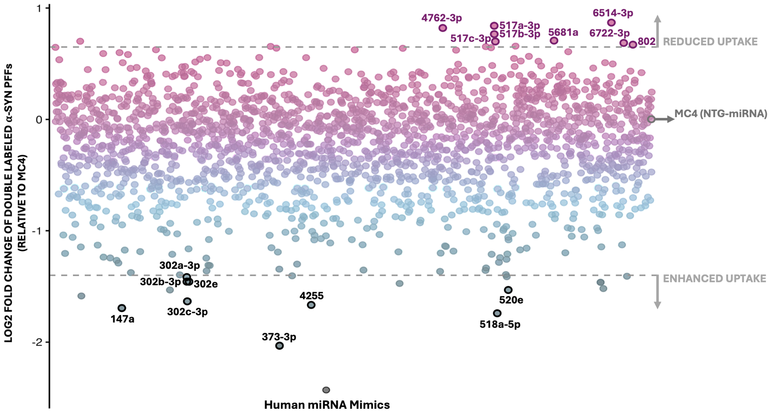

Fig. S1. Scatter plot quantifying log2 fold change in double-labeled α-syn PFF uptake relative to MC4. This panel corresponds to Fig. 1A in the main text, showing all identified miRNA hits from the primary screen.

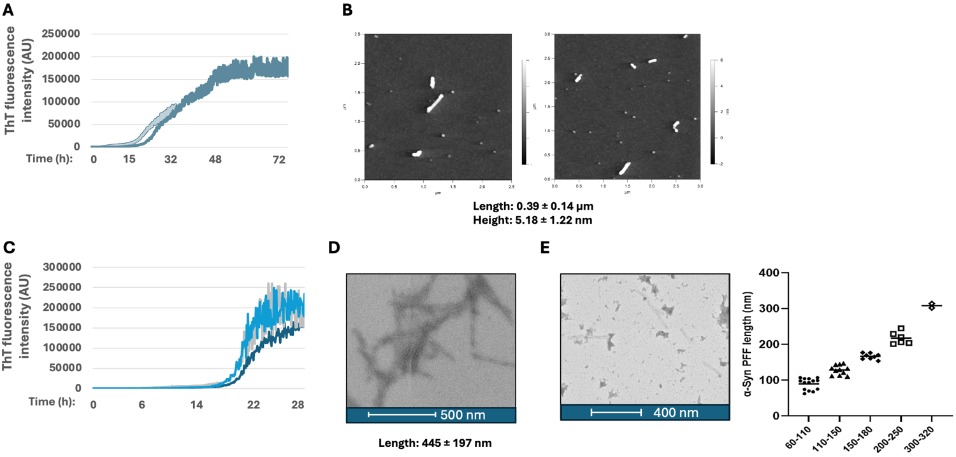

Fig. S2. Characterization of human α-synuclein preformed fibrils. (A) ThT fluorescence monitored kinetics of α-syn PFFs used for the genome-wide miRNA screen. (B) Recombinant human α-syn PFFs (used in the screen) visualized and characterized by AFM, with fibril length and height measured. (C) ThT fluorescence monitored kinetics of α-syn PFFs used for the uptake validation assays. (D) Recombinant human α-syn PFFs (used in the validation assays) visualized and characterized by TEM (before sonication), with fibril length and height measured. (E) Recombinant human α-syn PFFs (used in the validation assays) visualized and characterized by TEM (after sonication; left). The dot plot (right) illustrates the length of sonicated α-syn PFFs, categorized into discrete bins along the x-axis. Each point represents and individual measurement within these length categories. ThT, Thioflavin T; AFM, atomic force microscopy; TEM, transmission electron microscopy; α-syn PFFs, α-synuclein preformed fibrils.

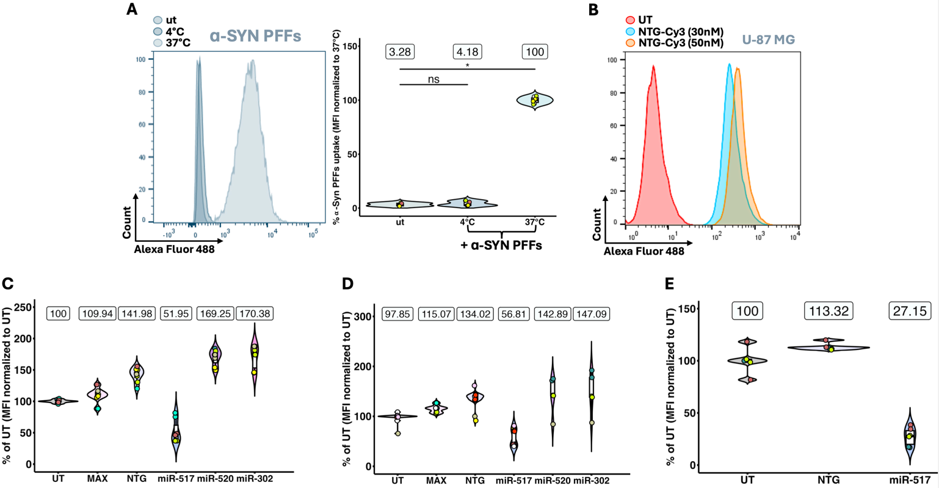

Fig. S3. Active endocytosis of α-synuclein preformed fibrils and validation of hit miRNAs in U-87 MG cells. (A) U-87 MG cells were analyzed under three conditions: untreated (ut), α-syn PFF treatment at 4°C, and α-syn PFF treatment at 37°C, all incubated for 3 hours. The histogram (left) displays fluorescence intensity distributions of Alexa Fluor-488-labeled α-syn PFFs. The violin-boxplot (right) quantifies α-syn PFF uptake in all conditions, relative to α-syn PFF treatment at 37°C (MFI normalized to 37°C). (B) The histogram shows fluorescence intensity distributions of Cy3-labeled NTG miRNA (30 or 50 nM), 72 hours post-transfection in U-87 MG cells. (C) This panel corresponds to Fig. 2B in the main text, showing additional tested conditions. (D) This panel corresponds to Fig. 2D in the main text and shows additional tested conditions. (E) This panel corresponds to Fig. 2C in the main text, showing additional tested conditions. MFI, median fluorescence intensity; ut, untreated control; NTG, non-targeting miRNA control; α-syn PFFs, α-synuclein preformed fibrils.

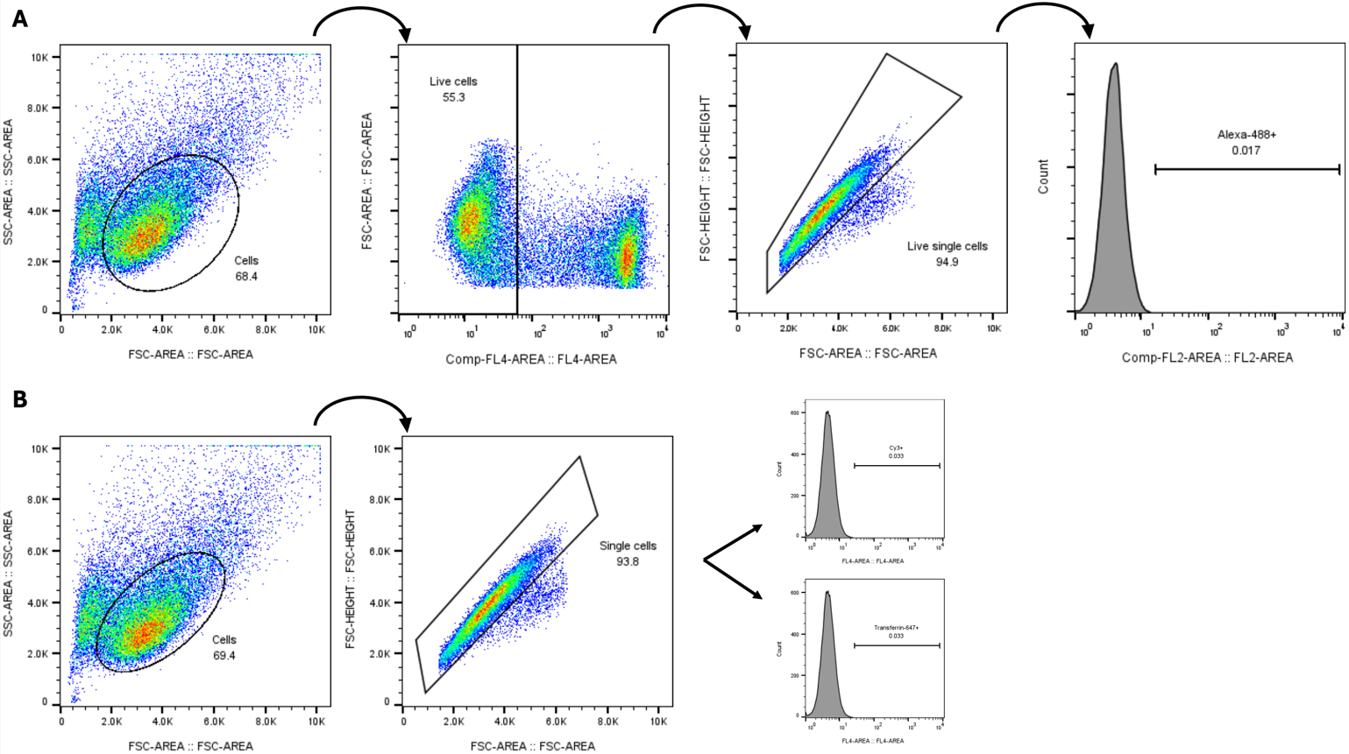

Fig. S4. Flow cytometry gating strategies used for the miR-517a-3p validation assays. (A) Gating strategy for Alexa Fluor-488 labeled proteins. Cells were first gated based on FSC and SSC properties. Live cells were gated using PI (FL4 channel) to exclude dead cells. Single cells were identified by FSC-A vs. FSC-H to remove doublets. Final gating for Alexa Fluor-488-positive cells was performed (FL2 channel) to quantify protein internalization. (B) Gating strategy for Alexa Fluor-647 labeled transferrin and Cy3 labeled NTG miRNA (NTG-Cy3). Cells were first gated based on FSC and SSC properties. Single cells were selected using FSC-A vs. FSC-H. Final gating for Alexa Fluor-647 or Cy3-positive cells was performed (FL2 channel) to quantify transferrin internalization or NTG-Cy3 miRNA transfection efficiency. FSC, forward scatter; FSC-A, FSC-Area; FSC-H, FSC-Height; SSC, side scatter; PI, propidium iodide; NTG, non-targeting microRNA.

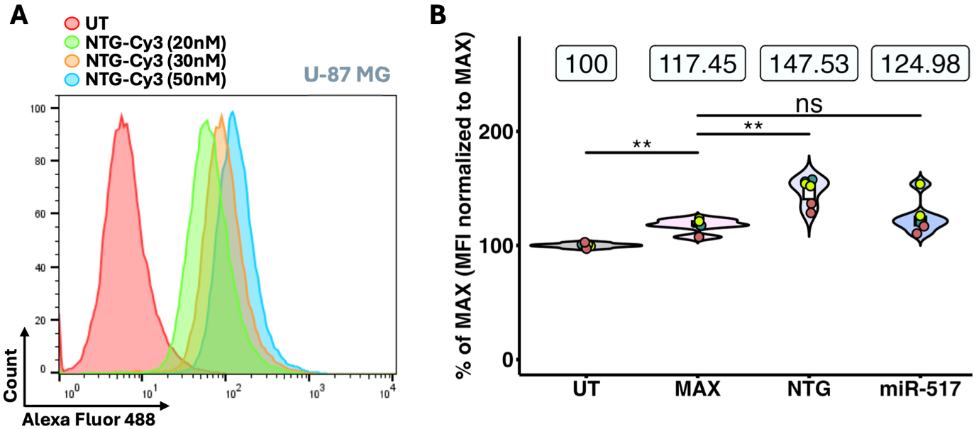

Fig. S5. Secretion/degradation assay to assess the mechanism of action of miR-517a-3p in U-87 MG cells. (A) The histogram shows fluorescence intensity distributions of Cy3-labeled NTG miRNA at different concentrations (20, 30 or 50 nM), 48 hours post-transfection in U-87 MG cells. (B) This panel corresponds to Fig. 3C in the main text, showing additional tested conditions and a different normalization strategy. The violin-boxplot (right) quantifies α-syn PFF uptake relative to MAX. Statistical significance was determined using the Wilcoxon rank-sum test (unadjusted p value). ns, not significant; **p < 0.01. The violin plot illustrates data distribution, with boxplots inside indicating the median and interquartile range. The boxes above the violins indicate the mean uptake percentages for each condition. Individual points are color-coded to represent independent experiments (biological replicates), with technical replicates sharing the same color within each condition. MFI, median fluorescence intensity; miR-517, hsa-miR-517a-3p; MAX, RNAiMAX transfection reagent; α-syn PFFs, α-synuclein preformed fibrils. N = 3 independent experiments.

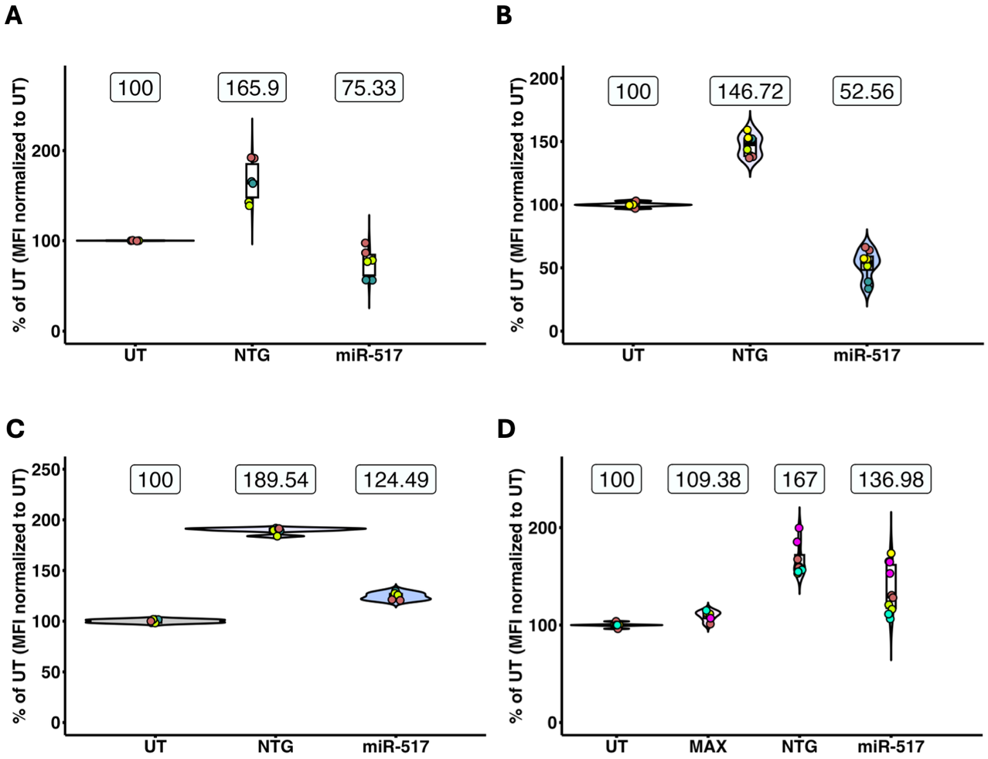

Fig. S6. Human monomeric α-synuclein and transferrin uptake in miR-517a-3p transfected U-87 MG cells. (A) This panel corresponds to Fig. 4A in the main text, showing additional tested conditions. (B) The panel corresponds to Fig. 4B in the main text, showing additional tested conditions. (C) This panel corresponds to Fig. 4C in the main text and shows additional tested conditions. (D) The panel corresponds to Fig. 4D in the main text and shows additional tested conditions.

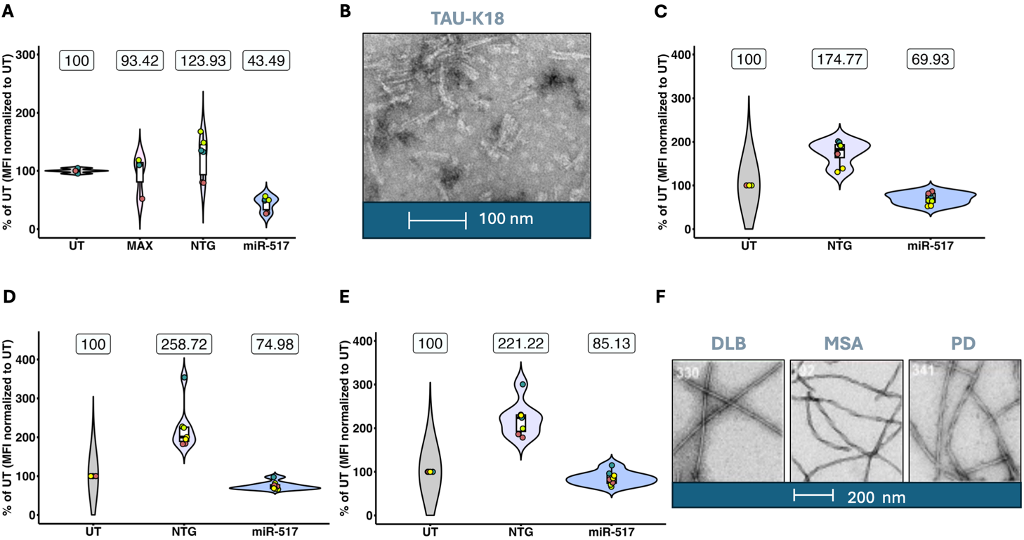

Fig. S7. miR-517a-3p reduces the internalization of Tau-K18 and patient-derived α-synuclein fibrils in U-87 MG cells. (A) This panel corresponds to Fig. 5A in the main text, showing additional tested conditions. (B) TEM micrograph showing Tau K18 PFFs generated from the human Tau K18 construct as reported in [296] (C) This panel corresponds to Fig. 5B in the main text, showing additional tested conditions. (D) This panel corresponds to Fig. 5C in the main text and shows additional tested conditions. (E) This panel corresponds to Fig. 5D in the main text, showing additional tested conditions. (F) TEM micrographs showing fibrils amplified from brain homogenates of patients with DLB, MSA or PD, as reported in [297]. Tau-K18 PFFs; Tau fibrils produced from recombinant human Tau K18 construct; DLB, Dementia with Lewy Bodies; MSA, Multiple System Atrophy; PD, Parkinson’s Disease; TEM, transmission electron microscopy.

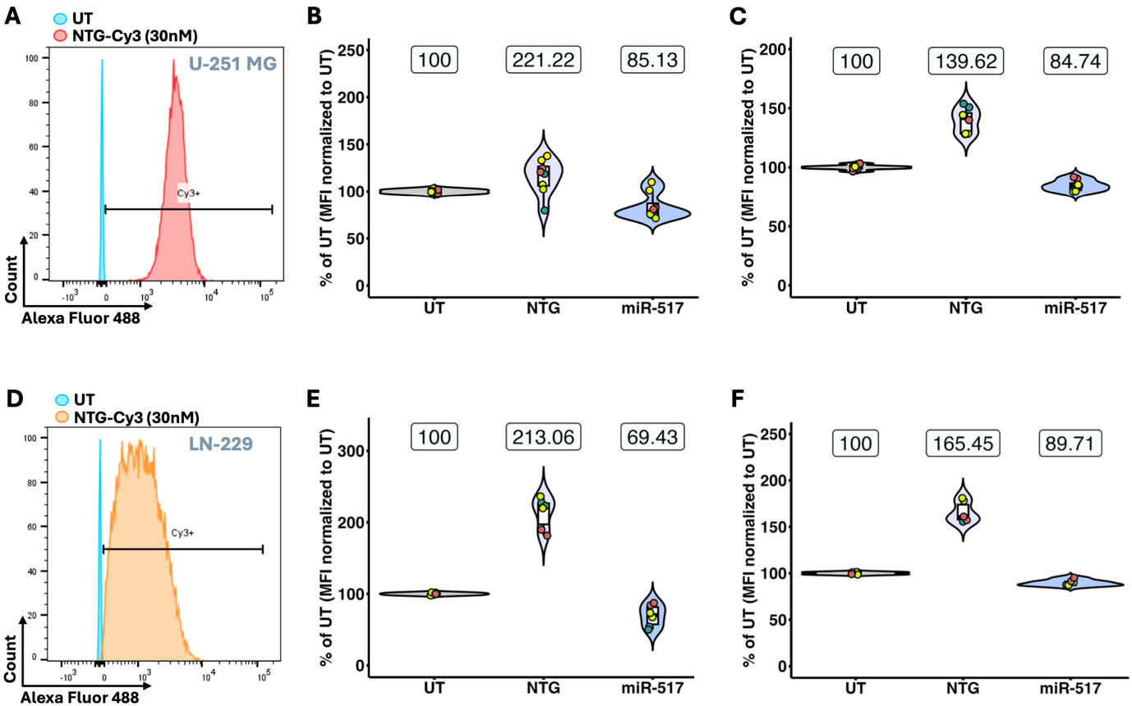

Fig. S8. miR-517a-3p reduces the internalization of α-synuclein across different glioblastoma cell lines. (A) The histogram shows fluorescence intensity distributions of Cy3-labeled NTG miRNA at 30 nM concentration, 72 hours post-transfection in U-251 MG cells. (B) This panel corresponds to Fig. 6A in the main text, showing additional tested conditions. (C) This panel corresponds to Fig. 6B in the main text, showing additional tested conditions. (D) The histogram shows fluorescence intensity distributions of Cy3-labeled NTG miRNA at 30 nM concentration, 72 hours post-transfection in LN-229 MG cells. (E) This panel corresponds to Fig. 6C in the main text, showing additional tested conditions. (F) This panel corresponds to Fig. 6D in the main text, showing additional tested conditions. NTG, non-targeting microRNA.

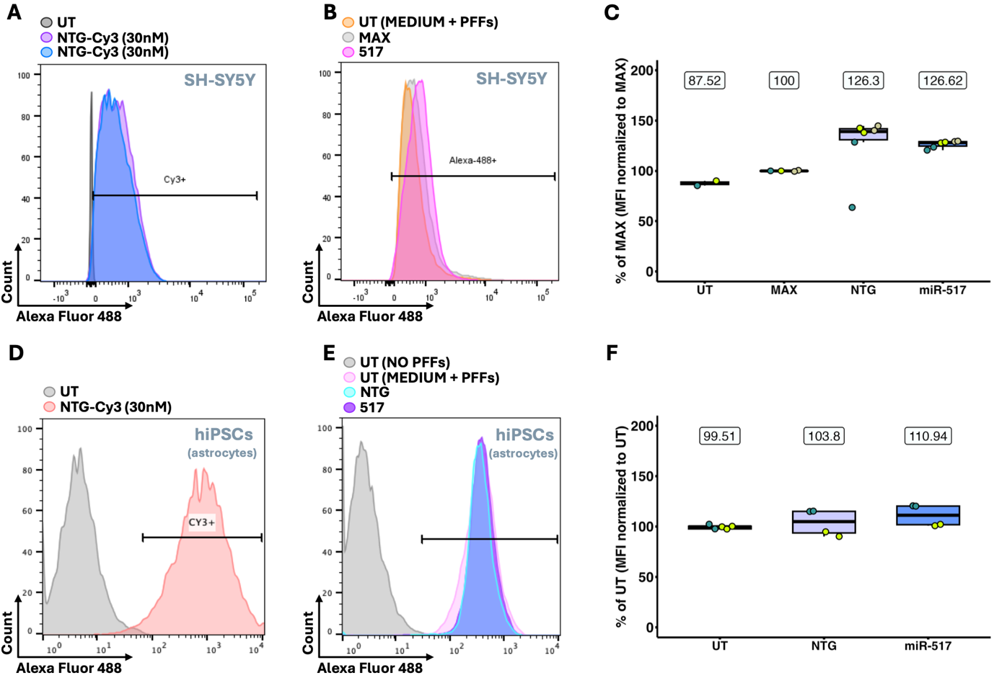

Fig. S9. Internalization of α-synuclein preformed fibrils in SH-SY5Y cells and hiPCS-derived astrocytes. (A) Flow cytometry histogram displays fluorescence intensity distributions for Cy3-labeled NTG miRNA at 30 nM concentration, 72 hours post-transfection in SH-SY5Y cells. (B) Flow cytometry histogram showing fluorescence intensity distributions for UT, MAX and miR-517-transfected SY-SY5Y cells treated with Alexa Fluor-488 labeled α-syn PFFs. (C) The box plot quantifies α-syn PFF internalization (in SH-SY5Y cells) as median fluorescence intensities (MFI) normalized to UT. N = 3 independent experiments. (D) Flow cytometry histogram displays fluorescence intensity distributions for Cy3-labeled NTG miRNA at 30 nM concentration, 72 hours post-transfection in hiPSC-derived astrocytes. (E) Flow cytometry histogram showing fluorescence intensity distributions for untransfected (UT (NO PFFs) and UT (MEDIUM + PFFs)) or microRNA (NTG and 517)-transfected hiPSC-derived astrocytes treated with Alexa Fluor-488 labeled α-syn PFFs. (F) The box plot quantifies α-syn PFF internalization (in hiPSC-derived astrocytes) as median fluorescence intensities (MFI) normalized to UT. N = 2 independent experiments. (C, F) Box plots indicate the median and interquartile range. The boxes above indicate the mean uptake percentages for each condition. Individual points are color-coded to represent independent experiments (biological replicates), with technical replicates sharing the same color within each condition. MFI, median fluorescence intensity; hiPSCs, human induced pluripotent stem cells; UT, untransfected control; MAX, RNAiMAX transfection reagent; NTG, non-targeting microRNA; miR-517, hsa-miR-517a-3p; α-syn PFFs, α-synuclein preformed fibrils.

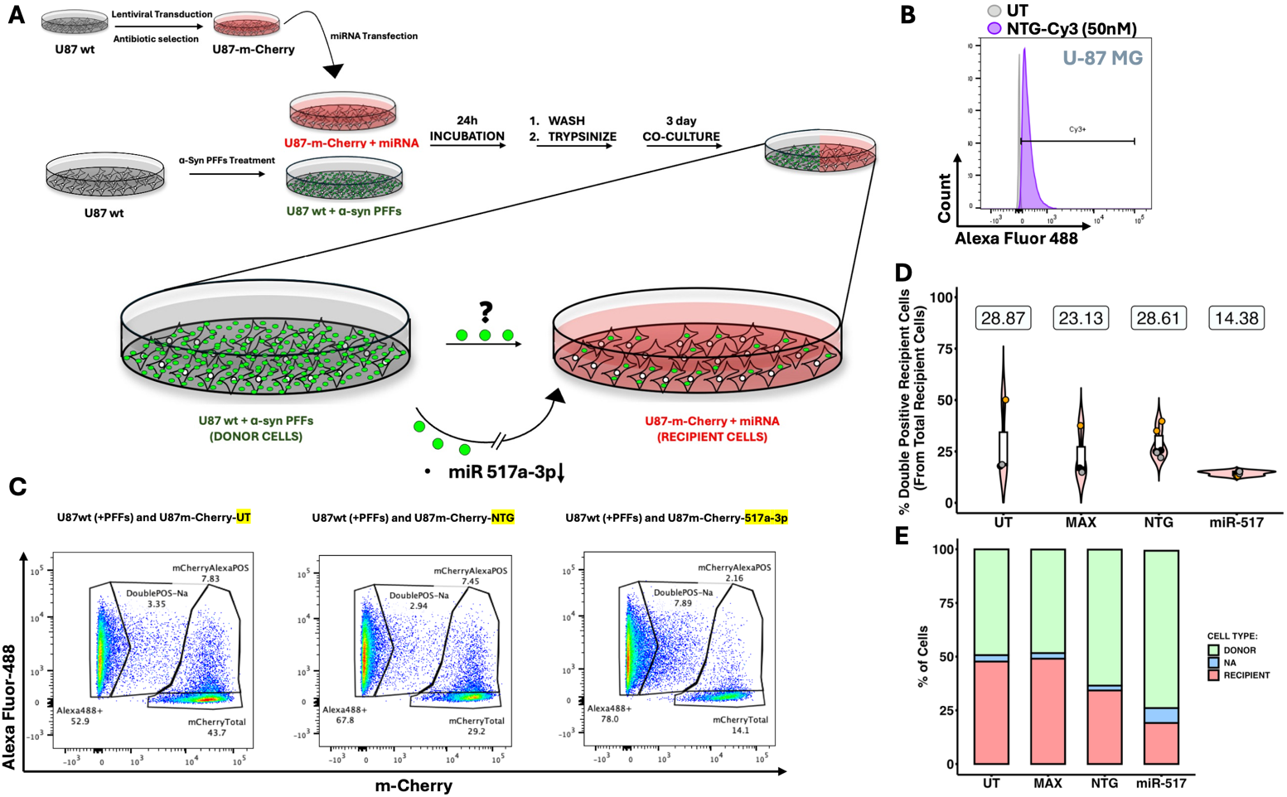

Fig. S10. miR-517a-3p reduces α-synuclein preformed fibril transfer in a co-culture assay and alters recipient cell growth dynamics. (A) Schematic of the co-culture cell-to-cell transmission assay. (B) Histogram showing the fluorescence intensity distribution of Cy3-labeled NTG miRNA (50 nM) in U-87 MG cells after transfection, trypsinization, replating, and a 3-day incubation period. (C) Flow cytometry gating strategy. Donor cells (Alexa Fluor-488-positive; Alexa488+), recipient cells (mCherry-positive; mCherryTotal), double-positive recipient cells (mCherry+/Alexa Fluor-488+; mCherryAlexaPOS), and an intermediate non-assigned double-positive population (DoublePOS-NA) were identified in each condition. (D) Violin-boxplots display the percentage of double-positive recipient cells (from total recipient cells). Violin plots depict data distribution, with boxplots inside indicating the median and interquartile range. The boxes above the violins represent mean uptake percentages for each condition. Individual points are color-coded to distinguish independent experiments (biological replicates), with technical replicates sharing the same color within each condition. N = 3 independent experiments. (E) Stacked bar plot quantifies the proportion of donor and recipient cells across different conditions. The bars represent the mean percentage of each cell type per condition, averaged across replicates. α-syn PFFs, α-synuclein preformed fibrils; UT, untransfected control; MAX, RNAiMAX transfection reagent with α-syn PFFs; miR-517, hsa-miR-517a-3p; NTG, non-targeting microRNA.

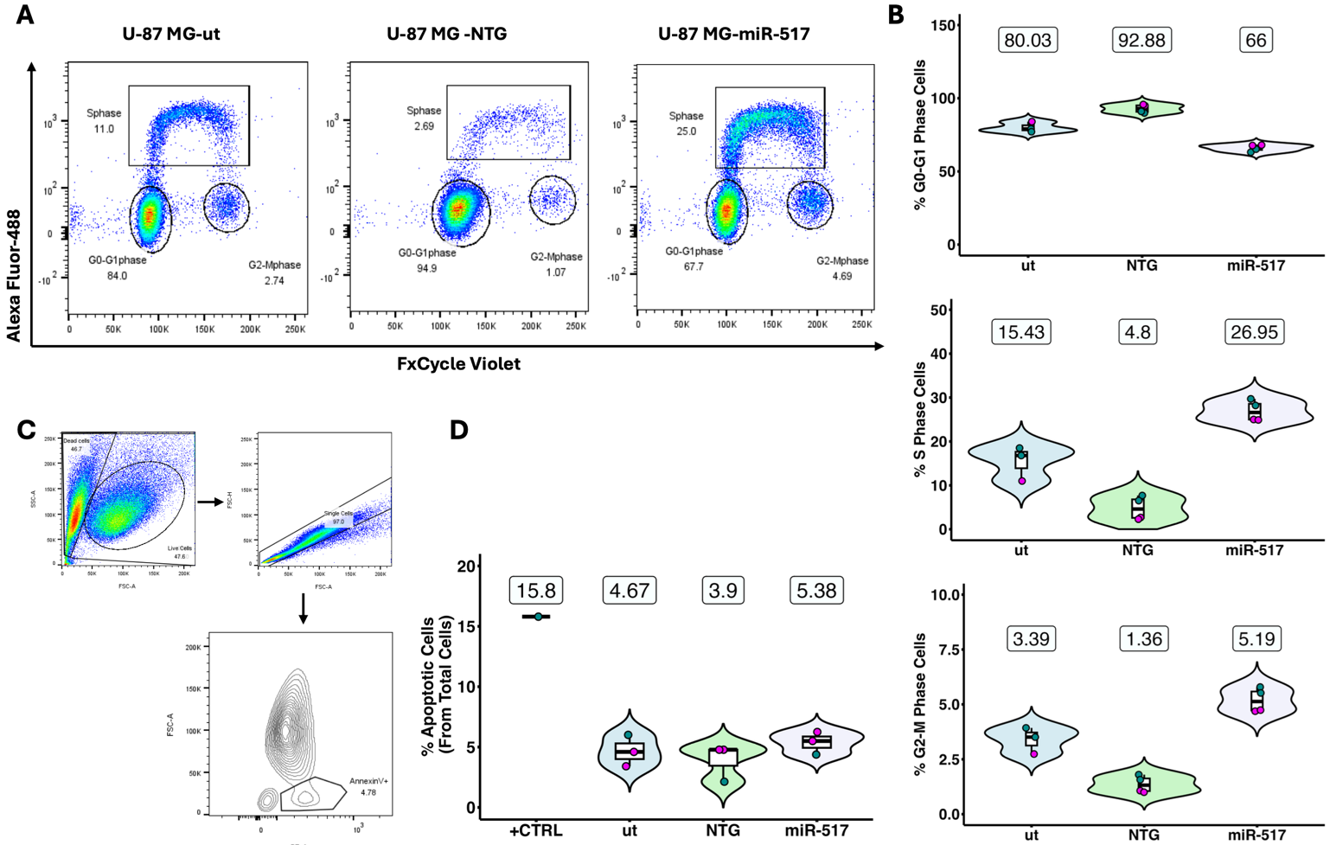

Fig. S11. Analysis of cell cycle progression and apoptosis in U-87 MG cells. (A) Gating strategy for ClickiT-EdU assay. (B) Quantification of cells in different cell cycle phases across experimental conditions. Violin plots show the distribution of cells in G0-G1, S, and G2-M phases of the cell cycle. (C) Gating strategy for Annexin V staining. (D) Quantification of Annexin V-positive apoptotic cells across experimental conditions. (B, D) Violin plots depict data distribution, with boxplots inside indicating the median and interquartile range. The boxes above the violins represent mean uptake percentages for each condition. Individual points are color-coded to distinguish independent experiments (biological replicates), with technical replicates sharing the same color within each condition. N = 2 independent experiments. ut, untransfected control without α-syn PFFs; miR-517, hsa-miR-517a-3p; NTG, non-targeting microRNA; +CRTL, positive control – UV treated cells.

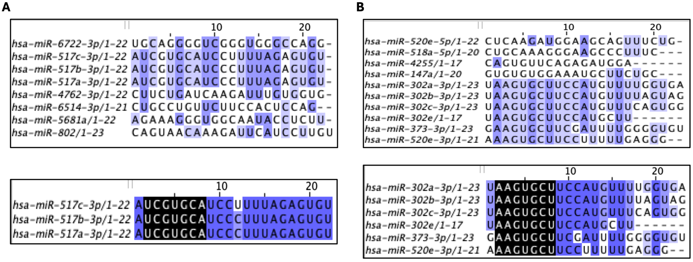

Fig. S12. Sequence conservation and seed sequence alignment of miRNAs. MiRNAs identified as suppressors (A) or enhancers (B) of α-syn PFF internalization. The top panels in (A) and (B) show the sequence overlap and conservation of mature human miRNAs identified in the primary screen. Sequence conservation is indicated by the intensity of purple shading, with darker purple representing higher conservation across miRNAs in each category. The bottom panels highlight the seed sequence (nucleotides 2-8, shown in black shading) of miRNAs from the same category that share identical seed regions.

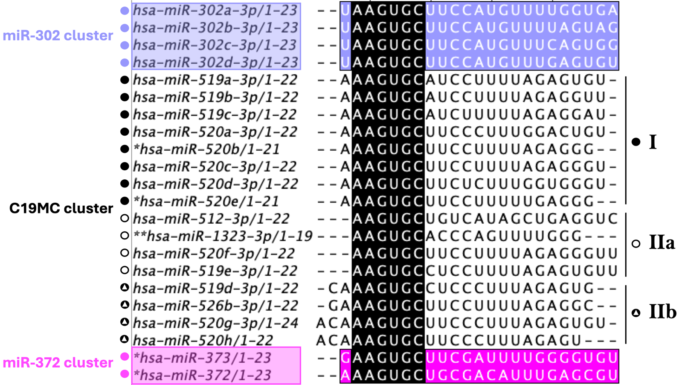

Fig. S13. MiRNAs containing the AAGUGC hexameric sequence. The figure illustrates sixteen C19MC miRNAs that share the AAGUGC hexameric seed sequence (black shading) with the miR-302 family (purple) and miR-372 family (pink). C19MC miRNAs are categorized in groups based on the position of the AAGUGC motif. Group I: MiRNAs with the AAGUGC seed sequence at the canonical seed region (nucleotides 2-7). Group II: MiRNAs with the AAGUGC sequence in non-canonical positions divided into subgroups; IIa and IIb. MiRNAs marked with * are annotated as 3p strand-derived (based on miRBase v22). MiR-1323-3p is computationally predicted, with no experimental validation yet. Adapted from [302], J. Biomed. Sci.

